**PRACTICAL IMPLEMENTATION**

**1 Overview of attribute**

Area:

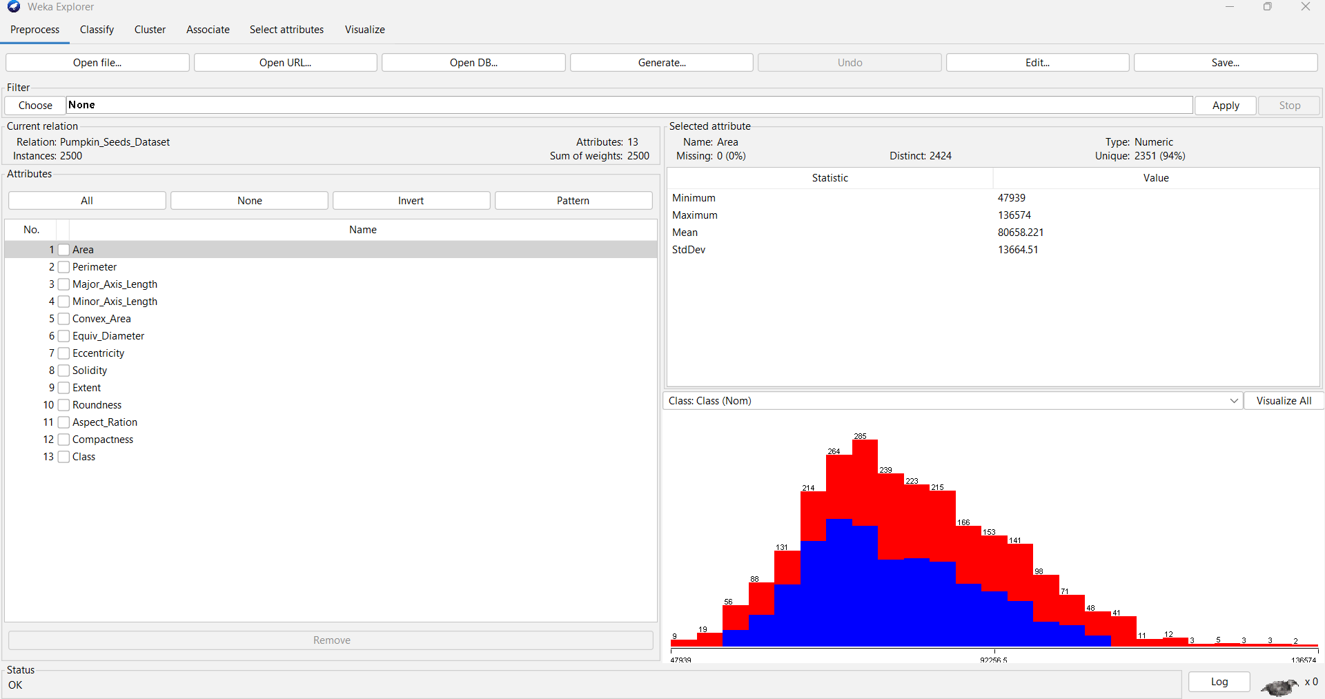

Perimeter:

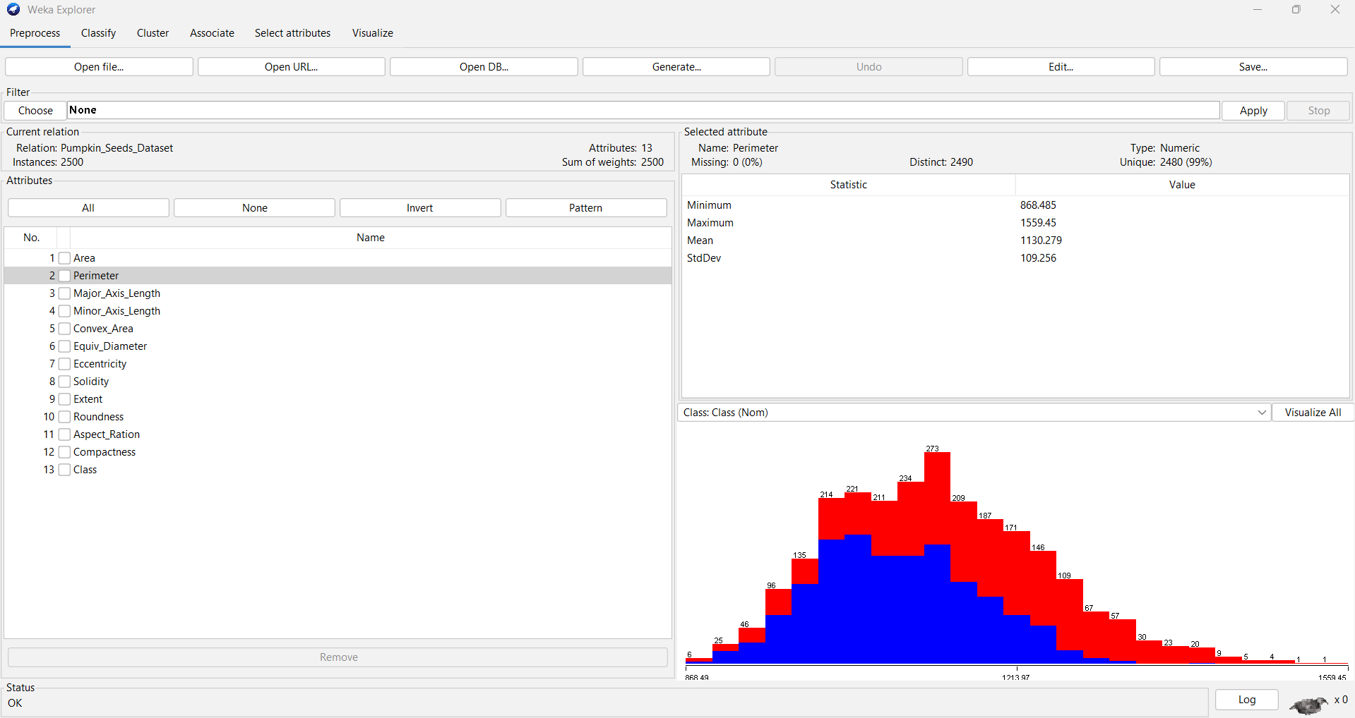

Major_Axis_Length:

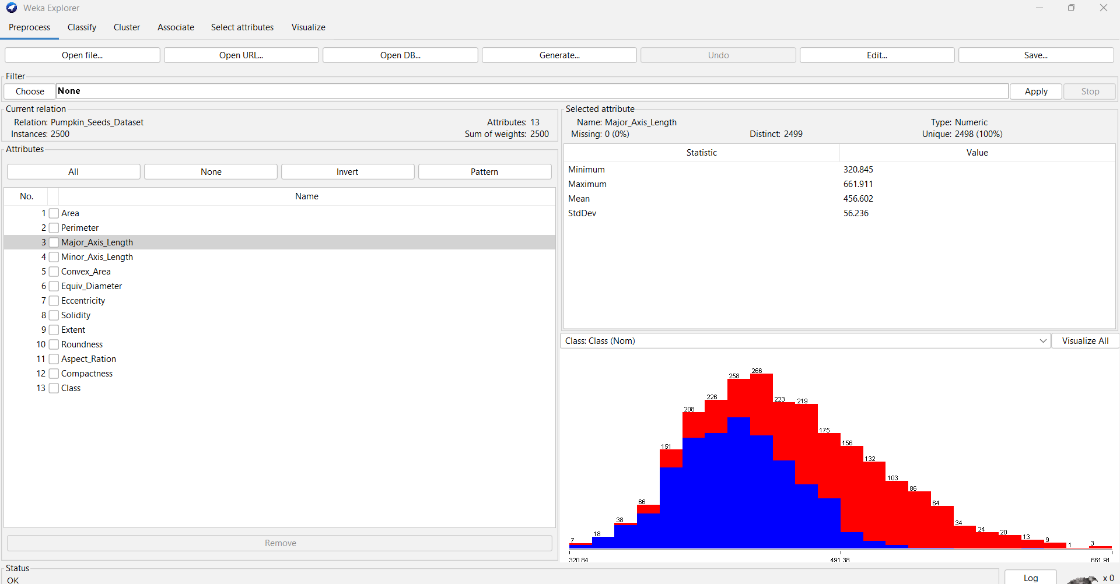

Minor_Axis_Length:

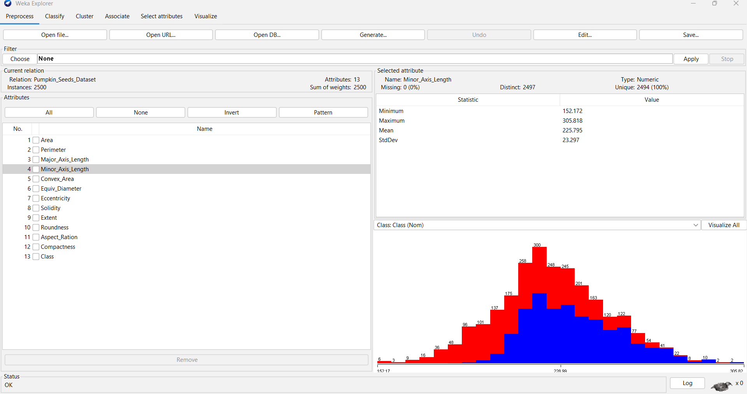

Convex_Area:

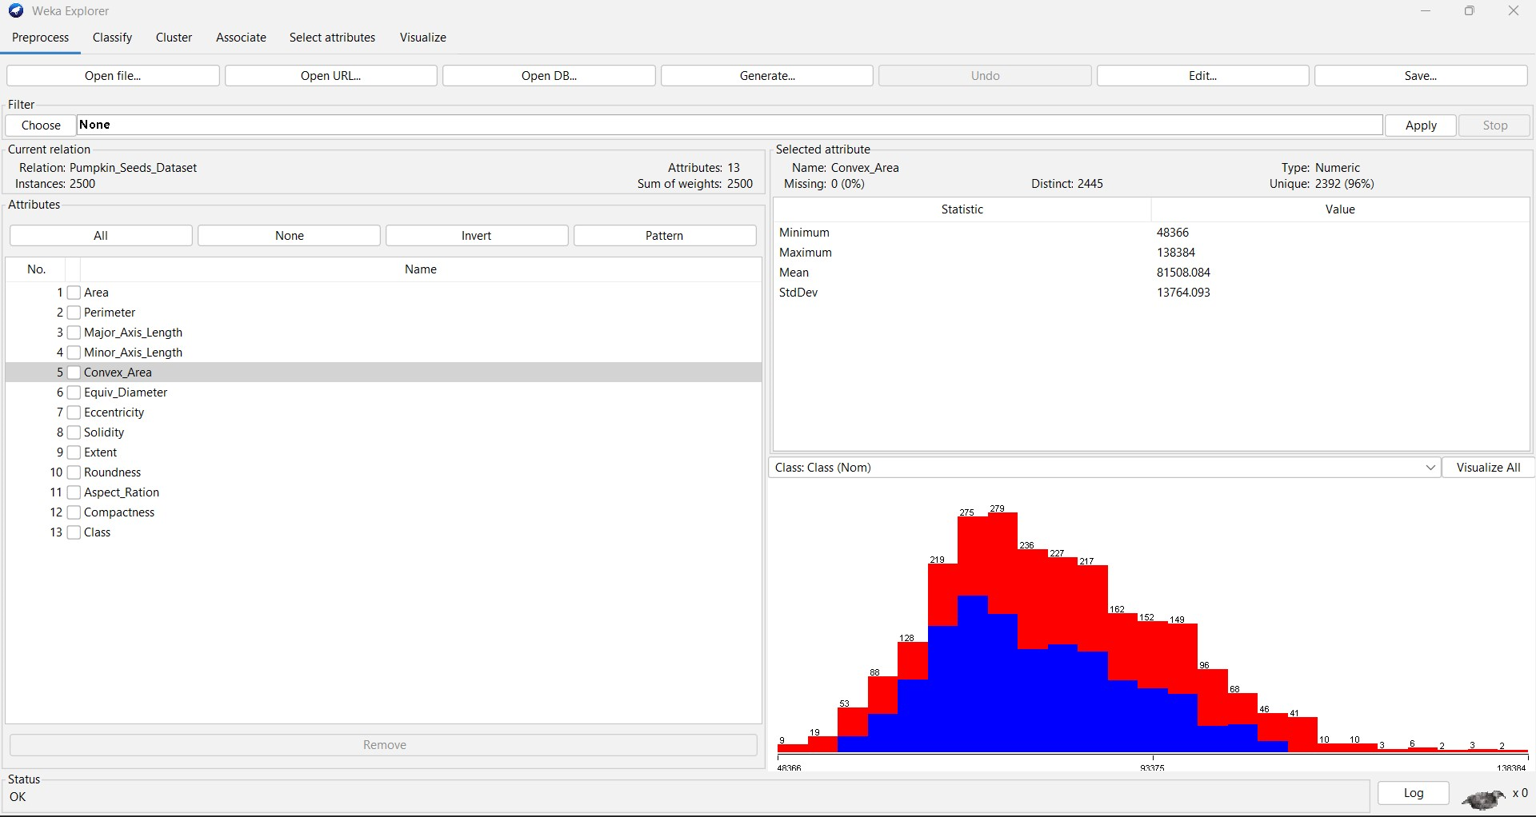

Eccentricity:

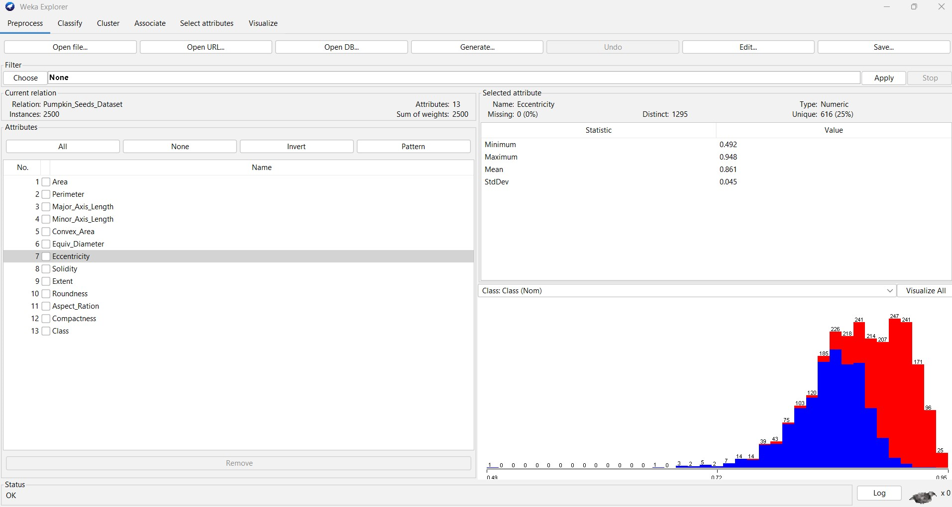

Solidity:

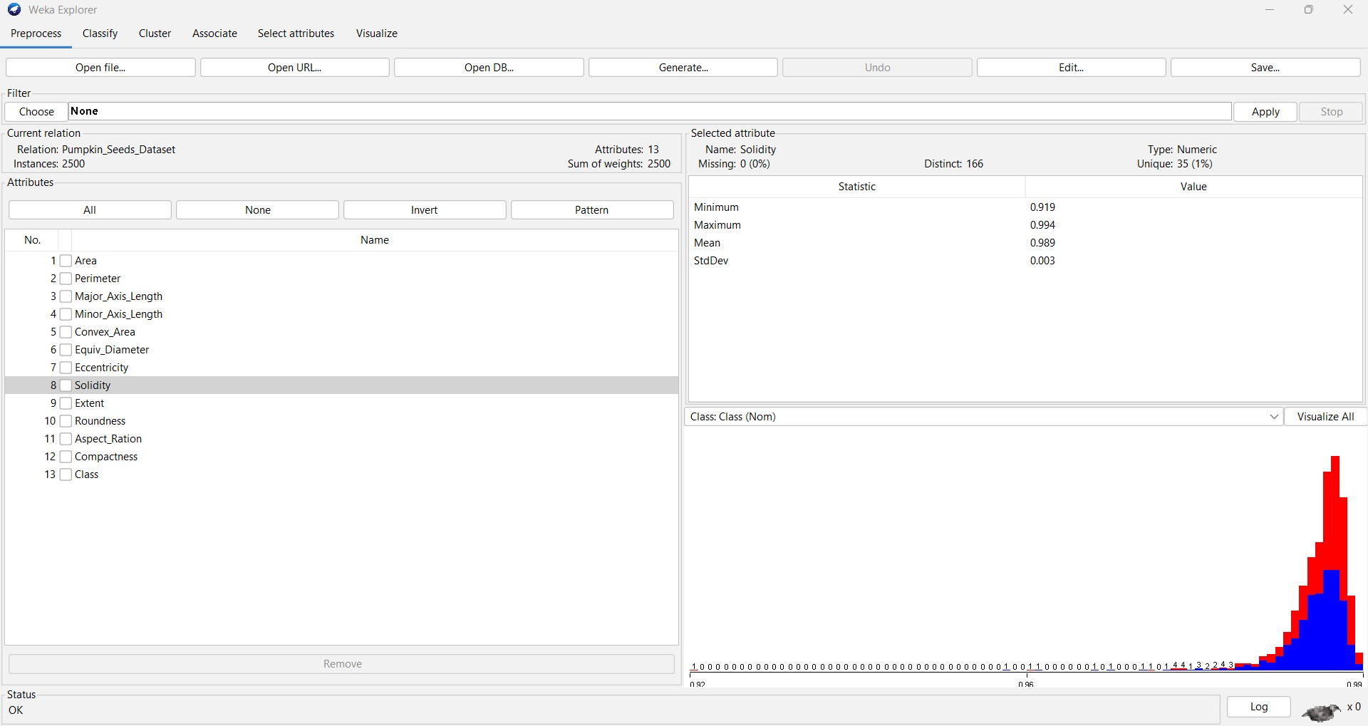

Extent:

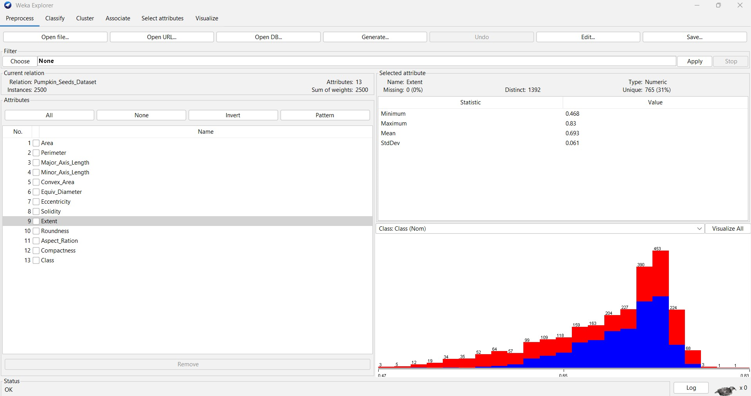

Roundness:

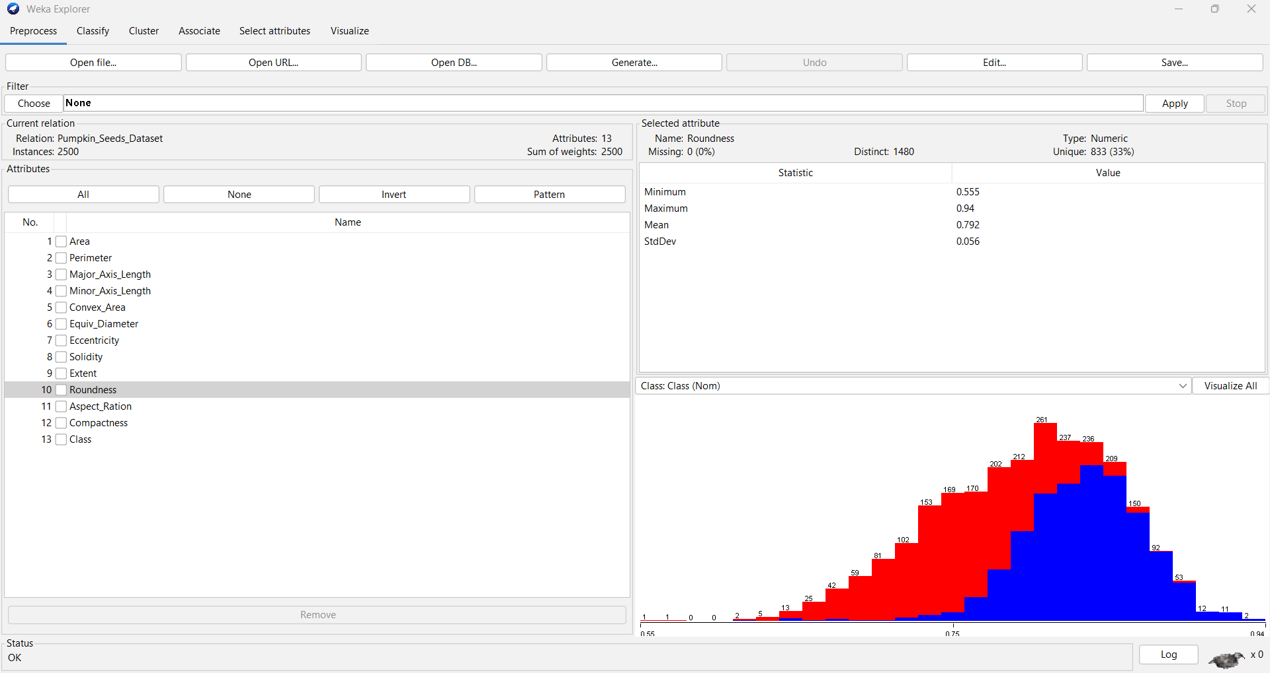

**Aspect_Ration:**

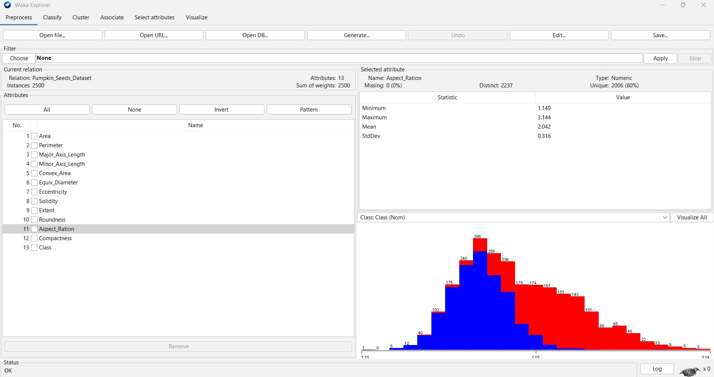

**Compactness:**

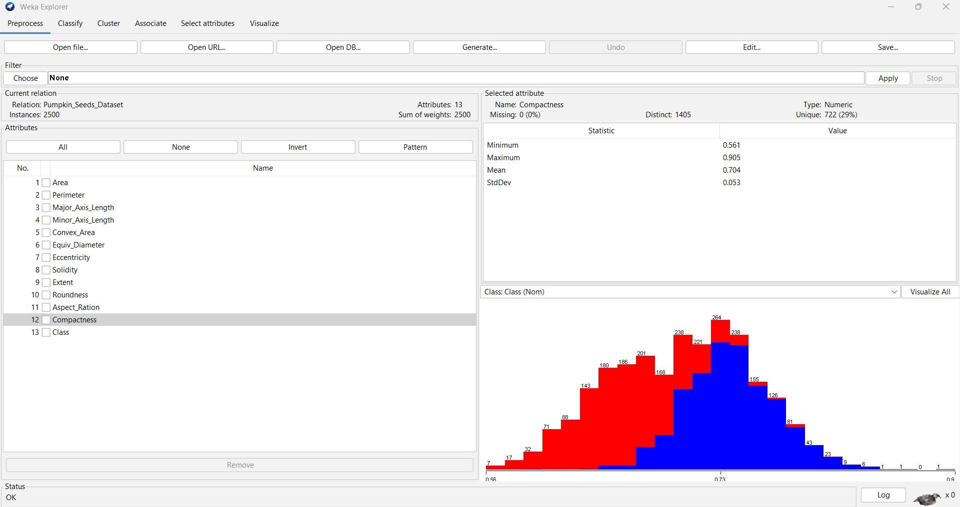

**Class:**

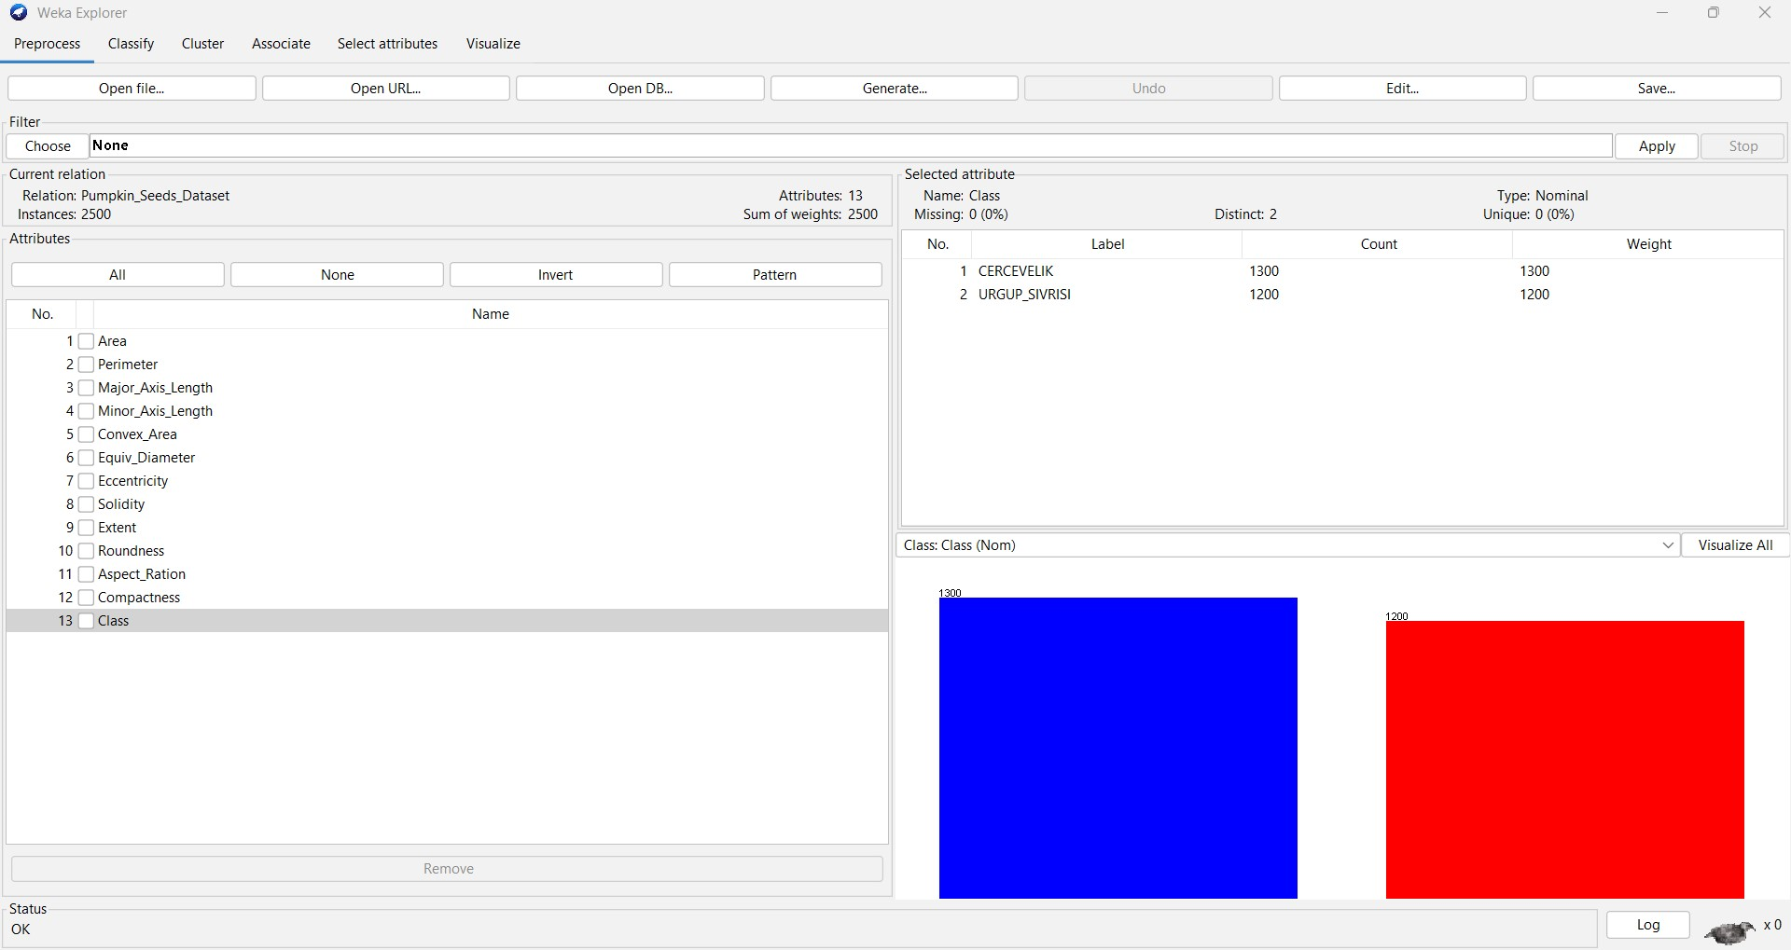

Visualizing all Attributes:

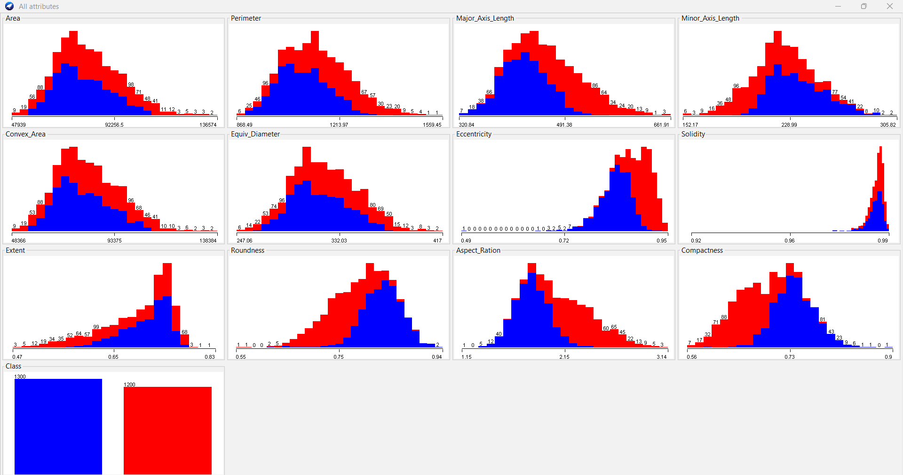

**2. Preprocessing data**

2.1 Missing values/holes: We don’t have missing values/holes in our data set.

2.2. Noise: We might or might not have noise in our data set and so, keeping an assumption that

testing data set will also have noise if training set has therefore, it would be better to not go into

identifying and removing noise.

2.3. Removing outliers: Select Unsupervised filter InterQuatrileRange(IQR)

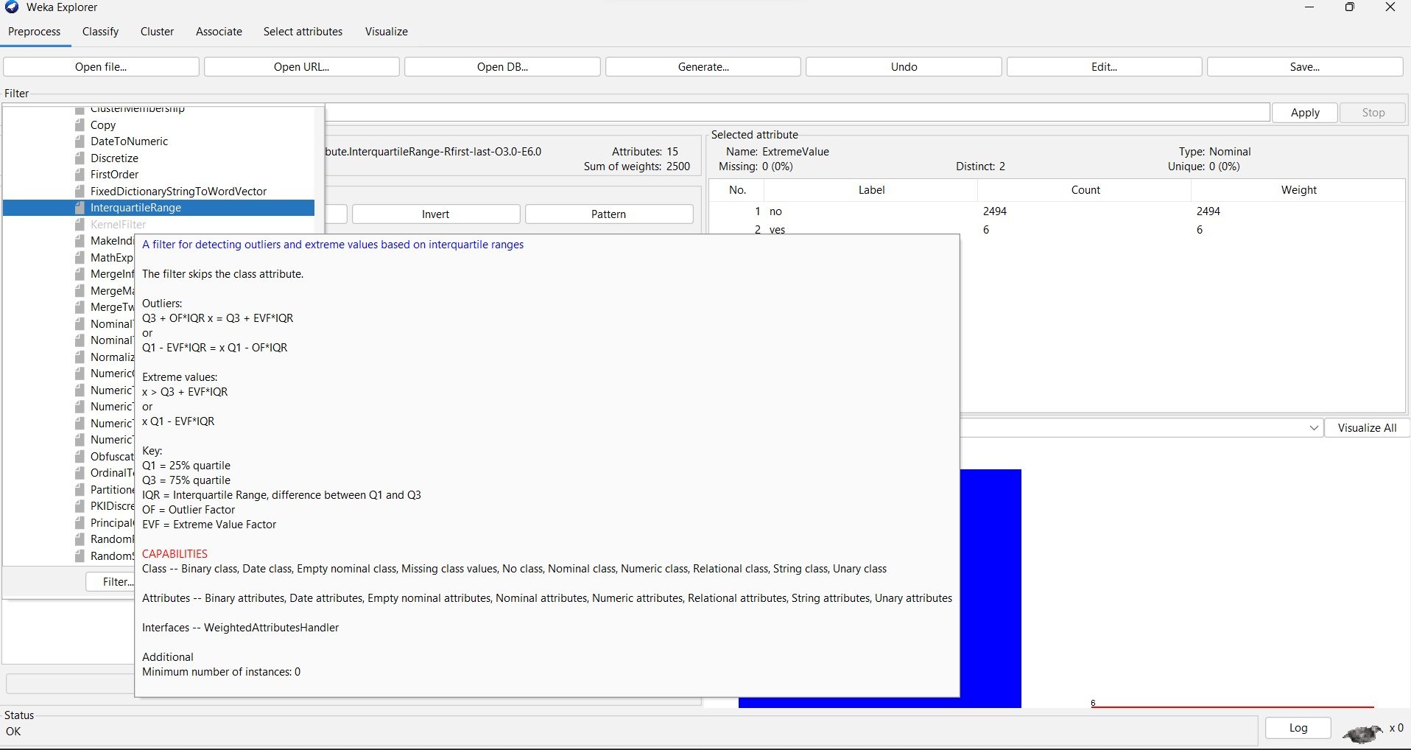

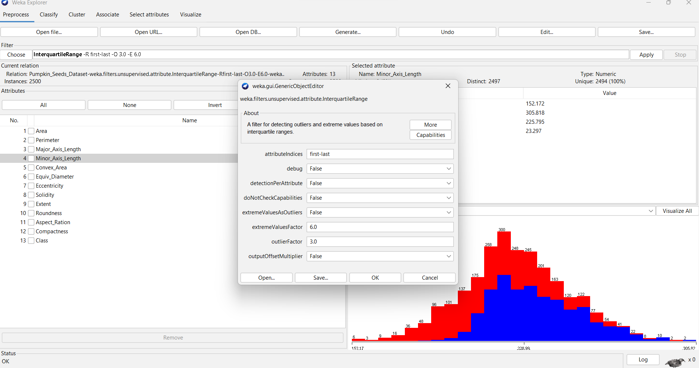

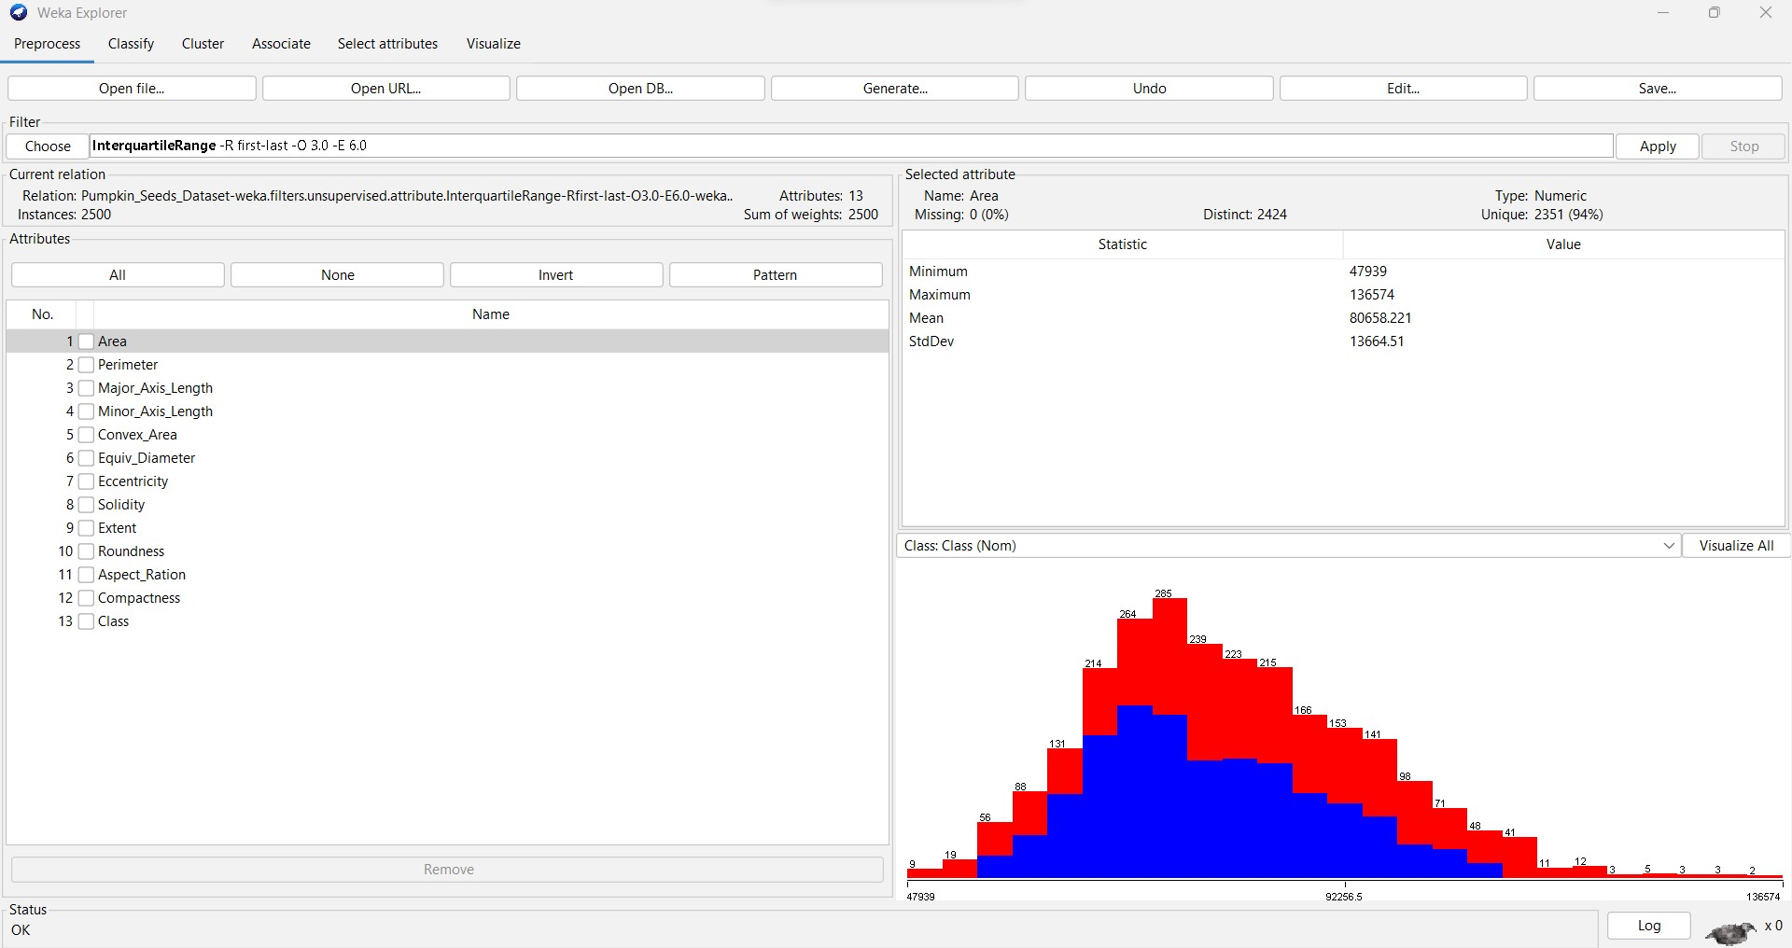

After applying the filter, we have found two more attributes added to the list –

Attribute 14 – Outliers

Attribute 15 – ExtremeValue

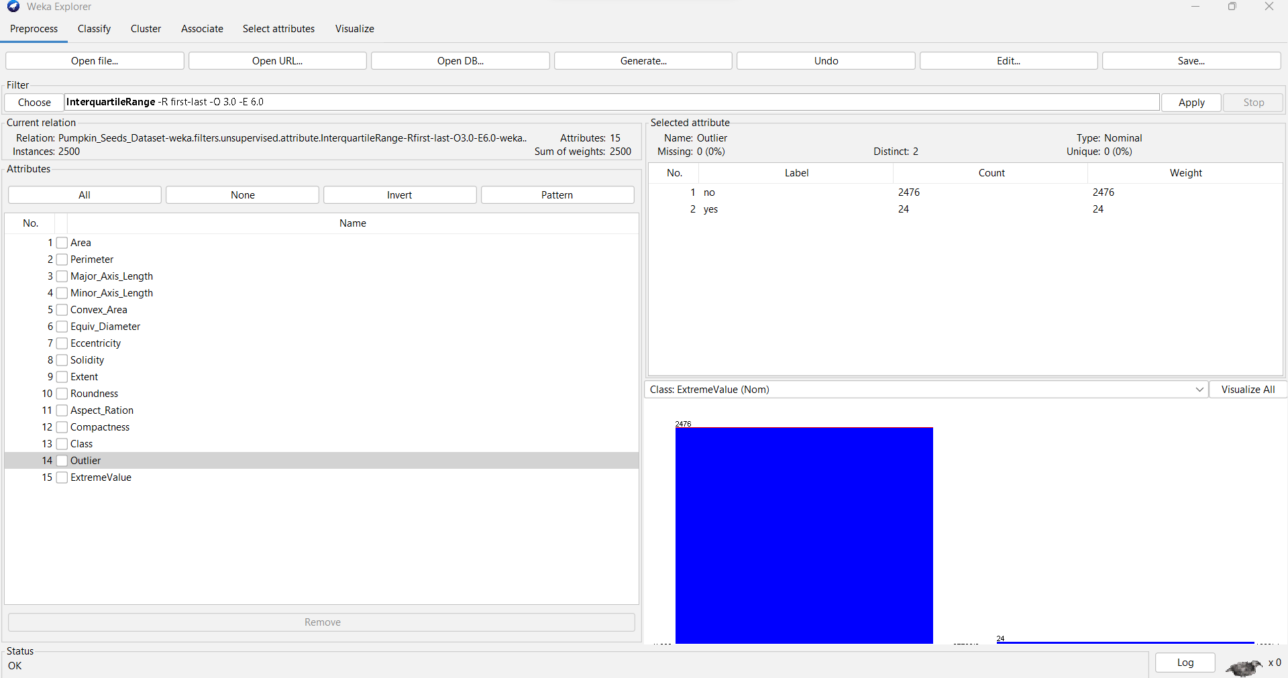

Filter -> Go to Unsupervised -> Instance -> RemoveWithValues

Set the attribute index to 14 (outlier attribute) and NominalIndices=last (ExtremeValues) because

we want to remove all the instances which has outliers value=yes

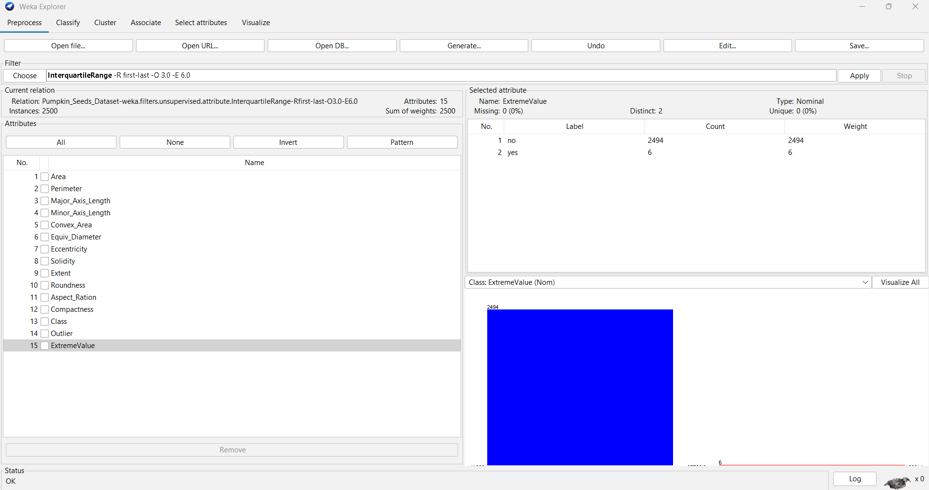

**ATTRIBUTE SELECTION:**

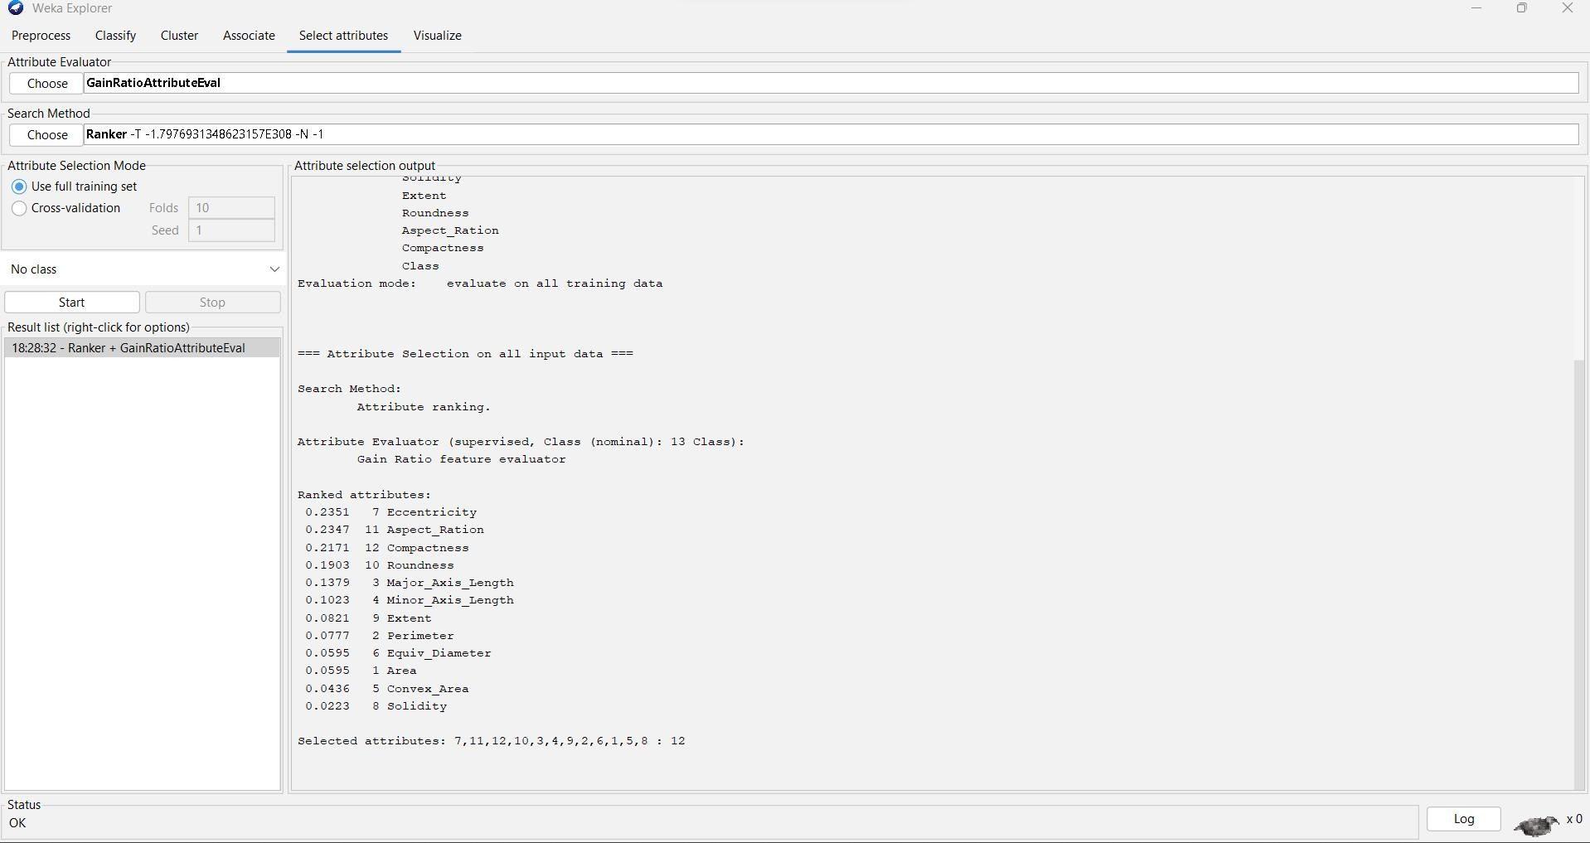

=== Run information ===

Evaluator: weka.attributeSelection.GainRatioAttributeEval

Search: weka.attributeSelection.Ranker -T -1.7976931348623157E308 -N -1 Relation: Pumpkin_Seeds_Dataset

Instances: 2500

Attributes: 13

Area Perimeter

Major_Axis_Length Minor_Axis_Length Convex_Area Equiv_Diameter Eccentricity Solidity

Extent Roundness Aspect_Ration

Compactness Class

Evaluation mode: evaluate on all training data

=== Attribute Selection on all input data ===

Search Method:

Attribute ranking.

Attribute Evaluator (supervised, Class (nominal): 13 Class): Gain Ratio feature evaluator

Ranked attributes:

|  |  |
| --- | --- |
| 0.2351 | 7 Eccentricity |
| 0.2347 | 11 Aspect_Ration |
| 0.2171 | 12 Compactness |
| 0.1903 | 10 Roundness |
| 0.1379 | 3 Major_Axis_Length |
| 0.1023 | 4 Minor_Axis_Length |
| 0.0821 | 9 Extent |
| 0.0777 | 2 Perimeter |
| 0.0595 | 6 Equiv_Diameter |
| 0.0595 | 1 Area |
| 0.0436 | 5 Convex_Area |
| 0.0223 | 8 Solidity |

Selected attributes: 7,11,12,10,3,4,9,2,6,1,5,8 : 12

**CLAASSIFICATION:**

1. **Naive Bayes:** The Naive Bayes classifier is a supervised machine learning algorithm, which is used for classification tasks, like text classification

To classify the data set, using the Naive Bayes Classification Go to Classify Tab

Under Classifier go to Choose >Classifiers>bayes>NaiveBayes

Test Options: Cross-validation Folds: 10

**ACCURACY : 86.72%**

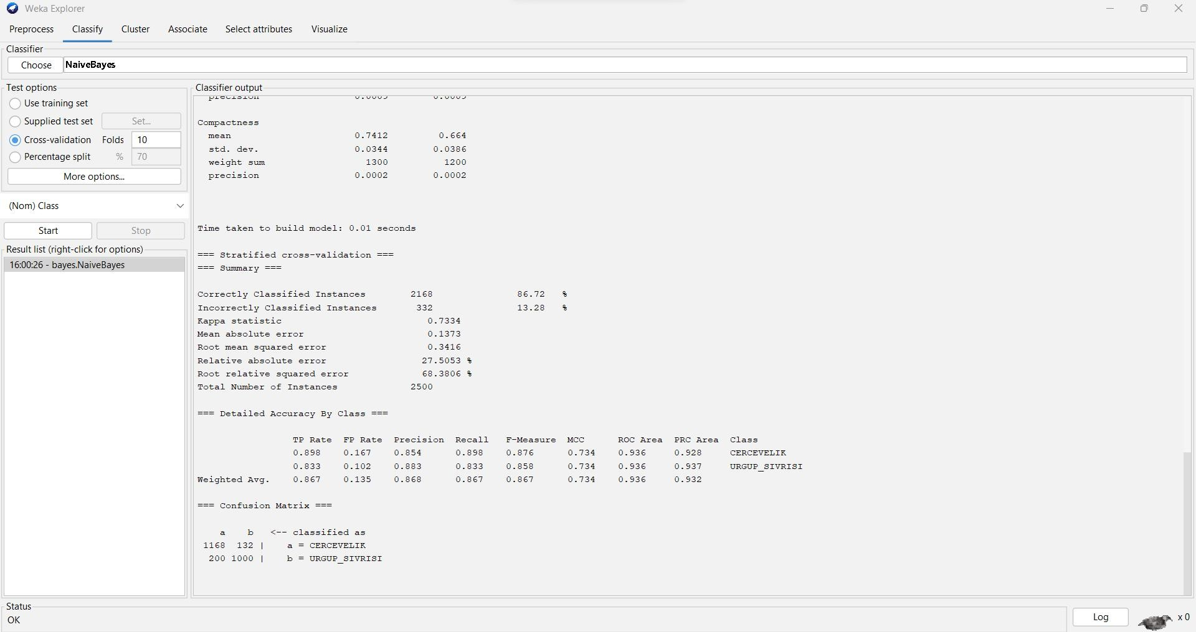

=== Run information ===

Scheme: weka.classifiers.bayes.NaiveBayes Relation: Pumpkin_Seeds_Dataset Instances: 2500

Attributes: 13

Area Perimeter

Major_Axis_Length Minor_Axis_Length Convex_Area

Equiv_Diameter Eccentricity Solidity

Extent Roundness Aspect_Ration Compactness Class

Test mode: 10-fold cross-validation

=== Classifier model (full training set) ===

Naive Bayes Classifier

Class

Attribute CERCEVELIK URGUP_SIVRISI (0.52) (0.48)

================================================

Area

|  |  |  |
| --- | --- | --- |
| mean | 78422.6576 | 83079.3389 |
| std. dev. | 11241.6199 | 15512.9004 |
| weight sum | 1300 | 1200 |
| precision | 36.5807 | 36.5807 |

Perimeter

mean 1089.5237 1174.4284

std. dev. 83.0966 116.7463

weight sum 1300 1200

precision 0.2776 0.2776

Major_Axis_Length

|  |  |  |
| --- | --- | --- |
| mean | 426.2707 | 489.4595 |
| std. dev. | 37.1811 | 54.883 |
| weight sum | 1300 | 1200 |
| precision | 0.1365 | 0.1365 |

Minor_Axis_Length

|  |  |  |
| --- | --- | --- |
| mean | 234.7771 | 216.0645 |
| std. dev. | 19.493 | 23.164 |
| weight sum | 1300 | 1200 |
| precision | 0.0616 | 0.0616 |

Convex_Area

|  |  |  |
| --- | --- | --- |
| mean | 79286.4162 | 83914.9589 |
| std. dev. | 11345.8192 | 15618.404 |
| weight sum | 1300 | 1200 |
| precision | 36.8322 | 36.8322 |

Equiv_Diameter

|  |  |  |
| --- | --- | --- |
| mean | 315.1933 | 323.8198 |
| std. dev. | 22.4645 | 30.3414 |
| weight sum | 1300 | 1200 |
| precision | 0.0701 | 0.0701 |

Eccentricity

|  |  |  |
| --- | --- | --- |
| mean | 0.8305 | 0.8938 |
| std. dev. | 0.0363 | 0.0272 |
| weight sum | 1300 | 1200 |
| precision | 0.0004 | 0.0004 |

Solidity

mean 0.9891 0.9899

std. dev. 0.0034 0.0035

weight sum 1300 1200

precision 0.0005 0.0005

|  |  |  |
| --- | --- | --- |
| Extent |  | |
| mean | 0.707 | 0.6782 |
| std. dev. | 0.0407 | 0.0742 |
| weight sum | 1300 | 1200 |
| precision | 0.0003 | 0.0003 |

Roundness

|  |  |  |
| --- | --- | --- |
| mean | 0.8275 | 0.7526 |
| std. dev. | 0.0375 | 0.0455 |
| weight sum | 1300 | 1200 |
| precision | 0.0003 | 0.0003 |

Aspect_Ration

|  |  |  |
| --- | --- | --- |
| mean | 1.8226 | 2.2791 |
| std. dev. | 0.1684 | 0.2624 |
| weight sum | 1300 | 1200 |
| precision | 0.0009 | 0.0009 |

Compactness

|  |  |  |
| --- | --- | --- |
| mean | 0.7412 | 0.664 |
| std. dev. | 0.0344 | 0.0386 |
| weight sum | 1300 | 1200 |
| precision | 0.0002 | 0.0002 |

Time taken to build model: 0.01 seconds.

=== Stratified cross-validation ===

=== Summary ===

|  |  |  |  |
| --- | --- | --- | --- |
| Correctly Classified Instances | | 2168 | 86.72 % |
| Incorrectly Classified Instances | | 332 | 13.28 % |
| Kappa statistic | 0.7334 | | |
| Mean absolute error | 0.1373 | | |
| Root mean squared error | 0.3416 | | |
| Relative absolute error | 27.5053 % | | |
| Root relative squared error | 68.3806 % | | |
| Total Number of Instances | 2500 | | |

=== Detailed Accuracy by Class ===

TP Rate FP Rate Precision Recall F-Measure MCC ROC Area PRC Area Class

|  |  |  |  |  |  |  |  |  |
| --- | --- | --- | --- | --- | --- | --- | --- | --- |
| 0.898 | 0.167 | 0.854 | 0.898 | 0.876 | 0.734 | 0.936 | 0.928 | CERCEVELIK |
| 0.833 | 0.102 | 0.883 | 0.833 | 0.858 | 0.734 | 0.936 | 0.937 | URGUP_SIVRISI |
| Weighted Avg. | 0.867 | 0.135 | 0.868 | 0.867 | 0.867 | 0.734 | 0.936 | 0.932 |

=== Confusion Matrix ===

a b <-- classified as 1168 132 | a = CERCEVELIK

200 1000 | b = URGUP_SIVRISI

1. **Logistic**: It is used to analyzing a dataset in which there are one or more independent variables that determine an outcome.

To classify the data set, using the Logistic Classification Go to Classify Tab

Under Classifier go to Choose >Classifiers>Functions>Logistic

Test Options: Cross-validation Folds: 10

**ACCURACY : 88.68%**

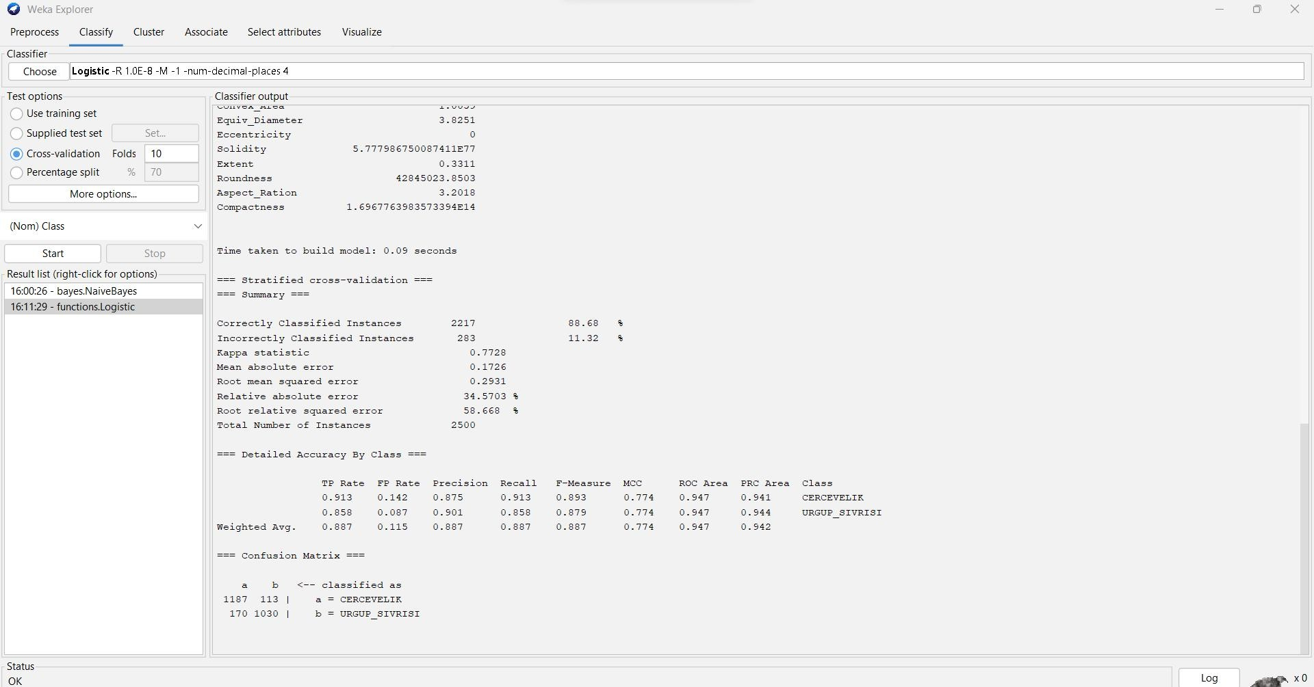

=== Run information ===

Scheme: weka.classifiers.functions.Logistic -R 1.0E-8 -M -1 -num-decimal-places 4 Relation: Pumpkin_Seeds_Dataset

Instances: 2500

Attributes: 13

Area Perimeter

Major_Axis_Length Minor_Axis_Length Convex_Area Equiv_Diameter Eccentricity Solidity

Extent Roundness Aspect_Ration Compactness

Class

Test mode: 10-fold cross-validation

=== Classifier model (full training set) ===

Logistic Regression with ridge parameter of 1.0E-8 Coefficients...

Class

Variable CERCEVELIK

==========================================

|  |  |
| --- | --- |
| Area | -0.007 |
| Perimeter | 0.014 |
| Major_Axis_Length | -0.3118 |
| Minor_Axis_Length | -0.5838 |
| Convex_Area | 0.0059 |
| Equiv_Diameter | 1.3416 |
| Eccentricity | -20.9669 |
| Solidity | 179.0531 |
| Extent | -1.1054 |
| Roundness | 17.5731 |
| Aspect_Ration | 1.1637 |
| Compactness | 32.7649 |
| Intercept | -282.2696 |

Odds Ratios...

Class

Variable CERCEVELIK

==========================================

Area 0.993

Perimeter 1.0141

|  |  |
| --- | --- |
| Major_Axis_Length | 0.7321 |
| Minor_Axis_Length | 0.5578 |
| Convex_Area | 1.0059 |
| Equiv_Diameter | 3.8251 |
| Eccentricity | 0 |

Solidity 5.777986750087411E77

Extent 0.3311

Roundness 42845023.8503

Aspect_Ration 3.2018

Compactness 1.6967763983573394E14

Time taken to build model: 0.09 seconds

=== Stratified cross-validation ===

=== Summary ===

|  |  |  |  |
| --- | --- | --- | --- |
| Correctly Classified Instances | | 2217 | 88.68 % |
| Incorrectly Classified Instances | | 283 | 11.32 % |
| Kappa statistic | 0.7728 | | |
| Mean absolute error | 0.1726 | | |
| Root mean squared error | 0.2931 | | |
| Relative absolute error | 34.5703 % | | |
| Root relative squared error | 58.668 % | | |
| Total Number of Instances | 2500 | | |

=== Detailed Accuracy by Class ===

TP Rate FP Rate Precision Recall F-Measure MCC ROC Area PRC Area Class

|  |  |  |  |  |
| --- | --- | --- | --- | --- |
| 0.913 0.142 0.875 | 0.913 0.893 | 0.774 0.947 | 0.941 | CERCEVELIK |
| 0.858 0.087 0.901 | 0.858 0.879 | 0.774 0.947 | 0.944 | URGUP_SIVRISI |

Weighted Avg. 0.887 0.115 0.887 0.887 0.887 0.774 0.947 0.942

=== Confusion Matrix ===

a b <-- classified as 1187 113 | a = CERCEVELIK

170 1030 | b = URGUP_SIVRISI

1. **Multilayer Perceptron :** it is a type of artificial neural network that is commonly used in machine learning for classification tasks and it has input, output and hidden layers where the data is acquired processed and analyzed.

To classify the data set, using the MultilayerPerceptron Classification Go to Classify Tab

Under Classifier go to Choose >Classifiers>Functions> MultilayerPerceptron

Test Options : Cross-validation Folds: 10

**ACCURACY : 88.4%**

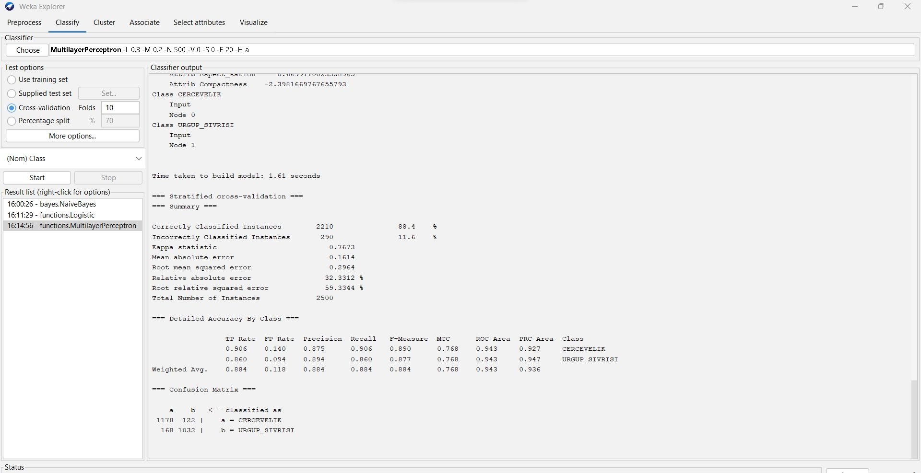

=== Run information ===

Scheme: weka.classifiers.functions.MultilayerPerceptron -L 0.3 -M 0.2 -N 500 -V 0 -S 0 -E 20 -H a Relation: Pumpkin_Seeds_Dataset

Instances: 2500

Attributes: 13

Area Perimeter

Major_Axis_Length Minor_Axis_Length Convex_Area Equiv_Diameter Eccentricity Solidity

Extent Roundness Aspect_Ration Compactness Class

Test mode: 10-fold cross-validation

=== Classifier model (full training set) ===

Sigmoid Node 0 Inputs Weights

Threshold -3.595490311186832

|  |  |
| --- | --- |
| Node 2 | 4.300540892376024 |
| Node 3 | 2.1824055560433075 |
| Node 4 | 1.3621371677089633 |
| Node 5 | -3.5382722455499986 |
| Node 6 | 1.2765901404006328 |
| Node 7 | -2.833202791332686 |
| Node 8 | -1.8882921237557697 |

Sigmoid Node 1 Inputs Weights

Threshold 3.595519507682398

|  |  |
| --- | --- |
| Node 2 | -4.300579158814876 |
| Node 3 | -2.182589704453731 |
| Node 4 | -1.3619918177093868 |
| Node 5 | 3.5383442828099425 |
| Node 6 | -1.2766168998388803 |
| Node 7 | 2.835040953813802 |
| Node 8 | 1.8880366690469699 |

Sigmoid Node 2 Inputs Weights

Threshold 11.381380808779928

Attrib Area 1.3907094788237673

Attrib Perimeter 3.315041319990196

Attrib Major_Axis_Length -2.997451874959911

Attrib Minor_Axis_Length 7.876121859501484

Attrib Convex_Area 2.491137054805032

Attrib Equiv_Diameter 6.185196825284903

Attrib Eccentricity 4.875591874021104

Attrib Solidity -7.741785656490237

Attrib Extent -1.2529345810224028

Attrib Roundness 1.9255354838571885

Attrib Aspect_Ration -7.18747936382351

Attrib Compactness 6.364972665945947

Sigmoid Node 3 Inputs Weights

Threshold 4.357907659949007

Attrib Area 4.3488880031925765

Attrib Perimeter 1.5581581218900182

Attrib Major_Axis_Length -0.2669209751284783

Attrib Minor_Axis_Length 6.790398976965309

Attrib Convex_Area 4.995634978861881

Attrib Equiv_Diameter 6.060312603897644

Attrib Eccentricity 1.1513589218214644

Attrib Solidity -7.0975286850563855

Attrib Extent 0.637932641689001

Attrib Roundness 7.193198666010584

Attrib Aspect_Ration -5.121208942641536

Attrib Compactness 4.823374503494573

Sigmoid Node 4 Inputs Weights

Threshold -0.7957574438826517

Attrib Area 0.4032822768959458

Attrib Perimeter -0.9002049358467858

Attrib Major_Axis_Length -1.3105500060053903

Attrib Minor_Axis_Length -0.3346462086041467

Attrib Convex_Area 0.583694958205666

Attrib Equiv_Diameter 1.52246664458544

Attrib Eccentricity -0.4787780695935083

Attrib Solidity -2.0267015042694543

Attrib Extent -2.561495224888639

Attrib Roundness 6.762737384642206

Attrib Aspect_Ration -0.555235183280251

Attrib Compactness 3.8019972561993383

Sigmoid Node 5 Inputs Weights

Threshold -14.239906958644841

Attrib Area 6.724183274839269

Attrib Perimeter -8.352873564848698

Attrib Major_Axis_Length 7.095467473408265

Attrib Minor_Axis_Length -3.9147221069234726

Attrib Convex_Area 5.002425249605707

Attrib Equiv_Diameter -0.8441576601673831

Attrib Eccentricity -5.23086391446063

Attrib Solidity 15.505062604731014

Attrib Extent -0.6833339103085704

Attrib Roundness 17.56795472150609

Attrib Aspect_Ration 14.228380046065215

Attrib Compactness -9.424379876599865

Sigmoid Node 6 Inputs Weights

Threshold 0.6317208501544459

Attrib Area -2.8440121222626153

Attrib Perimeter -4.302184616985027

Attrib Major_Axis_Length -4.115137685966828

Attrib Minor_Axis_Length -3.7468933231641732

Attrib Convex_Area -2.151202528045587

Attrib Equiv_Diameter -1.5926066510467671

Attrib Eccentricity 0.11586419481907043

Attrib Solidity -9.43924550826829

Attrib Extent 4.094643206034529

Attrib Roundness 6.692321874557361

Attrib Aspect_Ration -1.0321776377196756

Attrib Compactness 4.787499965308465

Sigmoid Node 7 Inputs Weights

Threshold -0.33963892751624025

Attrib Area 1.2768063364332822

Attrib Perimeter 2.2019395081728574

Attrib Major_Axis_Length 1.5032904912875449

Attrib Minor_Axis_Length 1.507530766758988

Attrib Convex_Area 1.5200247811410228

Attrib Equiv_Diameter 1.0770499786512302

Attrib Eccentricity -0.5318185985957871

Attrib Solidity -3.483560202391647

Attrib Extent 3.079532749128028

Attrib Roundness -2.848620818308142

Attrib Aspect_Ration 0.1979183295571494

Attrib Compactness -0.7253334334550989

Sigmoid Node 8 Inputs Weights

Threshold 1.9578230664154876

Attrib Area 2.6283377039999745

Attrib Perimeter 4.655377537202776

Attrib Major_Axis_Length 1.7354332758712092

Attrib Minor_Axis_Length 4.393811861123899

Attrib Convex_Area 2.8989134036691424

Attrib Equiv_Diameter 1.3552147448193648

Attrib Eccentricity 0.6925145709102509

Attrib Solidity -2.9447059163107308

Attrib Extent -3.290943993693713

Attrib Roundness -8.168380241201064

Attrib Aspect_Ration -0.6699110023358965

Attrib Compactness -2.3981669767655793 Class CERCEVELIK

Input Node 0

Class URGUP_SIVRISI

Input Node 1

Time taken to build model: 1.61 seconds

=== Stratified cross-validation ===

=== Summary ===

|  |  |  |  |  |
| --- | --- | --- | --- | --- |
| Correctly Classified Instances | | 2210 | 88.4 | % |
| Incorrectly Classified Instances | | 290 | 11.6 | % |
| Kappa statistic | 0.7673 | | | |
| Mean absolute error | 0.1614 | | | |
| Root mean squared error | 0.2964 | | | |
| Relative absolute error | 32.3312 % | | | |
| Root relative squared error | 59.3344 % | | | |
| Total Number of Instances | 2500 | | | |

=== Detailed Accuracy by Class ===

TP Rate FP Rate Precision Recall F-Measure MCC ROC Area PRC Area Class

|  |  |  |  |  |  |  |  |  |
| --- | --- | --- | --- | --- | --- | --- | --- | --- |
| 0.906 | 0.140 | 0.875 | 0.906 | 0.890 | 0.768 | 0.943 | 0.927 | CERCEVELIK |
| 0.860 | 0.094 | 0.894 | 0.860 | 0.877 | 0.768 | 0.943 | 0.947 | URGUP_SIVRISI |
| Weighted Avg. | 0.884 | 0.118 | 0.884 | 0.884 | 0.884 | 0.768 | 0.943 | 0.936 |

=== Confusion Matrix ===

a b <-- classified as 1178 122 | a = CERCEVELIK

168 1032 | b = URGUP_SIVRISI

1. **Stochastic Gradient Descent(SGD):** it is an iterative optimization process that searches for an objective function’s optimum value (Minimum/Maximum).

To classify the data set, using the SGD Classification Go to Classify Tab

Under Classifier go to Choose >Classifiers>Function>SGD

Test Options: Cross-validation Folds: 10

**ACCURACY : 86.88%**

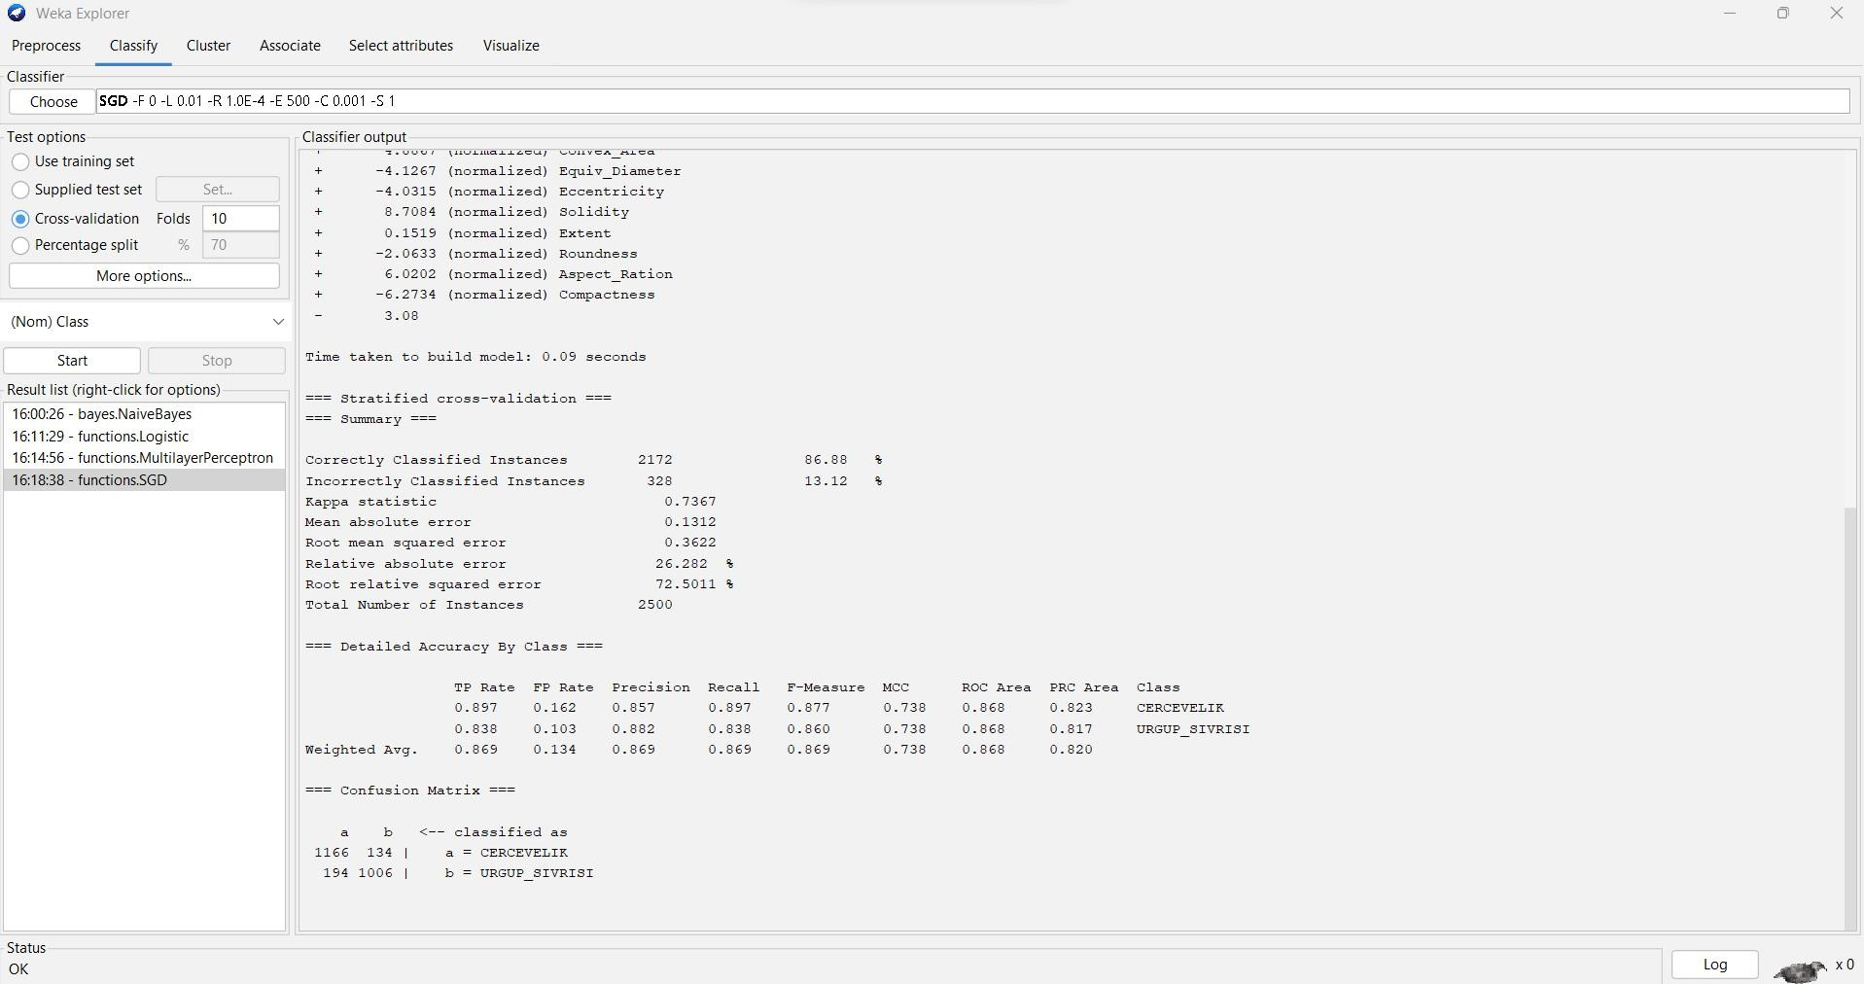

=== Run information ===

Scheme: weka.classifiers.functions.SGD -F 0 -L 0.01 -R 1.0E-4 -E 500 -C 0.001 -S 1 Relation: Pumpkin_Seeds_Dataset

Instances: 2500

Attributes: 13

Area

Perimeter Major_Axis_Length Minor_Axis_Length Convex_Area Equiv_Diameter Eccentricity Solidity

Extent Roundness Aspect_Ration Compactness Class

Test mode: 10-fold cross-validation

=== Classifier model (full training set) ===

Loss function: Hinge loss (SVM)

Class =

5.9809 (normalized) Area

+ -3.5693 (normalized) Perimeter.

+ 0.7 (normalized) Major_Axis_Length

+ -4.5707 (normalized) Minor_Axis_Length

+ 4.8867 (normalized) Convex_Area

+ -4.1267 (normalized) Equiv_Diameter

+ -4.0315 (normalized) Eccentricity

+ 8.7084 (normalized) Solidity

+ 0.1519 (normalized) Extent

+ -2.0633 (normalized) Roundness

+ 6.0202 (normalized) Aspect_Ration

+ -6.2734 (normalized) Compactness

- 3.08

Time taken to build model: 0.09 seconds

=== Stratified cross-validation ===

=== Summary ===

|  |  |  |  |
| --- | --- | --- | --- |
| Correctly Classified Instances | | 2172 | 86.88 % |
| Incorrectly Classified Instances | | 328 | 13.12 % |
| Kappa statistic | 0.7367 | | |
| Mean absolute error | 0.1312 | | |
| Root mean squared error | 0.3622 | | |
| Relative absolute error | 26.282 % | | |
| Root relative squared error | 72.5011 % | | |
| Total Number of Instances | 2500 | | |

=== Detailed Accuracy By Class ===

TP Rate FP Rate Precision Recall F-Measure MCC ROC Area PRC Area Class

|  |  |  |  |  |  |  |  |  |
| --- | --- | --- | --- | --- | --- | --- | --- | --- |
| 0.897 | 0.162 | 0.857 | 0.897 | 0.877 | 0.738 | 0.868 | 0.823 | CERCEVELIK |
| 0.838 | 0.103 | 0.882 | 0.838 | 0.860 | 0.738 | 0.868 | 0.817 | URGUP_SIVRISI |
| Weighted Avg. | 0.869 | 0.134 | 0.869 | 0.869 | 0.869 | 0.738 | 0.868 | 0.820 |

=== Confusion Matrix ===

a b <-- classified as 1166 134 | a = CERCEVELIK

194 1006 | b = URGUP_SIVRISI

1. **Lazy. Instance-Based Learning LBK:** The IBk (instance-based learning with parameter k), The k-nearest neighbors algorithm, also known as KNN or k-NN, is a non-parametric, supervised learning classifier, which uses proximity to make classifications or predictions about the grouping of an individual data point.

To classify the data set, using the lBK Classification Go to Classify Tab

Under Classifier go to Choose >Classifiers>lazy>lBk

Test Options: Cross-validation Folds: 10

**ACCURACY : 82.28%**

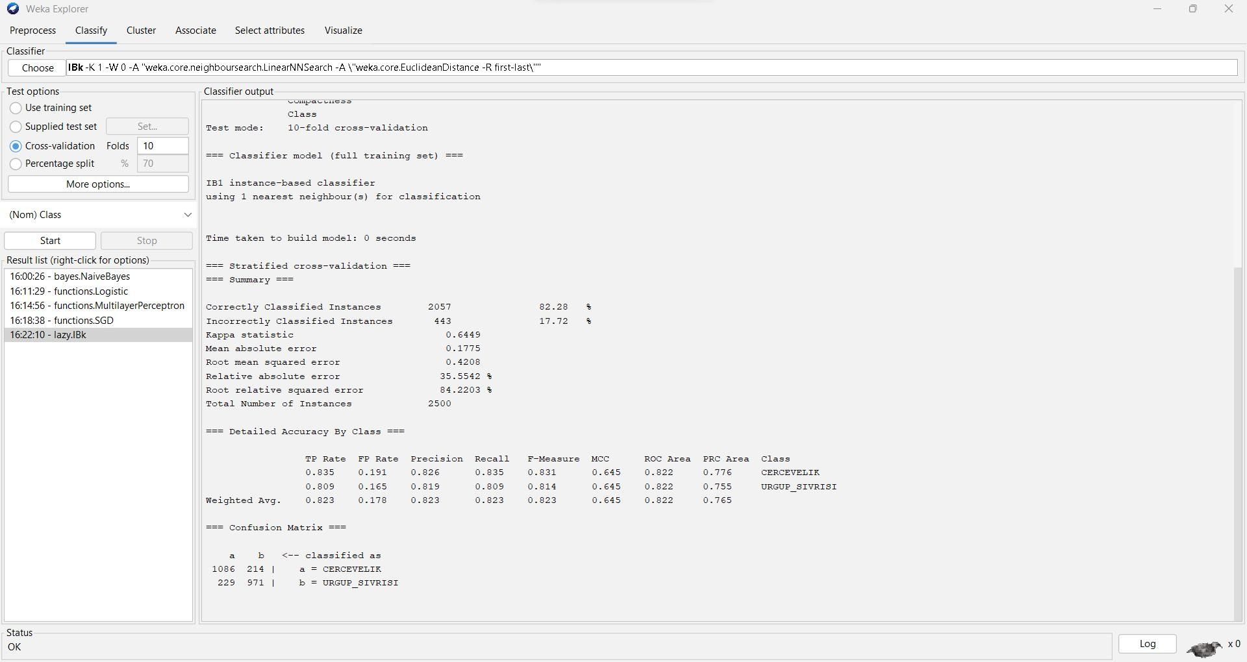

=== Run information ===

Scheme: weka.classifiers.lazy.IBk -K 1 -W 0 -A "weka.core.neighboursearch.LinearNNSearch -A

\"weka.core.EuclideanDistance -R first-last\"" Relation: Pumpkin_Seeds_Dataset Instances: 2500

Attributes: 13

Area Perimeter

Major_Axis_Length Minor_Axis_Length Convex_Area Equiv_Diameter Eccentricity Solidity

Extent Roundness Aspect_Ration Compactness Class

Test mode: 10-fold cross-validation

=== Classifier model (full training set) ===

IB1 instance-based classifier

using 1 nearest neighbour(s) for classification

Time taken to build model: 0 seconds

=== Stratified cross-validation ===

=== Summary ===

|  |  |  |  |
| --- | --- | --- | --- |
| Correctly Classified Instances 2057 | | 82.28 % | |
| Incorrectly Classified Instances 443 | | 17.72 % | |
| Kappa statistic 0.6449 | |  | |
| Mean absolute error 0.1775 | |  | |
| Root mean squared error 0.4208 | |  | |
| Relative absolute error | 35.5542 % | |
| Root relative squared error | 84.2203 % | |
| Total Number of Instances | 2500 | |

=== Detailed Accuracy By Class ===

TP Rate FP Rate Precision Recall F-Measure MCC ROC Area PRC Area Class

|  |  |  |  |  |  |  |  |  |
| --- | --- | --- | --- | --- | --- | --- | --- | --- |
| 0.835 | 0.191 | 0.826 | 0.835 | 0.831 | 0.645 | 0.822 | 0.776 | CERCEVELIK |
| 0.809 | 0.165 | 0.819 | 0.809 | 0.814 | 0.645 | 0.822 | 0.755 | URGUP_SIVRISI |
| Weighted Avg. | 0.823 | 0.178 | 0.823 | 0.823 | 0.823 | 0.645 | 0.822 | 0.765 |

=== Confusion Matrix ===

a b 🡨 classified as 1086 214 | a = CERCEVELIK

229 971 | b = URGUP_SIVRISI

**Rules**

1. **Decision Table:** Decision Table classifier algorithm that summarizes a dataset into a table- based model

To classify the data set, using the Decision Table Classification Go to Classify Tab

Under Classifier go to Choose >Classifiers>Rules>Decision Table

Test Options: Cross-validation Folds: 10

**ACCURACY : 86.76%**

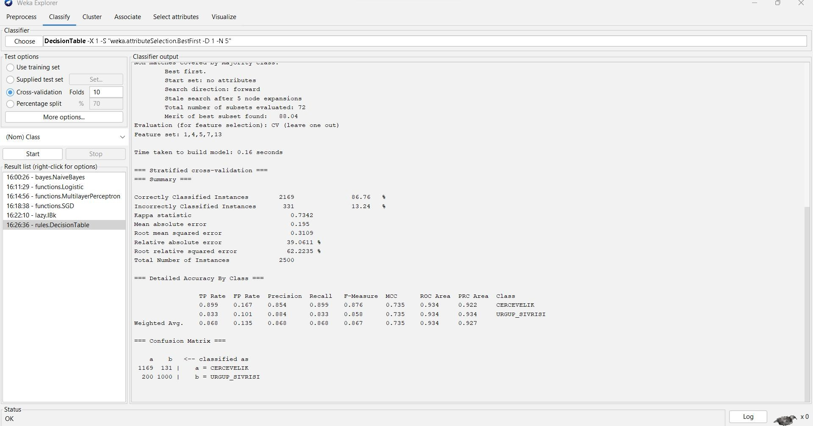

=== Run information ===

Scheme: weka.classifiers.rules.DecisionTable -X 1 -S "weka.attributeSelection.BestFirst -D 1 -N 5" Relation: Pumpkin_Seeds_Dataset

Instances: 2500

Attributes: 13

Area Perimeter

Major_Axis_Length Minor_Axis_Length Convex_Area Equiv_Diameter Eccentricity Solidity

Extent Roundness Aspect_Ration Compactness Class

Test mode: 10-fold cross-validation

=== Classifier model (full training set) ===

Decision Table:

Number of training instances: 2500 Number of Rules : 62

Non matches covered by Majority class.

Best first.

Start set: no attributes Search direction: forward

Stale search after 5 node expansions Total number of subsets evaluated: 72 Merit of best subset found: 88.04

Evaluation (for feature selection): CV (leave one out) Feature set: 1,4,5,7,13

Time taken to build model: 0.16 seconds

=== Stratified cross-validation ===

=== Summary ===

|  |  |  |  |  |
| --- | --- | --- | --- | --- |
| Correctly Classified Instances | | 2169 | 86.76 | % |
| Incorrectly Classified Instances | | 331 | 13.24 | % |
| Kappa statistic | 0.7342 | | | |
| Mean absolute error | 0.195 | | | |
| Root mean squared error | 0.3109 | | | |
| Relative absolute error | 39.0611 % | | | |
| Root relative squared error | 62.2235 % | | | |
| Total Number of Instances | 2500 | | | |

=== Detailed Accuracy By Class ===

TP Rate FP Rate Precision Recall F-Measure MCC ROC Area PRC Area Class

|  |  |  |  |  |  |  |  |  |
| --- | --- | --- | --- | --- | --- | --- | --- | --- |
| 0.899 | 0.167 | 0.854 | 0.899 | 0.876 | 0.735 | 0.934 | 0.922 | CERCEVELIK |
| 0.833 | 0.101 | 0.884 | 0.833 | 0.858 | 0.735 | 0.934 | 0.934 | URGUP_SIVRISI |
| Weighted Avg. | 0.868 | 0.135 | 0.868 | 0.868 | 0.867 | 0.735 | 0.934 | 0.927 |

=== Confusion Matrix ===

a b <-- classified as 1169 131 | a = CERCEVELIK

200 1000 | b = URGUP_SIVRISI

1. **ZeroR:** ZeroR (Zero Rule) is a simple and basic classification model that serves as a reference point for evaluating the performance of more complex models. ZeroR predicts the majority class for all instances in the dataset, making it a straightforward baseline model.

To classify the data set, using the ZeroR Classification Go to Classify Tab

Under Classifier go to Choose >Classifiers>Rules>ZeroR

Test Options: Cross-validation Folds: 10

**ACCURACY : 52%**

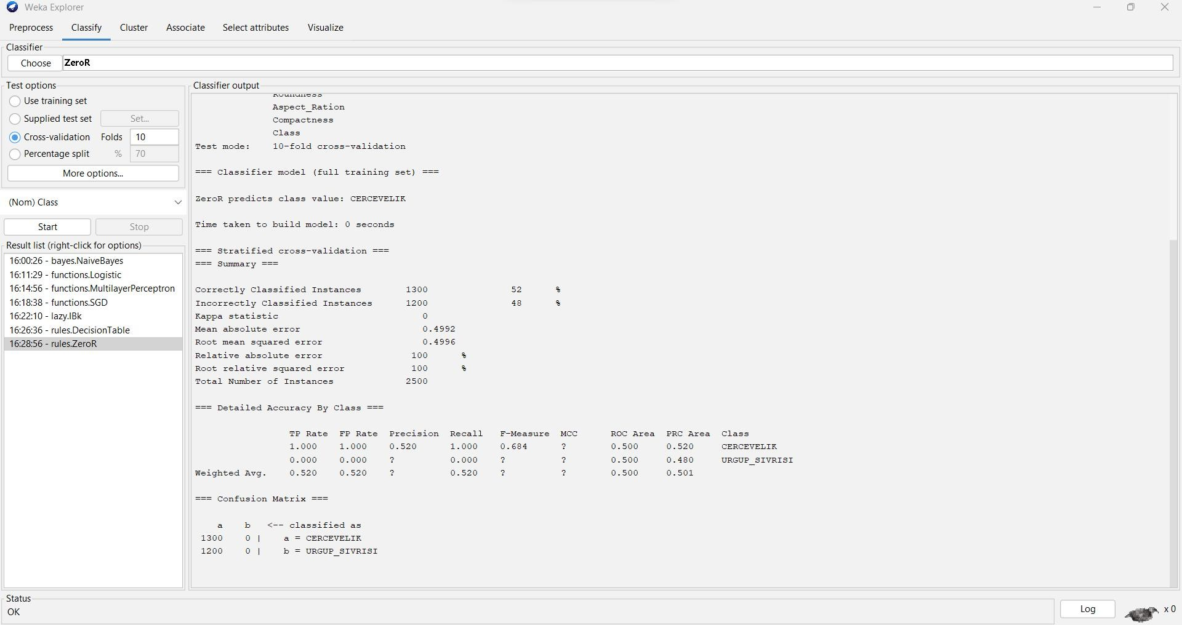

=== Run information ===

Scheme: weka.classifiers.rules.ZeroR Relation: Pumpkin_Seeds_Dataset Instances: 2500

Attributes: 13

Area Perimeter

Major_Axis_Length Minor_Axis_Length Convex_Area Equiv_Diameter Eccentricity Solidity

Extent Roundness Aspect_Ration Compactness Class

Test mode: 10-fold cross-validation

=== Classifier model (full training set) ===

ZeroR predicts class value: CERCEVELIK

Time taken to build model: 0 seconds

=== Stratified cross-validation ===

=== Summary ===

Correctly Classified Instances 1300 52 %

|  |  |  |  |
| --- | --- | --- | --- |
| Incorrectly Classified Instances | 1200 | 48 | % |
| Kappa statistic 0 |  |  |  |
| Mean absolute error | 0.4992 |  |  |
| Root mean squared error | 0.4996 |  |  |
| Relative absolute error | 100 % |  |  |
| Root relative squared error | 100 % |  |  |
| Total Number of Instances | 2500 |  |  |

=== Detailed Accuracy By Class ===

TP Rate FP Rate Precision Recall F-Measure MCC ROC Area PRC Area Class 1.000 1.000 0.520 1.000 0.684 ? 0.500 0.520 CERCEVELIK

0.000 0.000 ? 0.000 ? ? 0.500 0.480 URGUP_SIVRISI

Weighted Avg. 0.520 0.520 ? 0.520 ? ? 0.500 0.501

=== Confusion Matrix ===

a b <-- classified as 1300 0 | a = CERCEVELIK

1200 0 | b = URGUP_SIVRISI

**TREES**

1. **Decision Stump:** It is a single-level decision tree that makes a prediction based on a single attribute and its value.

To classify the data set, using the DecisionStump Classification Go to Classify Tab

Under Classifier go to Choose >Classifiers>trees>DecisionStump

Test Options: Cross-validation Folds: 10

**ACCURACY : 85.6%**

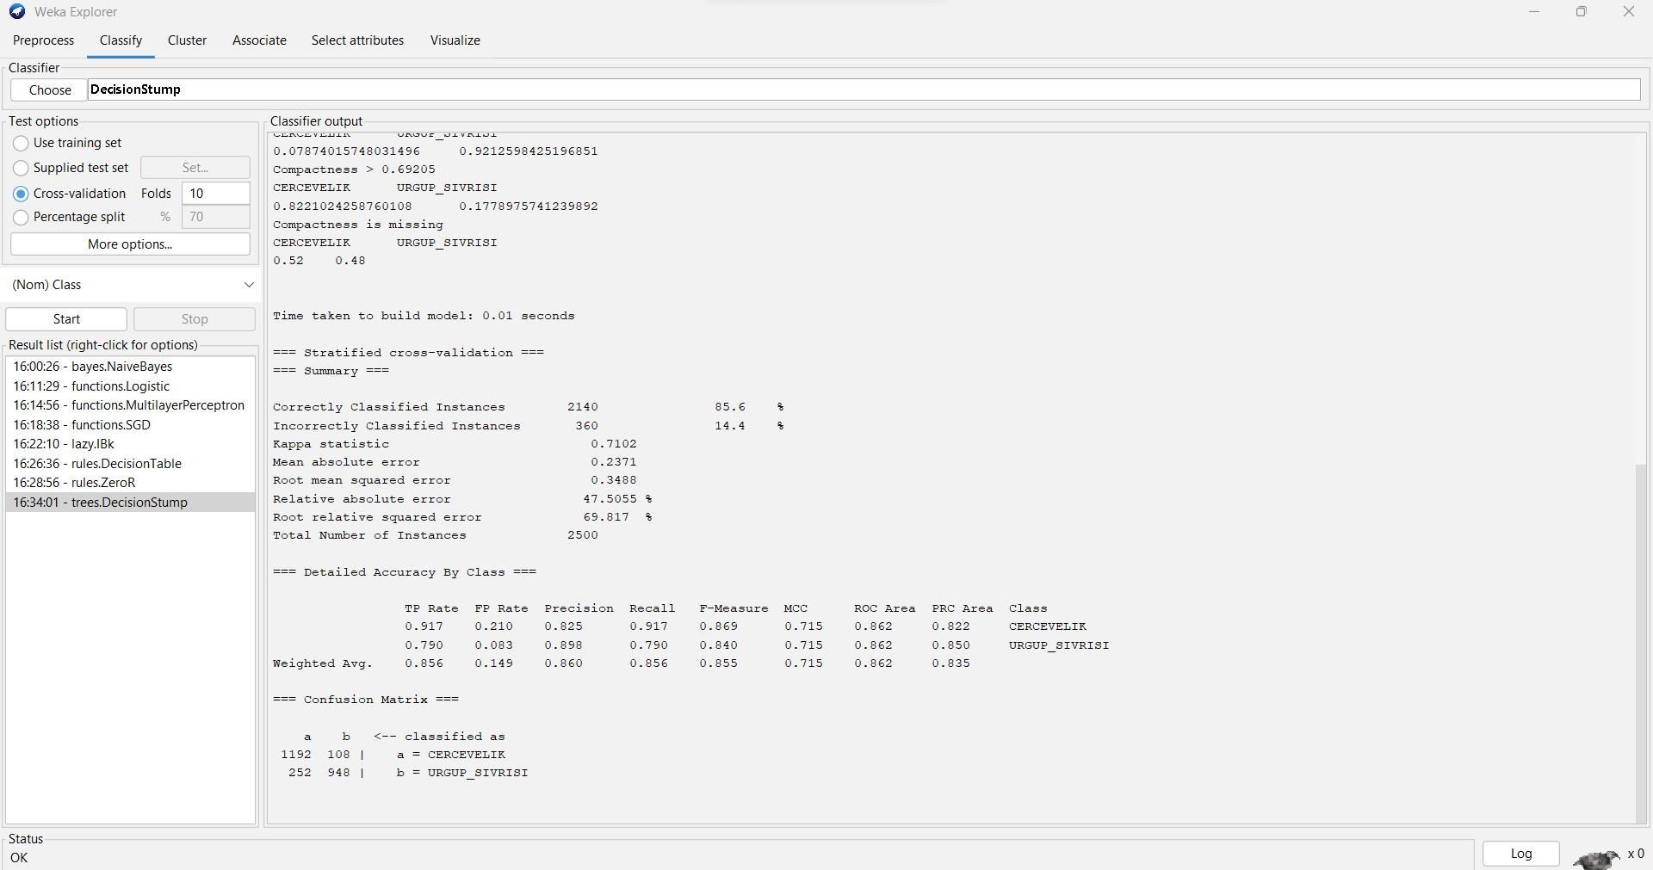

=== Run information ===

Scheme: weka.classifiers.trees.DecisionStump Relation: Pumpkin_Seeds_Dataset

Instances: 2500

Attributes: 13

Area Perimeter

Major_Axis_Length Minor_Axis_Length Convex_Area Equiv_Diameter Eccentricity Solidity

Extent Roundness Aspect_Ration Compactness Class

Test mode: 10-fold cross-validation

=== Classifier model (full training set) ===

Decision Stump

Classifications

Compactness <= 0.69205 : URGUP_SIVRISI Compactness > 0.69205 : CERCEVELIK Compactness is missing : CERCEVELIK

Class distributions

Compactness <= 0.69205 CERCEVELIK URGUP_SIVRISI

0.07874015748031496 0.9212598425196851

Compactness > 0.69205 CERCEVELIK URGUP_SIVRISI

0.8221024258760108 0.1778975741239892

Compactness is missing CERCEVELIK URGUP_SIVRISI 0.52 0.48

Time taken to build model: 0.01 seconds

=== Stratified cross-validation ===

=== Summary ===

|  |  |  |  |  |
| --- | --- | --- | --- | --- |
| Correctly Classified Instances | | 2140 | 85.6 % | |
| Incorrectly Classified Instances | | 360 | 14.4 % | |
| Kappa statistic | 0.7102 | | |
| Mean absolute error | 0.2371 | | |
| Root mean squared error | 0.3488 | | |
| Relative absolute error | 47.5055 % | | |
| Root relative squared error | 69.817 % | | |
| Total Number of Instances | 2500 | | |

=== Detailed Accuracy By Class ===

TP Rate FP Rate Precision Recall F-Measure MCC ROC Area PRC Area Class

|  |  |  |  |  |  |  |  |  |
| --- | --- | --- | --- | --- | --- | --- | --- | --- |
| 0.917 | 0.210 | 0.825 | 0.917 | 0.869 | 0.715 | 0.862 | 0.822 | CERCEVELIK |
| 0.790 | 0.083 | 0.898 | 0.790 | 0.840 | 0.715 | 0.862 | 0.850 | URGUP_SIVRISI |
| Weighted Avg. | 0.856 | 0.149 | 0.860 | 0.856 | 0.855 | 0.715 | 0.862 | 0.835 |

=== Confusion Matrix ===

a b <-- classified as

1192 108 | a = CERCEVELIK

252 948 | b = URGUP_SIVRISI

1. **J48:** J48 is a supervised, non-parametric machine learning algorithm that builds a decision tree model based on a training dataset

To classify the data set, using the J48 Classification Go to Classify Tab

Under Classifier go to Choose >Classifiers>Trees>J48

Test Options: Cross-validation Folds: 10

**ACCURACY : 87.56%**

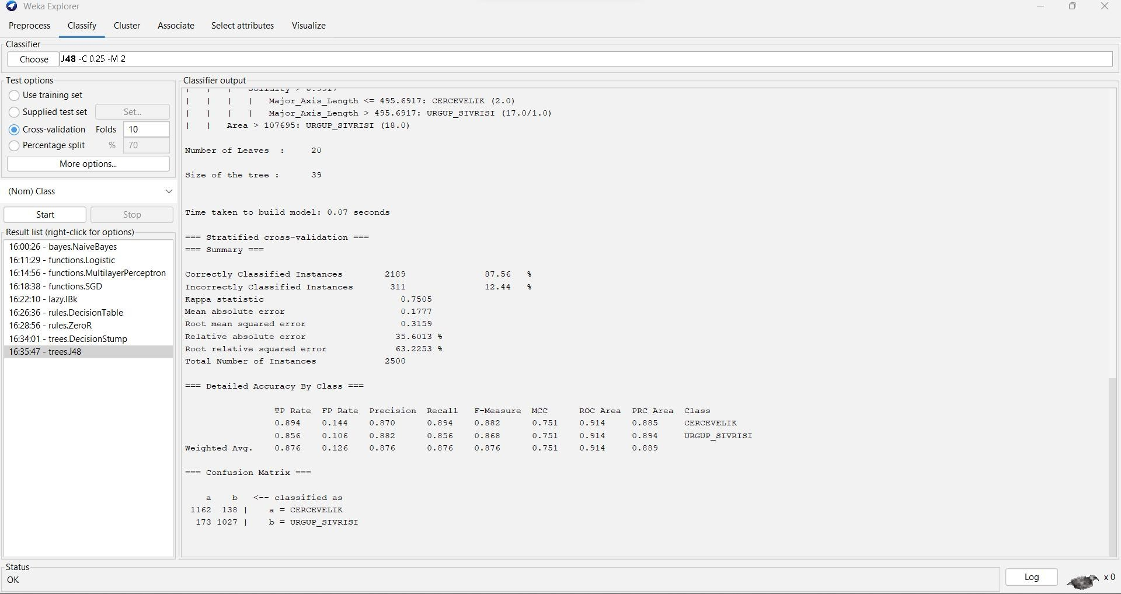

=== Run information ===

Scheme: weka.classifiers.trees.J48 -C 0.25 -M 2 Relation: Pumpkin_Seeds_Dataset

Instances: 2500

Attributes: 13

Area Perimeter

Major_Axis_Length Minor_Axis_Length Convex_Area Equiv_Diameter Eccentricity Solidity

Extent Roundness Aspect_Ration Compactness Class

Test mode: 10-fold cross-validation

=== Classifier model (full training set) ===

J48 pruned tree

Compactness <= 0.692: URGUP_SIVRISI (1016.0/80.0)

Compactness > 0.692

| Major_Axis_Length <= 492.3956

| | Minor_Axis_Length <= 202.9421

| | | Minor_Axis_Length <= 191.091: URGUP_SIVRISI (13.0)

| | | Minor_Axis_Length > 191.091

| | | | Perimeter <= 937.288: CERCEVELIK (3.0)

| | | | Perimeter > 937.288: URGUP_SIVRISI (28.0/7.0)

| | Minor_Axis_Length > 202.9421

| | | Compactness <= 0.7326

| | | | Solidity <= 0.9906

| | | | | Roundness <= 0.778

| | | | | | Minor_Axis_Length <= 214.398: CERCEVELIK (9.0)

| | | | | | Minor_Axis_Length > 214.398: URGUP_SIVRISI (31.0/12.0)

| | | | | Roundness > 0.778: CERCEVELIK (342.0/39.0)

| | | | Solidity > 0.9906

| | | | | Eccentricity <= 0.8647

|  |  |  |  |  |  |  |
| --- | --- | --- | --- | --- | --- | --- |
| | | | | | | | | | | | | Solidity <= 0.992: CERCEVELIK (79.0/18.0) |
| | | | | | | | | | | | | Solidity > 0.992 |
| | | | | | | | | | | | | | Roundness <= 0.8335 |
| | | | | | | | | | | | | | | Major_Axis_Length <= 482.075 |
| | | | | | | | | | | | | | | | Extent <= 0.6814: URGUP_SIVRISI (8.0) |
| | | | | | | | | | | | | | | | Extent > 0.6814 |
| | | | | | | | | | | | | | | | | Extent <= 0.7085: CERCEVELIK (4.0) |
| | | | | | | | | | | | | | | | | Extent > 0.7085 |

| | | | | | | | | | | Extent <= 0.7392: URGUP_SIVRISI (9.0)

| | | | | | | | | | | Extent > 0.7392: CERCEVELIK (5.0/1.0)

| | | | | | | | Major_Axis_Length > 482.075: CERCEVELIK (4.0)

| | | | | | | Roundness > 0.8335: CERCEVELIK (11.0/1.0)

| | | | | Eccentricity > 0.8647: URGUP_SIVRISI (60.0/16.0)

| | | Compactness > 0.7326: CERCEVELIK (803.0/42.0)

| Major_Axis_Length > 492.3956

| | Area <= 107695

| | | Solidity <= 0.9917: CERCEVELIK (38.0/15.0)

| | | Solidity > 0.9917

| | | | Major_Axis_Length <= 495.6917: CERCEVELIK (2.0)

| | | | Major_Axis_Length > 495.6917: URGUP_SIVRISI (17.0/1.0)

| | Area > 107695: URGUP_SIVRISI (18.0)

Number of Leaves : 20

Size of the tree : 39

Time taken to build model: 0.07 seconds

=== Stratified cross-validation ===

=== Summary ===

|  |  |  |  |
| --- | --- | --- | --- |
| Correctly Classified Instances | | 2189 | 87.56 % |
| Incorrectly Classified Instances | | 311 | 12.44 % |
| Kappa statistic | 0.7505 | | |
| Mean absolute error | 0.1777 | | |
| Root mean squared error | 0.3159 | | |
| Relative absolute error | 35.6013 % | | |
| Root relative squared error | 63.2253 % | | |

Total Number of Instances 2500

=== Detailed Accuracy By Class ===

TP Rate FP Rate Precision Recall F-Measure MCC ROC Area PRC Area Class

|  |  |  |  |  |  |  |  |  |
| --- | --- | --- | --- | --- | --- | --- | --- | --- |
| 0.894 | 0.144 | 0.870 | 0.894 | 0.882 | 0.751 | 0.914 | 0.885 | CERCEVELIK |
| 0.856 | 0.106 | 0.882 | 0.856 | 0.868 | 0.751 | 0.914 | 0.894 | URGUP_SIVRISI |
| Weighted Avg. | 0.876 | 0.126 | 0.876 | 0.876 | 0.876 | 0.751 | 0.914 | 0.889 |

=== Confusion Matrix ===

a b <-- classified as

1162 138 | a = CERCEVELIK

173 1027 | b = URGUP_SIVRISI

1. **Random Forest:** It is an ensemble learning method that combines multiple decision trees to improve the overall accuracy and robustness of the model.

To classify the data set, using the Random Forest Classification Go to Classify Tab

Under Classifier go to Choose >Classifiers>Trees > Random Forest

Test Options: Cross-validation Folds: 10

**ACCURACY : 88.72%**

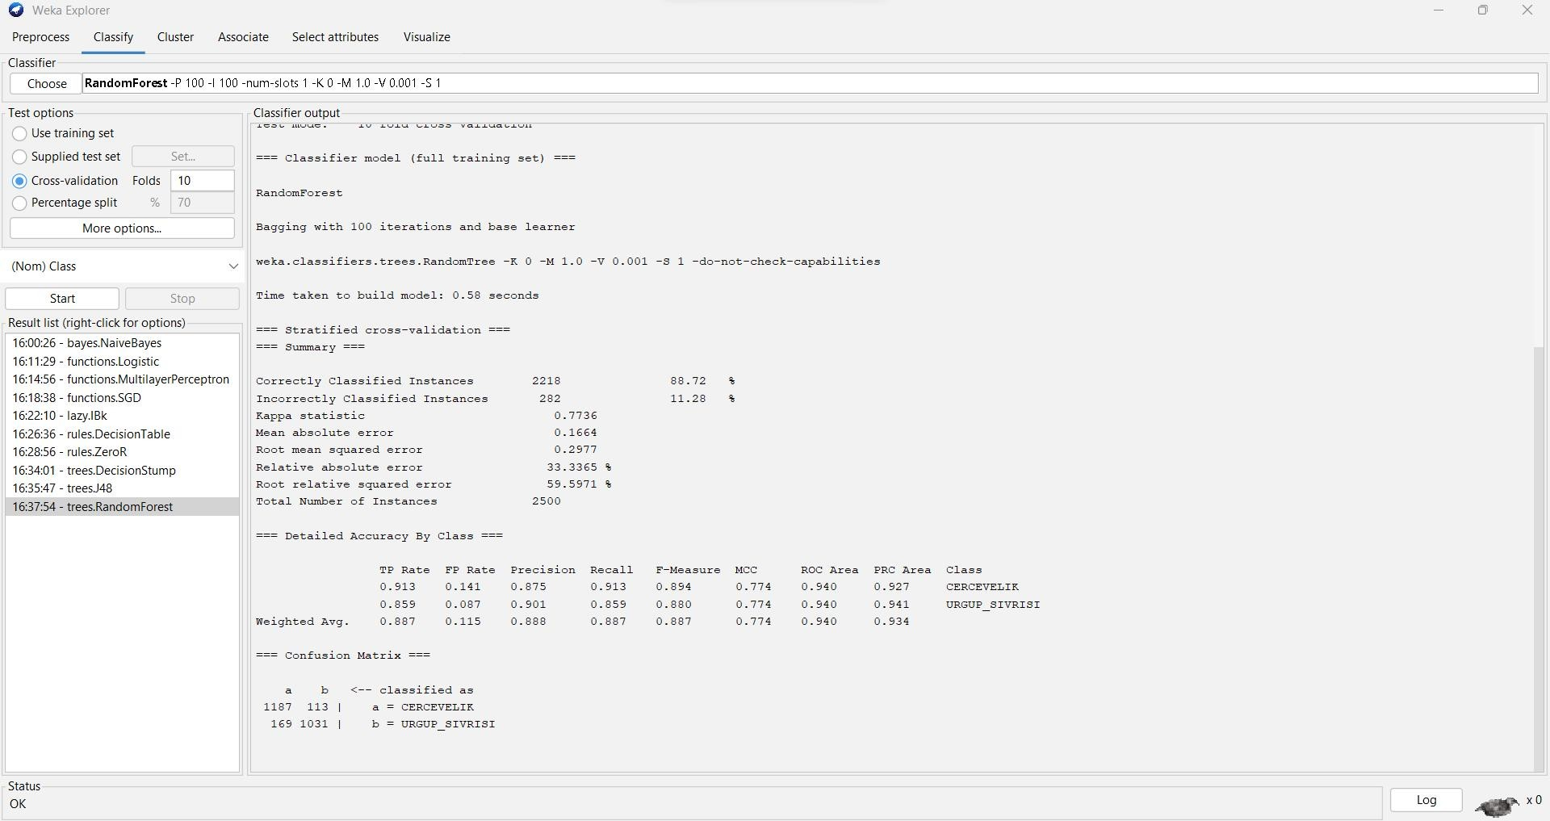

=== Run information ===

Scheme: weka.classifiers.trees.RandomForest -P 100 -I 100 -num-slots 1 -K 0 -M 1.0 -V 0.001 -S 1 Relation: Pumpkin_Seeds_Dataset

Instances: 2500

Attributes: 13

Area Perimeter

Major_Axis_Length Minor_Axis_Length Convex_Area Equiv_Diameter Eccentricity Solidity

Extent Roundness Aspect_Ration

Compactness Class

Test mode: 10-fold cross-validation

=== Classifier model (full training set) ===

RandomForest

Bagging with 100 iterations and base learner

weka.classifiers.trees.RandomTree -K 0 -M 1.0 -V 0.001 -S 1 -do-not-check-capabilities

Time taken to build model: 0.58 seconds

=== Stratified cross-validation ===

=== Summary ===

|  |  |  |  |
| --- | --- | --- | --- |
| Correctly Classified Instances | | 2218 | 88.72 % |
| Incorrectly Classified Instances | | 282 | 11.28 % |
| Kappa statistic | 0.7736 | | |
| Mean absolute error | 0.1664 | | |
| Root mean squared error | 0.2977 | | |
| Relative absolute error | 33.3365 % | | |
| Root relative squared error | 59.5971 % | | |
| Total Number of Instances | 2500 | | |

=== Detailed Accuracy By Class ===

TP Rate FP Rate Precision Recall F-Measure MCC ROC Area PRC Area Class

|  |  |  |  |  |
| --- | --- | --- | --- | --- |
| 0.913 0.141 0.875 | 0.913 0.894 | 0.774 0.940 | 0.927 | CERCEVELIK |
| 0.859 0.087 0.901 | 0.859 0.880 | 0.774 0.940 | 0.941 | URGUP_SIVRISI |

Weighted Avg. 0.887 0.115 0.888 0.887 0.887 0.774 0.940 0.934

=== Confusion Matrix ===

a b <-- classified as

1187 113 | a = CERCEVELIK

169 1031 | b = URGUP_SIVRISI

1. **Random Tree:** Random Tree algorithm is a supervised classifier that generates a decision tree for classification and regression tasks

To classify the data set, using the Random Tree Classification Go to Classify Tab

Under Classifier go to Choose >Classifiers>trees>Random Tree

Test Options: Cross-validation Folds: 10

**ACCURACY : 82.92%**

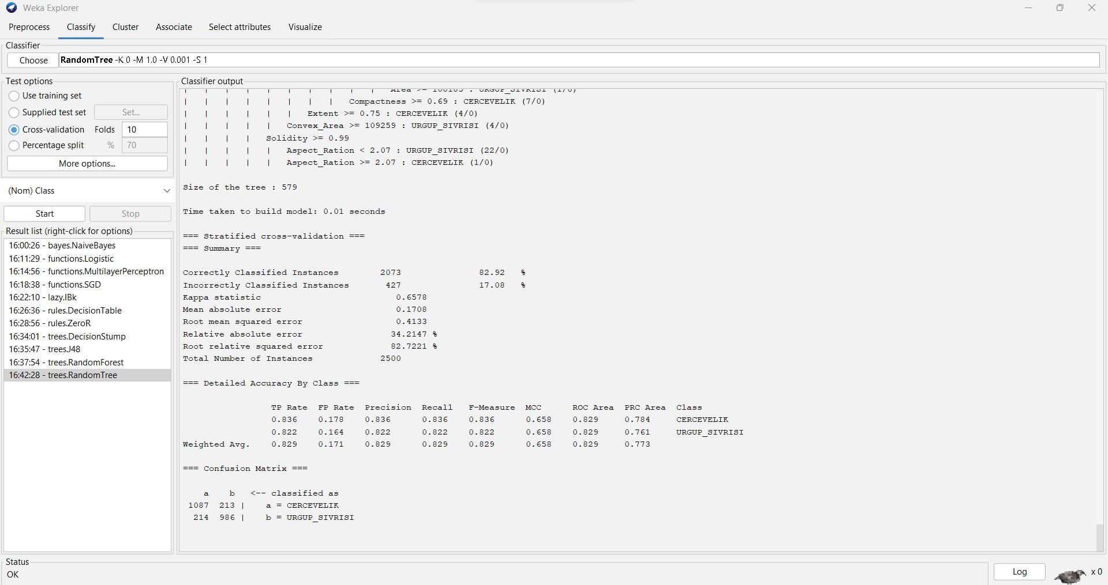

=== Run information ===

Scheme: weka.classifiers.trees.RandomTree -K 0 -M 1.0 -V 0.001 -S 1 Relation: Pumpkin_Seeds_Dataset

Instances: 2500

Attributes: 13

Area Perimeter

Major_Axis_Length Minor_Axis_Length Convex_Area Equiv_Diameter Eccentricity Solidity

Extent Roundness Aspect_Ration Compactness Class

Test mode: 10-fold cross-validation

=== Classifier model (full training set) ===

RandomTree

==========

Compactness < 0.69

| Compactness < 0.67

| | Solidity < 0.98

| | | Aspect_Ration < 2.47

| | | | Extent < 0.68

| | | | | Major_Axis_Length < 404.86 : URGUP_SIVRISI (1/0)

| | | | | Major_Axis_Length >= 404.86

| | | | | | Minor_Axis_Length < 201.98

| | | | | | | Major_Axis_Length < 454.1 : CERCEVELIK (1/0)

| | | | | | | Major_Axis_Length >= 454.1 : URGUP_SIVRISI (1/0)

| | | | | | Minor_Axis_Length >= 201.98 : CERCEVELIK (3/0)

| | | | Extent >= 0.68 : URGUP_SIVRISI (5/0)

| | | Aspect_Ration >= 2.47 : URGUP_SIVRISI (4/0)

| | Solidity >= 0.98

| | | Eccentricity < 0.91

| | | | Aspect_Ration < 2.39

| | | | | Roundness < 0.73

| | | | | | Eccentricity < 0.91

| | | | | | | Solidity < 0.99

| | | | | | | | Major_Axis_Length < 475.74

| | | | | | | | | Area < 62685 : CERCEVELIK (1/0)

| | | | | | | | | Area >= 62685 : URGUP_SIVRISI (4/0)

| | | | | | | | Major_Axis_Length >= 475.74 : CERCEVELIK (3/0)

| | | | | | | Solidity >= 0.99 : URGUP_SIVRISI (7/0)

| | | | | | Eccentricity >= 0.91 : URGUP_SIVRISI (11/0)

| | | | | Roundness >= 0.73

| | | | | | Minor_Axis_Length < 223.84

| | | | | | | Minor_Axis_Length < 223.42

|  |  |  |  |  |  |  |  |  |  |
| --- | --- | --- | --- | --- | --- | --- | --- | --- | --- |
| | | | | | | | | | | | | | | | | Perimeter < 1231.26 | |
| | | | | | | | | | | | | | | | | | | Aspect_Ration < 2.31 |
| | | | | | | | | | | | | | | | | | | | Extent < 0.62 |
| | | | | | | | | | | | | | | | | | | | | Eccentricity < 0.9 |
| | | | | | | | | | | | | | | | | | | | | | Solidity < 0.99 : URGUP_SIVRISI (22/0) |
| | | | | | | | | | | | | | | | | | | | | | Solidity >= 0.99 |
| | | | | | | | | | | | | | | | | | | | | | | Major_Axis_Length < 473.64 : URGUP_SIVRISI (3/0) |
| | | | | | | | | | | | | | | | | | | | | | | Major_Axis_Length >= 473.64 |
| | | | | | | | | | | | | | | | | | | | | | | | Perimeter < 1169.06 : CERCEVELIK (2/0) |
| | | | | | | | | | | | | | | | | | | | | | | | Perimeter >= 1169.06 : URGUP_SIVRISI (1/0) |
| | | | | | | | | | | | | | | | | | | | | Eccentricity >= 0.9 : CERCEVELIK (1/0) |

|  |  |  |  |  |  |  |  |  |
| --- | --- | --- | --- | --- | --- | --- | --- | --- |
| | | | | | | | | | | | | | | | | | | Extent >= 0.62 : URGUP_SIVRISI (78/0) |
| | | | | | | | | | | | | | | | | | Aspect_Ration >= 2.31 : URGUP_SIVRISI (71/0) |
| | | | | | | | | | | | | | | | | Perimeter >= 1231.26 |
| | | | | | | | | | | | | | | | | | Eccentricity < 0.91 : CERCEVELIK (1/0) |
| | | | | | | | | | | | | | | | | | Eccentricity >= 0.91 : URGUP_SIVRISI (2/0) |
| | | | | | | | | | | | | | | Minor_Axis_Length >= 223.42 : CERCEVELIK (1/0) | |
| | | | | | | | | | | | | Minor_Axis_Length >= 223.84 : URGUP_SIVRISI (104/0) | | |
| | | | | | | | | Aspect_Ration >= 2.39 : CERCEVELIK (1/0) | | | | |
| | | | | | | Eccentricity >= 0.91 | | | | | |
| | | | | | | | Roundness < 0.64 | | | | | |
| | | | | | | | | Area < 100633.5 : URGUP_SIVRISI (7/0) | | | | | |
| | | | | | | | | Area >= 100633.5 : CERCEVELIK (1/0) | | | | | |
| | | | | | | | Roundness >= 0.64 : URGUP_SIVRISI (386/0) | | | | | |

| Compactness >= 0.67

| | Equiv_Diameter < 350.1

| | | Minor_Axis_Length < 202.14

| | | | Eccentricity < 0.88 : URGUP_SIVRISI (21/0)

| | | | Eccentricity >= 0.88

| | | | | Aspect_Ration < 2.14

| | | | | | Area < 59602 : URGUP_SIVRISI (1/0)

| | | | | | Area >= 59602 : CERCEVELIK (2/0)

| | | | | Aspect_Ration >= 2.14 : URGUP_SIVRISI (20/0)

| | | Minor_Axis_Length >= 202.14

| | | | Solidity < 0.99

| | | | | Eccentricity < 0.88

| | | | | | Perimeter < 1229.04

|  |  |  |  |  |  |  |  |
| --- | --- | --- | --- | --- | --- | --- | --- |
| | | | | | | | | | | | | | | Convex_Area < 90035.5 |
| | | | | | | | | | | | | | | | Compactness < 0.69 |
| | | | | | | | | | | | | | | | | Eccentricity < 0.88 : CERCEVELIK (4/0) |
| | | | | | | | | | | | | | | | | Eccentricity >= 0.88 |
| | | | | | | | | | | | | | | | | | Roundness < 0.78 |

|  |  |  |  |  |  |  |  |  |  |  |  |  |  |  |
| --- | --- | --- | --- | --- | --- | --- | --- | --- | --- | --- | --- | --- | --- | --- |
| | | | | | | | | | | | | | | | | | | | | | | Equiv_Diameter < 307.76 | | | |
| | | | | | | | | | | | | | | | | | | | | | | | Minor_Axis_Length < 210.42 | | | |
| | | | | | | | | | | | | | | | | | | | | | | | | Extent < 0.62 : URGUP_SIVRISI (2/0) | | | |
| | | | | | | | | | | | | | | | | | | | | | | | | Extent >= 0.62 : CERCEVELIK (4/0) | | | |
| | | | | | | | | | | | | | | | | | | | | | | | Minor_Axis_Length >= 210.42 : URGUP_SIVRISI (3/0) | | | |
| | | | | | | | | | | | | | | | | | | | | | | Equiv_Diameter >= 307.76 | | | |
| | | | | | | | | | | | | | | | | | | | | | | | Convex_Area < 87864 : CERCEVELIK (11/0) | | | |
| | | | | | | | | | | | | | | | | | | | | | | | Convex_Area >= 87864 | | | |
| | | | | | | | | | | | | | | | | | | | | | | | | Minor_Axis_Length < 230.61 : URGUP_SIVRISI (1/0) | | | |
| | | | | | | | | | | | | | | | | | | | | | | | | Minor_Axis_Length >= 230.61 : CERCEVELIK (1/0) | | | |
| | | | | | | | | | | | | | | | | | | | | Roundness >= 0.78 | | | | |
| | | | | | | | | | | | | | | | | | | | | | Eccentricity < 0.88 : URGUP_SIVRISI (3/0) | | | | |
| | | | | | | | | | | | | | | | | | | | | | Eccentricity >= 0.88 | | | | |
| | | | | | | | | | | | | | | | | | | | | | | Roundness < 0.78 : URGUP_SIVRISI (2/0) | | | | |
| | | | | | | | | | | | | | | | | | | | | | | Roundness >= 0.78 | | | | |
| | | | | | | | | | | | | | | | | | | | | | | | Area < 86055 | | | | |
| | | | | | | | | | | | | | | | | | | | | | | | | | | | | Extent < 0.74 : CERCEVELIK (5/0) |
| | | | | | | | | | | | | | | | | | | | | | | | | | | | | Extent >= 0.74 |
| | | | | | | | | | | | | | | | | | | | | | | | | | | | | | Perimeter < 1152.62 : URGUP_SIVRISI (2/0) |
| | | | | | | | | | | | | | | | | | | | | | | | | | | | | | Perimeter >= 1152.62 : CERCEVELIK (1/0) |
| | | | | | | | | | | | | | | | | | | | | | | | | | | Area >= 86055 : URGUP_SIVRISI (2/0) | |

| | | | | | | | Compactness >= 0.69 : URGUP_SIVRISI (4/0)

| | | | | | | Convex_Area >= 90035.5 : URGUP_SIVRISI (5/0)

| | | | | | Perimeter >= 1229.04 : CERCEVELIK (5/0)

|  |  |  |  |  |  |
| --- | --- | --- | --- | --- | --- |
| | | | | | | | | | | Eccentricity >= 0.88 |
| | | | | | | | | | | | Aspect_Ration < 2.14 : URGUP_SIVRISI (6/0) |
| | | | | | | | | | | | Aspect_Ration >= 2.14 |
| | | | | | | | | | | | | Area < 71042.5 : CERCEVELIK (2/0) |
| | | | | | | | | | | | | Area >= 71042.5 |
| | | | | | | | | | | | | | Roundness < 0.78 |
| | | | | | | | | | | | | | | Extent < 0.75 |

|  |  |  |  |  |  |  |  |  |  |  |
| --- | --- | --- | --- | --- | --- | --- | --- | --- | --- | --- |
| | | | | | | | | | | | | | | | | | | | | Major_Axis_Length < 492.31 |
| | | | | | | | | | | | | | | | | | | | | | Area < 80573 |
| | | | | | | | | | | | | | | | | | | | | | | Area < 79171 |
| | | | | | | | | | | | | | | | | | | | | | | | Area < 78991.5 |
| | | | | | | | | | | | | | | | | | | | | | | | | Roundness < 0.77 : URGUP_SIVRISI (12/0) |
| | | | | | | | | | | | | | | | | | | | | | | | | Roundness >= 0.77 |
| | | | | | | | | | | | | | | | | | | | | | | | | | Area < 76606 : CERCEVELIK (3/0) |
| | | | | | | | | | | | | | | | | | | | | | | | | | Area >= 76606 : URGUP_SIVRISI (1/0) |
| | | | | | | | | | | | | | | | | | | | | | | | Area >= 78991.5 : CERCEVELIK (2/0) |
| | | | | | | | | | | | | | | | | | | | | | | Area >= 79171 : URGUP_SIVRISI (7/0) |
| | | | | | | | | | | | | | | | | | | | | | Area >= 80573 |
| | | | | | | | | | | | | | | | | | | | | | | Eccentricity < 0.89 |
| | | | | | | | | | | | | | | | | | | | | | | | Roundness < 0.74 : CERCEVELIK (3/0) |
| | | | | | | | | | | | | | | | | | | | | | | | Roundness >= 0.74 |
| | | | | | | | | | | | | | | | | | | | | | | | | Convex_Area < 82033.5 : CERCEVELIK (2/0) |
| | | | | | | | | | | | | | | | | | | | | | | | | Convex_Area >= 82033.5 |
| | | | | | | | | | | | | | | | | | | | | | | | | | Extent < 0.7 : URGUP_SIVRISI (5/0) |
| | | | | | | | | | | | | | | | | | | | | | | | | | Extent >= 0.7 |
| | | | | | | | | | | | | | | | | | | | | | | | | | | Perimeter < 1171.27 : URGUP_SIVRISI (1/0) |
| | | | | | | | | | | | | | | | | | | | | | | | | | | Perimeter >= 1171.27 : CERCEVELIK (3/0) |
| | | | | | | | | | | | | | | | | | | | | | | Eccentricity >= 0.89 : CERCEVELIK (4/0) |
| | | | | | | | | | | | | | | | | | | | | Major_Axis_Length >= 492.31 |
| | | | | | | | | | | | | | | | | | | | | | Equiv_Diameter < 347.49 : URGUP_SIVRISI (13/0) |
| | | | | | | | | | | | | | | | | | | | | | Equiv_Diameter >= 347.49 : CERCEVELIK (1/0) |
| | | | | | | | | | | | | | | | | | | Extent >= 0.75 | |
| | | | | | | | | | | | | | | | | | | | Area < 89917 : CERCEVELIK (5/0) | |
| | | | | | | | | | | | | | | | | | | | Area >= 89917 | |
| | | | | | | | | | | | | | | | | | | | | Area < 92918.5 : URGUP_SIVRISI (1/0) | |
| | | | | | | | | | | | | | | | | | | | | Area >= 92918.5 : CERCEVELIK (1/0) | |

| | | | | | | | Roundness >= 0.78 : URGUP_SIVRISI (4/0)

| | | | Solidity >= 0.99

|  |  |  |  |  |  |
| --- | --- | --- | --- | --- | --- |
| | | | | | | | | | | Minor_Axis_Length < 212.46 |
| | | | | | | | | | | | Roundness < 0.79 |
| | | | | | | | | | | | | Minor_Axis_Length < 212.2 |
| | | | | | | | | | | | | | Roundness < 0.78 : URGUP_SIVRISI (9/0) |
| | | | | | | | | | | | | | Roundness >= 0.78 |
| | | | | | | | | | | | | | | Convex_Area < 73494.5 : URGUP_SIVRISI (1/0) |
| | | | | | | | | | | | | | | Convex_Area >= 73494.5 : CERCEVELIK (1/0) |
| | | | | | | | | | | | | Minor_Axis_Length >= 212.2 : CERCEVELIK (1/0) |
| | | | | | | | | | | | Roundness >= 0.79 : CERCEVELIK (2/0) |
| | | | | | | | | | | Minor_Axis_Length >= 212.46 |
| | | | | | | | | | | | Eccentricity < 0.88 |
| | | | | | | | | | | | | Roundness < 0.79 |
| | | | | | | | | | | | | | Extent < 0.7 : URGUP_SIVRISI (4/0) |
| | | | | | | | | | | | | | Extent >= 0.7 |
| | | | | | | | | | | | | | | Solidity < 0.99 : URGUP_SIVRISI (2/0) |
| | | | | | | | | | | | | | | Solidity >= 0.99 : CERCEVELIK (2/0) |
| | | | | | | | | | | | | Roundness >= 0.79 : URGUP_SIVRISI (10/0) |
| | | | | | | | | | | | Eccentricity >= 0.88 : URGUP_SIVRISI (36/0) |
| | | | | Equiv_Diameter >= 350.1 : URGUP_SIVRISI (51/0) | | | |

Compactness >= 0.69

| Eccentricity < 0.85

| | Major_Axis_Length < 492.03

| | | Area < 54969.5 : URGUP_SIVRISI (3/0)

| | | Area >= 54969.5

| | | | Roundness < 0.85

| | | | | Solidity < 0.99

|  |  |  |  |  |  |  |
| --- | --- | --- | --- | --- | --- | --- |
| | | | | | | | | | | | | Minor_Axis_Length < 264.38 |
| | | | | | | | | | | | | | Minor_Axis_Length < 263.65 |
| | | | | | | | | | | | | | | Roundness < 0.78 |
| | | | | | | | | | | | | | | | Eccentricity < 0.83 : CERCEVELIK (10/0) |
| | | | | | | | | | | | | | | | Eccentricity >= 0.83 |

|  |  |  |  |  |  |  |  |  |  |  |  |  |  |  |  |
| --- | --- | --- | --- | --- | --- | --- | --- | --- | --- | --- | --- | --- | --- | --- | --- |
| |  |  | | |  |  | | |  |  | | |  |  | | |  |  | | |  |  | | |  |  | | |  |  | | |  |  | | |  |  | | Convex_Area < 65455 : CERCEVELIK (2/0)  Convex_Area >= 65455  | Eccentricity < 0.85 | | | | | |
| | | | | | | | | | | | | | | | | | | | | | | Solidity < 0.97 : CERCEVELIK (1/0) | | | | | |
| | | | | | | | | | | | | | | | | | | | | | | Solidity >= 0.97 : URGUP_SIVRISI (7/0) | | | | | |
| | | | | | | | | | | | | | | | | | | | | | Eccentricity >= 0.85 | | | | | |
| | | | | | | | | | | | | | | | | | | | | | | Area < 75527 : URGUP_SIVRISI (1/0) | | | | | |
| | | | | | | | | | | | | | | | | | | | | | | Area >= 75527 : CERCEVELIK (3/0) | | | | | |
| | | | | | | | | | | | | | | | | Roundness >= 0.78 | | | | | | | |
| | | | | | | | | | | | | | | | | | Equiv_Diameter < 278.09 | | | | | | | |
| | | | | | | | | | | | | | | | | | | Roundness < 0.83 | | | | | | | |
| | | | | | | | | | | | | | | | | | | | Major_Axis_Length < 362.3 : CERCEVELIK (1/0) | | | | | | | |
| | | | | | | | | | | | | | | | | | | | Major_Axis_Length >= 362.3 | | | | | | | |
| | | | | | | | | | | | | | | | | | | | | Area < 58693 : URGUP_SIVRISI (3/0) | | | | | | | |
| | | | | | | | | | | | | | | | | | | | | Area >= 58693 | | | | | | | |
| | | | | | | | | | | | | | | | | | | | | | Eccentricity < 0.82 : URGUP_SIVRISI (1/0) | | | | | | | |
| | | | | | | | | | | | | | | | | | | | | | Eccentricity >= 0.82 | | | | | | | |
| | | | | | | | | | | | | | | | | | | | | | | Area < 59695 : CERCEVELIK (1/0) | | | | | | | |
| | | | | | | | | | | | | | | | | | | | | | | Area >= 59695 : URGUP_SIVRISI (1/0) | | | | | | | |
| | | | | | | | | | | | | | | | | | | Roundness >= 0.83 : CERCEVELIK (7/0) | | | | | | | |
| | | | | | | | | | | | | | | | | | Equiv_Diameter >= 278.09 | | | | | | | |
| | | | | | | | | | | | | | | | | | | Solidity < 0.99 | | | | | | | |
| | | | | | | | | | | | | | | | | | | | Extent < 0.75 | | | | | | | |
| | | | | | | | | | | | | | | | | | | | | Major_Axis_Length < 360.69 : URGUP_SIVRISI (1/0) | | | | | | | |
| | | | | | | | | | | | | | | | | | | | | Major_Axis_Length >= 360.69 | | | | | | | |
| | | | | | | | | | | | | | | | | | | | | | Convex_Area < 96925.5 | | | | | | | |
| | | | | | | | | | | | | | | | | | | | | | | Eccentricity < 0.84 | | | | | | | |
| | | | | | | | | | | | | | | | | | | | | | | | | | | | | | | Eccentricity < 0.84 |
| | | | | | | | | | | | | | | | | | | | | | | | | | | | | | | | Extent < 0.64 |
| | | | | | | | | | | | | | | | | | | | | | | | | | | | | | | | | Perimeter < 1095.57 : URGUP_SIVRISI (1/0) |
| | | | | | | | | | | | | | | | | | | | | | | | | | | | | | | | | Perimeter >= 1095.57 : CERCEVELIK (1/0) |

| | | | | | | | | | | | | | | | Extent >= 0.64

| | | | | | | | | | | | | | | | | Extent < 0.68 : CERCEVELIK (48/0)

| | | | | | | | | | | | | | | | | Extent >= 0.68

| | | | | | | | | | | | | | | | | | Eccentricity < 0.82 : CERCEVELIK (39/0)

| | | | | | | | | | | | | | | | | | Eccentricity >= 0.82

| | | | | | | | | | | | | | | | | | | Eccentricity < 0.82 : URGUP_SIVRISI (1/0)

| | | | | | | | | | | | | | | | | | | Eccentricity >= 0.82

| | | | | | | | | | | | | | | | | | | | Eccentricity < 0.84

| | | | | | | | | | | | | | | | | | | | | Extent < 0.68 : URGUP_SIVRISI (1/0)

| | | | | | | | | | | | | | | | | | | | | Extent >= 0.68

| | | | | | | | | | | | | | | | | | | | | | Aspect_Ration < 1.77 : CERCEVELIK (38/0)

| | | | | | | | | | | | | | | | | | | | | | Aspect_Ration >= 1.77

| | | | | | | | | | | | | | | | | | | | | | | Compactness < 0.75

| | | | | | | | | | | | | | | | | | | | | | | | Compactness < 0.75

| | | | | | | | | | | | | | | | | | | | | | | | | Aspect_Ration < 1.78 : URGUP_SIVRISI (1/0)

| | | | | | | | | | | | | | | | | | | | | | | | | Aspect_Ration >= 1.78

| | | | | | | | | | | | | | | | | | | | | | | | | | Roundness < 0.83 : CERCEVELIK (25/0)

| | | | | | | | | | | | | | | | | | | | | | | | | | Roundness >= 0.83

| | | | | | | | | | | | | | | | | | | | | | | | | | | Compactness < 0.74

| | | | | | | | | | | | | | | | | | | | | | | | | | | | Extent < 0.72 : CERCEVELIK (9/0)

| | | | | | | | | | | | | | | | | | | | | | | | | | | | Extent >= 0.72

| | | | | | | | | | | | | | | | | | | | | | | | | | | | | Roundness < 0.83 : URGUP_SIVRISI (2/0)

| | | | | | | | | | | | | | | | | | | | | | | | | | | | | Roundness >= 0.83

| | | | | | | | | | | | | | | | | | | | | | | | | | | | | | Aspect_Ration <

1.81 : URGUP_SIVRISI (1/0)

| | | | | | | | | | | | | | | | | | | | | | | | | | | | | | Aspect_Ration >= 1.81 : CERCEVELIK (12/0)

| | | | | | | | | | | | | | | | | | | | | | | | | | | Compactness >= 0.74 : CERCEVELIK (16/0)

|  |  |  |  |  |  |  |  |  |  |  |  |  |  |  |  |  |  |  |  |  |
| --- | --- | --- | --- | --- | --- | --- | --- | --- | --- | --- | --- | --- | --- | --- | --- | --- | --- | --- | --- | --- |
| | | | | | | | | |  CERCEVELIK (20/0) | | | | | | | | | | | | | | | | | | | | | | | | | | | | | | | | | | | Compactness >= 0.75 : |
| | | | | | | | | | URGUP_SIVRISI (1/0) | | | | | | | | | | | | | | | | | | | | | | | | | | | | | | | | | | Compactness >= 0.75 : |
| | | | | | | | | | | | | | | | | | | | | | | | | | | | | | | | | | | | | | | | | Eccentricity >= 0.84 |
| | | | | | | | | | CERCEVELIK (1/0) | | | | | | | | | | | | | | | | | | | | | | | | | | | | | | | | Minor_Axis_Length < 238.92 : |
| | | | | | | | | | URGUP_SIVRISI (1/0) | | | | | | | | | | | | | | | | | | | | | | | | | | | | | | | | Minor_Axis_Length >= 238.92 : |
| | | | | | | | | | | | | | | | | | | | | | | | | | | | | | | Eccentricity >= 0.84 : CERCEVELIK (66/0) | | | | | |
| | | | | | | | | | | | | | | | | | | | | | | | | | | | | Eccentricity >= 0.84 | | | | | | |
| | | | | | | | | | | | | | | | | | | | | | | | | | | | | | Roundness < 0.84 | | | | | | |
| | | | | | | | | | | | | | | | | | | | | | | | | | | | | | | Minor_Axis_Length < 247.42 | | | | | | |
| | | | | | | | | | | | | | | | | | | | | | | | | | | | | | | | Roundness < 0.81 | | | | | | |
| | | | | | | | | | | | | | | | | | | | | | | | | | | | | | | | | Roundness < 0.8 | | | | | | |
| | | | | | | | | | | | | | | | | | | | | | | | | | | | | | | | | | Area < 64825 : URGUP_SIVRISI (1/0) | | | | | | |
| | | | | | | | | | | | | | | | | | | | | | | | | | | | | | | | | | Area >= 64825 : CERCEVELIK (16/0) | | | | | | |
| | | | | | | | | | | | | | | | | | | | | | | | | | | | | | | | | Roundness >= 0.8 | | | | | | |
| | | | | | | | | | | | | | | | | | | | | | | | | | | | | | | | | | Major_Axis_Length < 405.23 : CERCEVELIK (1/0) | | | | | | |
| | | | | | | | | | | | | | | | | | | | | | | | | | | | | | | | | | Major_Axis_Length >= 405.23 : URGUP_SIVRISI | | | | | | |
| (2/0) | | | | | | | | | | | | | | | | | | | | |
| | | | | | | | | | | | | | | | | | | | | | | | | | | | | | | | | | | Roundness >= 0.81 | | | |
| | | | | | | | | | | | | | | | | | | | | | | | | | | | | | | | | | | | Perimeter < 1024.44 : CERCEVELIK (22/0) | | | |
| | | | | | | | | | | | | | | | | | | | | | | | | | | | | | | | | | | | Perimeter >= 1024.44 | | | |
| | | | | | | | | | | | | | | | | | | | | | | | | | | | | | | | | | | | | Major_Axis_Length < 408.52 : URGUP_SIVRISI | | | |
| (1/0) | | | | | | | | | | | | | | | | | | | | |
| | | | | | | | | | | | | | | | | | | | | | | | | | | | | | | | | | | | | | | Major_Axis_Length >= 408.52 | |
| | | | | | | | | | | | | | | | | | | | | | | | | | | | | | | | | | | | | | | | Solidity < 0.99 | |
| | | | | | | | | | | | | | | | | | | | | | | | | | | | | | | | | | | | | | | | | Extent < 0.69 : CERCEVELIK (3/0) | |
| | | | | | | | | | | | | | | | | | | | | | | | | | | | | | | | | | | | | | | | | Extent >= 0.69 : URGUP_SIVRISI (1/0) | |
| | | | | | | | | | | | | | | | | | | | | | | | | | | | | | | | | | | | | | | | Solidity >= 0.99 | |
| | | | | | | | | | | | | | | | | | | | | | | | | | | | | | | | | | | | | | | | | Equiv_Diameter < 320.77 : CERCEVELIK | |

(31/0)

|  |  |  |  |  |  |  |  |  |  |  |  |  |  |  |  |  |  |  |  |  |  |
| --- | --- | --- | --- | --- | --- | --- | --- | --- | --- | --- | --- | --- | --- | --- | --- | --- | --- | --- | --- | --- | --- |
| | | | | | | | | | | | | | | | | | | | | | | | | | | | | | | | | | | | | | | | | | | Equiv_Diameter >= 320.77 |
| | | | | | | | | URGUP_SIVRISI (1/0) | | | | | | | | | | | | | | | | | | | | | | | | | | | | | | | | | | | Minor_Axis_Length < 234.69 : |
| | | | | | | | CERCEVELIK (14/0) | | | | | | | | | | | | | | | | | | | | | | | | | | | | | | | | | | | | Minor_Axis_Length >= 234.69 : |
| | | | | | | | | | | | | | | | | | | | | | | | | | | | | | | | | Minor_Axis_Length >= 247.42 | | | | | |
| | | | | | | | | | | | | | | | | | | | | | | | | | | | | | | | | | Perimeter < 1194.37 | | | | | |
| | | | | | | | | | | | | | | | | | | | | | | | | | | | | | | | | | | Extent < 0.66 : CERCEVELIK (1/0) | | | | | |
| | | | | | | | | | | | | | | | | | | | | | | | | | | | | | | | | | | Extent >= 0.66 : URGUP_SIVRISI (2/0) | | | | | |
| | | | | | | | | | | | | | | | | | | | | | | | | | | | | | | | | | Perimeter >= 1194.37 : CERCEVELIK (5/0) | | | | | |
| | | | | | | | | | | | | | | | | | | | | | | | | | | | | | | Roundness >= 0.84 : URGUP_SIVRISI (2/0) | | | | | | |
| | | | | | | | | | | | | | | | | | | | | | | | | | | Convex_Area >= 96925.5 | | | | | | | | |
| | | | | | | | | | | | | | | | | | | | | | | | | | | | Convex_Area < 97116.5 : URGUP_SIVRISI (2/0) | | | | | | | | |
| | | | | | | | | | | | | | | | | | | | | | | | | | | | Convex_Area >= 97116.5 | | | | | | | | |
| | | | | | | | | | | | | | | | | | | | | | | | | | | | | Area < 98610.5 : CERCEVELIK (7/0) | | | | | | | | |
| | | | | | | | | | | | | | | | | | | | | | | | | | | | | Area >= 98610.5 | | | | | | | | |
| | | | | | | | | | | | | | | | | | | | | | | | | | | | | | Major_Axis_Length < 484.98 : URGUP_SIVRISI (1/0) | | | | | | | | |
| | | | | | | | | | | | | | | | | | | | | | | | | | | | | | Major_Axis_Length >= 484.98 : CERCEVELIK (2/0) | | | | | | | | |
| | | | | | | | | | | | | | | | | | | | | | | Extent >= 0.75 | | | | | | | | | | |
| | | | | | | | | | | | | | | | | | | | | | | | Eccentricity < 0.82 | | | | | | | | | | |
| | | | | | | | | | | | | | | | | | | | | | | | | Solidity < 0.99 | | | | | | | | | | |
| | | | | | | | | | | | | | | | | | | | | | | | | | Major_Axis_Length < 369.75 : URGUP_SIVRISI (1/0) | | | | | | | | | | |
| | | | | | | | | | | | | | | | | | | | | | | | | | Major_Axis_Length >= 369.75 | | | | | | | | | | |
| | | | | | | | | | | | | | | | | | | | | | | | | | | Extent < 0.75 : URGUP_SIVRISI (1/0) | | | | | | | | | | |
| | | | | | | | | | | | | | | | | | | | | | | | | | | Extent >= 0.75 : CERCEVELIK (4/0) | | | | | | | | | | |
| | | | | | | | | | | | | | | | | | | | | | | | | Solidity >= 0.99 : URGUP_SIVRISI (2/0) | | | | | | | | | | |
| | | | | | | | | | | | | | | | | | | | | | | | Eccentricity >= 0.82 | | | | | | | | | | |
| | | | | | | | | | | | | | | | | | | | | | | | | Perimeter < 1109.15 : CERCEVELIK (10/0) | | | | | | | | | | |
| | | | | | | | | | | | | | | | | | | | | | | | | Perimeter >= 1109.15 | | | | | | | | | | |
| | | | | | | | | | | | | | | | | | | | | | | | | | Aspect_Ration < 1.88 | | | | | | | | | | |
| | | | | | | | | | | | | | | | | | | | | | | | | | | Major_Axis_Length < 459.55 | | | | | | | | | | |
| | | | | | | | | | | | | | | | | | | | | | | | | | | | Perimeter < 1123.76 : URGUP_SIVRISI (1/0) | | | | | | | | | | |

| | | | | | | | | | | | | | | | Perimeter >= 1123.76 : CERCEVELIK (2/0)

| | | | | | | | | | | | | | | Major_Axis_Length >= 459.55 : URGUP_SIVRISI (2/0)

|  |  |  |  |  |  |  |  |  |  |  |  |  |  |  |
| --- | --- | --- | --- | --- | --- | --- | --- | --- | --- | --- | --- | --- | --- | --- |
| | | | | | | | | | | | | | | | | | | | | | | | | | | | | Aspect_Ration >= 1.88 : CERCEVELIK (3/0) |
| | | | | | | | | | | | | | | | | | | | | Solidity >= 0.99 | | | | |
| | | | | | | | | | | | | | | | | | | | | | Minor_Axis_Length < 232.3 | | | | |
| | | | | | | | | | | | | | | | | | | | | | | Solidity < 0.99 | | | | |
| | | | | | | | | | | | | | | | | | | | | | | | Equiv_Diameter < 307.79 | | | | |
| | | | | | | | | | | | | | | | | | | | | | | | | Eccentricity < 0.84 : CERCEVELIK (5/0) | | | | |
| | | | | | | | | | | | | | | | | | | | | | | | | Eccentricity >= 0.84 | | | | |
| | | | | | | | | | | | | | | | | | | | | | | | | | Eccentricity < 0.84 : URGUP_SIVRISI (2/0) | | | | |
| | | | | | | | | | | | | | | | | | | | | | | | | | Eccentricity >= 0.84 | | | | |
| | | | | | | | | | | | | | | | | | | | | | | | | | | Eccentricity < 0.85 : CERCEVELIK (2/0) | | | | |
| | | | | | | | | | | | | | | | | | | | | | | | | | | Eccentricity >= 0.85 | | | | |
| | | | | | | | | | | | | | | | | | | | | | | | | | | | Area < 65703.5 : CERCEVELIK (1/0) | | | | |
| | | | | | | | | | | | | | | | | | | | | | | | | | | | Area >= 65703.5 : URGUP_SIVRISI (2/0) | | | | |
| | | | | | | | | | | | | | | | | | | | | | | | Equiv_Diameter >= 307.79 : URGUP_SIVRISI (4/0) | | | | |
| | | | | | | | | | | | | | | | | | | | | | | Solidity >= 0.99 : CERCEVELIK (5/0) | | | | |
| | | | | | | | | | | | | | | | | | | | | | Minor_Axis_Length >= 232.3 | | | | |
| | | | | | | | | | | | | | | | | | | | | | | Aspect_Ration < 1.87 : CERCEVELIK (16/0) | | | | |
| | | | | | | | | | | | | | | | | | | | | | | Aspect_Ration >= 1.87 | | | | |
| | | | | | | | | | | | | | | | | | | | | | | | Area < 84482.5 : CERCEVELIK (3/0) | | | | |
| | | | | | | | | | | | | | | | | | | | | | | | Area >= 84482.5 | | | | |
| | | | | | | | | | | | | | | | | | | | | | | | | Eccentricity < 0.85 | | | | |
| | | | | | | | | | | | | | | | | | | | | | | | | | Roundness < 0.83 : URGUP_SIVRISI (3/0) | | | | |
| | | | | | | | | | | | | | | | | | | | | | | | | | Roundness >= 0.83 : CERCEVELIK (1/0) | | | | |
| | | | | | | | | | | | | | | | | | | | | | | | | Eccentricity >= 0.85 : CERCEVELIK (2/0) | | | | |
| | | | | | | | | | | | | | | Minor_Axis_Length >= 263.65 : URGUP_SIVRISI (2/0) | | | | | | | |

| | | | | | Minor_Axis_Length >= 264.38 : CERCEVELIK (31/0)

| | | | | Solidity >= 0.99 : URGUP_SIVRISI (3/0)

| | | | Roundness >= 0.85

| | | | | Roundness < 0.85 : CERCEVELIK (81/0)

|  |  |  |  |  |  |  |  |  |  |  |  |  |  |  |  |  |  |
| --- | --- | --- | --- | --- | --- | --- | --- | --- | --- | --- | --- | --- | --- | --- | --- | --- | --- |
| | | | | | | | | | | Roundness >= 0.85 | | | | | | | | | | | | |
| | | | | | | | | | | | Major_Axis_Length < 378.88 : CERCEVELIK (86/0) | | | | | | | | | | | | |
| | | | | | | | | | | | Major_Axis_Length >= 378.88 | | | | | | | | | | | | |
| | | | | | | | | | | | | Eccentricity < 0.83 | | | | | | | | | | | | |
| | | | | | | | | | | | | | Perimeter < 1124.32 | | | | | | | | | | | | |
| | | | | | | | | | | | | | | | | | | Extent < 0.67 | | | | | | | | |
| | | | | | | | | | | | | | | | | | | | Minor_Axis_Length < 224.87 : URGUP_SIVRISI (1/0) | | | | | | | | |
| | | | | | | | | | | | | | | | | | | | Minor_Axis_Length >= 224.87 | | | | | | | | |
| | | | | | | | | | | | | | | | | | | | | Area < 74605 : CERCEVELIK (2/0) | | | | | | | | |
| | | | | | | | | | | | | | | | | | | | | Area >= 74605 : URGUP_SIVRISI (1/0) | | | | | | | | |
| | | | | | | | | | | | | | | | | | | Extent >= 0.67 | | | | | | | | |
| | | | | | | | | | | | | | | | | | | | Area < 87172 | | | | | | | | |
| | | | | | | | | | | | | | | | | | | | | Roundness < 0.86 : CERCEVELIK (55/0) | | | | | | | | |
| | | | | | | | | | | | | | | | | | | | | Roundness >= 0.86 | | | | | | | | |
| | | | | | | | | | | | | | | | | | | | | | Roundness < 0.86 : URGUP_SIVRISI (1/0) | | | | | | | | |
| | | | | | | | | | | | | | | | | | | | | | Roundness >= 0.86 | | | | | | | | |
| | | | | | | | | | | | | | | | | | | | | | | | | | | Area < 65472.5 : URGUP_SIVRISI (1/0) | | | | |
| | | | | | | | | | | | | | | | | | | | | | | | | | | Area >= 65472.5 | | | | |
| | | | | | | | | | | | | | | | | | | | | | | | | | | | Extent < 0.77 | | | | |
| | | | | | | | | | | | | | | | | | | | | | | | | | | | | Compactness < 0.78 : CERCEVELIK (68/0) | | | | |
| | | | | | | | | | | | | | | | | | | | | | | | | | | | | Compactness >= 0.78 | | | | |
| | | | | | | | | | | | | | | | | | | | | | | | | | | | | | Equiv_Diameter < 314.18 | | | | |
| | | | | | | | | | | | | | | | | | | | | | | | | | | | | | | | | | | Major_Axis_Length < 401.66 |
| | | | | | | | | | | | | | | | | | | | | | | | | | | | | | | | | | | | Minor_Axis_Length < 246.48 : CERCEVELIK (14/0) |
| | | | | | | | | | | | | | | | | | | | | | | | | | | | | | | | | | | | Minor_Axis_Length >= 246.48 |
| | | | | | | | | | | | | | | | | | | | | | | | | | | | | | | | | | | | | Equiv_Diameter < 309.05 : URGUP_SIVRISI (1/0) |
| | | | | | | | | | | | | | | | | | | | | | | | | | | | | | | | | | | | | Equiv_Diameter >= 309.05 : CERCEVELIK (7/0) |
| | | | | | | | | | | | | | | | | | | | | | | | | | | | | | | | | | | Major_Axis_Length >= 401.66 : URGUP_SIVRISI (1/0) |
| | | | | | | | | | | | | | | | | | | | | | | | | | | | | | | | | Equiv_Diameter >= 314.18 : CERCEVELIK (29/0) | |
| | | | | | | | | | | | | | | | | | | | | | | | | | | | | Extent >= 0.77 | | | |

| | | | | | | | | | | | | | | Area < 78542.5 : CERCEVELIK (1/0)

|  |  |  |  |  |  |  |  |  |  |  |
| --- | --- | --- | --- | --- | --- | --- | --- | --- | --- | --- |
| | | | | | | | | | | | | | | | | | | | | | | | | | Area >= 78542.5 : URGUP_SIVRISI (1/0) |
| | | | | | | | | | | | | | | | | | | | | Area >= 87172 |
| | | | | | | | | | | | | | | | | | | | | | Major_Axis_Length < 423.91 : CERCEVELIK (4/0) |
| | | | | | | | | | | | | | | | | | | | | | Major_Axis_Length >= 423.91 |
| | | | | | | | | | | | | | | | | | | | | | | Area < 87694 : URGUP_SIVRISI (1/0) |
| | | | | | | | | | | | | | | | | | | | | | | Area >= 87694 |
| | | | | | | | | | | | | | | | | | | | | | | | Eccentricity < 0.78 : URGUP_SIVRISI (1/0) |
| | | | | | | | | | | | | | | | | | | | | | | | Eccentricity >= 0.78 : CERCEVELIK (2/0) |
| | | | | | | | | | | | | | | | | Perimeter >= 1124.32 : CERCEVELIK (69/0) | | |
| | | | | | | | | | | | | | | Eccentricity >= 0.83 | | | |
| | | | | | | | | | | | | | | | Perimeter < 1075.91 | | | |
| | | | | | | | | | | | | | | | | Aspect_Ration < 1.8 | | | |
| | | | | | | | | | | | | | | | | | Perimeter < 1023.51 : CERCEVELIK (1/0) | | | |
| | | | | | | | | | | | | | | | | | Perimeter >= 1023.51 : URGUP_SIVRISI (1/0) | | | |
| | | | | | | | | | | | | | | | | Aspect_Ration >= 1.8 : CERCEVELIK (5/0) | | | |
| | | | | | | | | | | | | | | | Perimeter >= 1075.91 : URGUP_SIVRISI (2/0) | | | |

| | Major_Axis_Length >= 492.03

| | | Area < 107447

| | | | Solidity < 0.99 : CERCEVELIK (4/0)

| | | | Solidity >= 0.99

| | | | | Convex_Area < 107133.5 : URGUP_SIVRISI (3/0)

| | | | | Convex_Area >= 107133.5 : CERCEVELIK (1/0)

| | | Area >= 107447 : URGUP_SIVRISI (7/0)

| Eccentricity >= 0.85

| | Perimeter < 981.57

| | | Major_Axis_Length < 387.37 : URGUP_SIVRISI (14/0)

| | | Major_Axis_Length >= 387.37

| | | | Area < 57951.5 : CERCEVELIK (1/0)

| | | | Area >= 57951.5

| | | | | Major_Axis_Length < 388.35

| | | | | | Perimeter < 961.55 : CERCEVELIK (1/0)

| | | | | | Perimeter >= 961.55 : URGUP_SIVRISI (1/0)

| | | | | Major_Axis_Length >= 388.35 : URGUP_SIVRISI (9/0)

| | Perimeter >= 981.57

| | | Major_Axis_Length < 495.45

| | | | Compactness < 0.7

| | | | | Area < 66006 : URGUP_SIVRISI (5/0)

| | | | | Area >= 66006

|  |  |  |  |  |  |  |  |  |  |  |
| --- | --- | --- | --- | --- | --- | --- | --- | --- | --- | --- |
| | | | | | | | | | | | | Area < 71643.5 | | | | |
| | | | | | | | | | | | | | Roundness < 0.8 : CERCEVELIK (14/0) | | | | |
| | | | | | | | | | | | | | Roundness >= 0.8 | | | | |
| | | | | | | | | | | | | | | Major_Axis_Length < 415.97 : CERCEVELIK (1/0) | | | | |
| | | | | | | | | | | | | | | Major_Axis_Length >= 415.97 : URGUP_SIVRISI (4/0) | | | | |
| | | | | | | | | | | | | Area >= 71643.5 | | | | |
| | | | | | | | | | | | | | Solidity < 0.99 | | | | |
| | | | | | | | | | | | | | | Convex_Area < 72585 : URGUP_SIVRISI (2/0) | | | | |
| | | | | | | | | | | | | | | Convex_Area >= 72585 | | | | |
| | | | | | | | | | | | | | | | Perimeter < 1199.56 | | | | |
| | | | | | | | | | | | | | | | | | | | | Extent < 0.67 |
| | | | | | | | | | | | | | | | | | | | | | Compactness < 0.69 : CERCEVELIK (2/0) |
| | | | | | | | | | | | | | | | | | | | | | Compactness >= 0.69 |
| | | | | | | | | | | | | | | | | | | | | | | Eccentricity < 0.87 : CERCEVELIK (1/0) |
| | | | | | | | | | | | | | | | | | | | | | | Eccentricity >= 0.87 : URGUP_SIVRISI (7/0) |
| | | | | | | | | | | | | | | | | | | | | Extent >= 0.67 |
| | | | | | | | | | | | | | | | | | | | | | Convex_Area < 74546 |
| | | | | | | | | | | | | | | | | | | | | | | Major_Axis_Length < 437.27 : CERCEVELIK (1/0) |
| | | | | | | | | | | | | | | | | | | | | | | Major_Axis_Length >= 437.27 : URGUP_SIVRISI (2/0) |
| | | | | | | | | | | | | | | | | | | | | | Convex_Area >= 74546 |
| | | | | | | | | | | | | | | | | | | | | | | Convex_Area < 81074.5 : CERCEVELIK (12/0) |
| | | | | | | | | | | | | | | | | | | | | | | Convex_Area >= 81074.5 |
| | | | | | | | | | | | | | | | | | | | | | | | Extent < 0.68 : CERCEVELIK (1/0) |
| | | | | | | | | | | | | | | | | | | | | | | | Extent >= 0.68 : URGUP_SIVRISI (2/0) |

|  |  |  |  |  |  |  |  |  |  |  |  |
| --- | --- | --- | --- | --- | --- | --- | --- | --- | --- | --- | --- |
| | | | | | | | | | | | | | | | | Perimeter >= 1199.56 : CERCEVELIK (4/0) | | | | |
| | | | | | | | | | | | | | | Solidity >= 0.99 | | | | |
| | | | | | | | | | | | | | | | Area < 90923.5 | | | | |
| | | | | | | | | | | | | | | | | Eccentricity < 0.87 | | | | |
| | | | | | | | | | | | | | | | | | Eccentricity < 0.87 | | | | |
| | | | | | | | | | | | | | | | | | | | | | | Perimeter < 1102.88 : URGUP_SIVRISI (6/0) |
| | | | | | | | | | | | | | | | | | | | | | | Perimeter >= 1102.88 |
| | | | | | | | | | | | | | | | | | | | | | | | Perimeter < 1111.88 : CERCEVELIK (1/0) |
| | | | | | | | | | | | | | | | | | | | | | | | Perimeter >= 1111.88 |
| | | | | | | | | | | | | | | | | | | | | | | | | Area < 84391.5 |
| | | | | | | | | | | | | | | | | | | | | | | | | | Major_Axis_Length < 465.33 : URGUP_SIVRISI (3/0) |
| | | | | | | | | | | | | | | | | | | | | | | | | | Major_Axis_Length >= 465.33 : CERCEVELIK (1/0) |
| | | | | | | | | | | | | | | | | | | | | | | | | Area >= 84391.5 : URGUP_SIVRISI (5/0) |
| | | | | | | | | | | | | | | | | | | | | Eccentricity >= 0.87 : CERCEVELIK (1/0) | |

| | | | | | | | | Eccentricity >= 0.87 : URGUP_SIVRISI (11/0)

| | | | | | | | Area >= 90923.5 : CERCEVELIK (2/0)

|  |  |  |  |  |
| --- | --- | --- | --- | --- |
| | | | | | | | | Compactness >= 0.7 |
| | | | | | | | | | Area < 74233 |
| | | | | | | | | | | Roundness < 0.8 |
| | | | | | | | | | | | Extent < 0.69 |
| | | | | | | | | | | | | Perimeter < 1091.18 |
| | | | | | | | | | | | | | Major_Axis_Length < 419.91 |
| | | | | | | | | | | | | | | Major_Axis_Length < 413.36 : CERCEVELIK (8/0) |
| | | | | | | | | | | | | | | Major_Axis_Length >= 413.36 |
| | | | | | | | | | | | | | | | Area < 68211 : URGUP_SIVRISI (1/0) |
| | | | | | | | | | | | | | | | Area >= 68211 |
| | | | | | | | | | | | | | | | | Area < 70179 : CERCEVELIK (3/0) |
| | | | | | | | | | | | | | | | | Area >= 70179 : URGUP_SIVRISI (1/0) |
| | | | | | | | | | | | | | Major_Axis_Length >= 419.91 : CERCEVELIK (15/0) |
| | | | | | | | | | | | | Perimeter >= 1091.18 : URGUP_SIVRISI (2/0) |
| | | | | | | | | | | | Extent >= 0.69 : CERCEVELIK (29/0) |

|  |  |  |  |  |  |  |  |  |  |  |  |
| --- | --- | --- | --- | --- | --- | --- | --- | --- | --- | --- | --- |
| | | | | | | | | | | | | Roundness >= 0.8 | | | | | |
| | | | | | | | | | | | | | Perimeter < 1030.45 | | | | | |
| | | | | | | | | | | | | | | Roundness < 0.81 : URGUP_SIVRISI (2/0) | | | | | |
| | | | | | | | | | | | | | | Roundness >= 0.81 | | | | | |
| | | | | | | | | | | | | | | | Extent < 0.7 | | | | | |
| | | | | | | | | | | | | | | | | Area < 64737.5 | | | | | |
| | | | | | | | | | | | | | | | | | | | | | | Minor_Axis_Length < 203.06 : CERCEVELIK (3/0) |
| | | | | | | | | | | | | | | | | | | | | | | Minor_Axis_Length >= 203.06 |
| | | | | | | | | | | | | | | | | | | | | | | | Equiv_Diameter < 285.4 : URGUP_SIVRISI (1/0) |
| | | | | | | | | | | | | | | | | | | | | | | | Equiv_Diameter >= 285.4 |
| | | | | | | | | | | | | | | | | | | | | | | | | Convex_Area < 65196 : URGUP_SIVRISI (1/0) |
| | | | | | | | | | | | | | | | | | | | | | | | | Convex_Area >= 65196 : CERCEVELIK (1/0) |
| | | | | | | | | | | | | | | | | | | | | Area >= 64737.5 : CERCEVELIK (7/0) | |
| | | | | | | | | | | | | | | | | | | Extent >= 0.7 | | |
| | | | | | | | | | | | | | | | | | | | Compactness < 0.71 : URGUP_SIVRISI (3/0) | | |
| | | | | | | | | | | | | | | | | | | | Compactness >= 0.71 | | |
| | | | | | | | | | | | | | | | | | | | | Major_Axis_Length < 411.73 | | |
| | | | | | | | | | | | | | | | | | | | | | Area < 67625.5 | | |
| | | | | | | | | | | | | | | | | | | | | | | Convex_Area < 66409 : URGUP_SIVRISI (1/0) | | |
| | | | | | | | | | | | | | | | | | | | | | | Convex_Area >= 66409 : CERCEVELIK (3/0) | | |
| | | | | | | | | | | | | | | | | | | | | | Area >= 67625.5 : URGUP_SIVRISI (2/0) | | |
| | | | | | | | | | | | | | | | | | | | | Major_Axis_Length >= 411.73 : CERCEVELIK (2/0) | | |
| | | | | | | | | | | | | | | Perimeter >= 1030.45 | | | | |
| | | | | | | | | | | | | | | | Extent < 0.7 : CERCEVELIK (19/0) | | | | |
| | | | | | | | | | | | | | | | Extent >= 0.7 | | | | |
| | | | | | | | | | | | | | | | | Aspect_Ration < 1.92 : URGUP_SIVRISI (2/0) | | | | |
| | | | | | | | | | | | | | | | | Aspect_Ration >= 1.92 | | | | |
| | | | | | | | | | | | | | | | | | Eccentricity < 0.86 : CERCEVELIK (7/0) | | | | |
| | | | | | | | | | | | | | | | | | Eccentricity >= 0.86 | | | | |
| | | | | | | | | | | | | | | | | | | Minor_Axis_Length < 217.63 | | | | |
| | | | | | | | | | | | | | | | | | | | Convex_Area < 70803 | | | | |

|  |  |  |  |  |  |  |  |  |  |  |  |  |  |  |  |
| --- | --- | --- | --- | --- | --- | --- | --- | --- | --- | --- | --- | --- | --- | --- | --- |
| | | | | | | | | | | | | | | | | | | | | | | | | | | Area < 69071 : CERCEVELIK (1/0) | | |
| | | | | | | | | | | | | | | | | | | | | | | | | | | Area >= 69071 | | |
| | | | | | | | | | | | | | | | | | | | | | | | | | | | Perimeter < 1039.13 : CERCEVELIK (1/0) | | |
| | | | | | | | | | | | | | | | | | | | | | | | | | | | Perimeter >= 1039.13 : URGUP_SIVRISI (2/0) | | |
| | | | | | | | | | | | | | | | | | | | | | | | | Convex_Area >= 70803 : CERCEVELIK (7/0) | | | |
| | | | | | | | | | | | Minor_Axis_Length >= 217.63 : URGUP_SIVRISI (2/0) | | | | | | | | | | | | | | | |
| | | | | | | | | | | Area >= 74233 | | | | | | | | | | |
| | | | | | | | | | | | Roundness < 0.81 | | | | | | | | | | |
| | | | | | | | | | | | | Roundness < 0.76 : URGUP_SIVRISI (3/0) | | | | | | | | | | |
| | | | | | | | | | | | | Roundness >= 0.76 | | | | | | | | | | |
| | | | | | | | | | | | | | Area < 90711 | | | | | | | | | | |
| | | | | | | | | | | | | | | Major_Axis_Length < 478.84 | | | | | | | | | | |
| | | | | | | | | | | | | | | | | | | | | Solidity < 0.99 | | | | | |
| | | | | | | | | | | | | | | | | | | | | | Roundness < 0.78 | | | | | |
| | | | | | | | | | | | | | | | | | | | | | | Major_Axis_Length < 444.02 : URGUP_SIVRISI (1/0) | | | | | |
| | | | | | | | | | | | | | | | | | | | | | | Major_Axis_Length >= 444.02 | | | | | |
| | | | | | | | | | | | | | | | | | | | | | | | Extent < 0.74 : CERCEVELIK (2/0) | | | | | |
| | | | | | | | | | | | | | | | | | | | | | | | Extent >= 0.74 : URGUP_SIVRISI (1/0) | | | | | |
| | | | | | | | | | | | | | | | | | | | | | Roundness >= 0.78 | | | | | |
| | | | | | | | | | | | | | | | | | | | | | | Extent < 0.73 | | | | | |
| | | | | | | | | | | | | | | | | | | | | | | | Convex_Area < 81756.5 | | | | | |
| | | | | | | | | | | | | | | | | | | | | | | | | Area < 80657 | | | | | |
| | | | | | | | | | | | | | | | | | | | | | | | | | | | | | | Aspect_Ration < 2 : CERCEVELIK (16/0) |
| | | | | | | | | | | | | | | | | | | | | | | | | | | | | | | Aspect_Ration >= 2 |
| | | | | | | | | | | | | | | | | | | | | | | | | | | | | | | | Aspect_Ration < 2 : URGUP_SIVRISI (1/0) |
| | | | | | | | | | | | | | | | | | | | | | | | | | | | | | | | Aspect_Ration >= 2 |
| | | | | | | | | | | | | | | | | | | | | | | | | | | | | | | | | Roundness < 0.79 : URGUP_SIVRISI (1/0) |
| | | | | | | | | | | | | | | | | | | | | | | | | | | | | | | | | Roundness >= 0.79 : CERCEVELIK (8/0) |
| | | | | | | | | | | | | | | | | | | | | | | | | | | | | Area >= 80657 : URGUP_SIVRISI (1/0) | |

| | | | | | | | | | | | | Convex_Area >= 81756.5 : CERCEVELIK (24/0)

| | | | | | | | | | | | Extent >= 0.73

|  |  |  |  |  |  |  |  |  |  |  |  |  |  |  |
| --- | --- | --- | --- | --- | --- | --- | --- | --- | --- | --- | --- | --- | --- | --- |
| |  |  | | |  |  | | |  |  | | |  |  | | |  |  | | |  |  | | |  |  | | |  |  | | |  |  | | |  |  | | |  |  | | |  |  | | |  |  | | Perimeter < 1086.46 : URGUP_SIVRISI (2/0)  Perimeter >= 1086.46  | Solidity < 0.99 | |
| | | | | | | | | | | | | | | | | | | | | | | | | | | | | Convex_Area < 91509 : CERCEVELIK (14/0) | |
| | | | | | | | | | | | | | | | | | | | | | | | | | | | | Convex_Area >= 91509 : URGUP_SIVRISI (1/0) | |
| | | | | | | | | | | | | | | | | | | | | | | | | | | | Solidity >= 0.99 | |
| | | | | | | | | | | | | | | | | | | | | | | | | | | | | Perimeter < 1122.34 : CERCEVELIK (4/0) | |
| | | | | | | | | | | | | | | | | | | | | | | | | | | | | Perimeter >= 1122.34 | |
| | | | | | | | | | | | | | | | | | | | | | | | | | | | | | Area < 85193.5 : URGUP_SIVRISI (3/0) | |
| | | | | | | | | | | | | | | | | | | | | | | | | | | | | | Area >= 85193.5 | |
| | | | | | | | | | | | | | | | | | | | | | | | | | | | | | | Minor_Axis_Length < 236.1 : URGUP_SIVRISI (1/0) | |
| | | | | | | | | | | | | | | | | | | | | | | | | | | | | | | Minor_Axis_Length >= 236.1 : CERCEVELIK (1/0) | |
| | | | | | | | | | | | | | | | | | | | | Solidity >= 0.99 | | | | |
| | | | | | | | | | | | | | | | | | | | | | Area < 76698.5 : URGUP_SIVRISI (2/0) | | | | |
| | | | | | | | | | | | | | | | | | | | | | Area >= 76698.5 | | | | |
| | | | | | | | | | | | | | | | | | | | | | | Minor_Axis_Length < 224.81 : CERCEVELIK (2/0) | | | | |
| | | | | | | | | | | | | | | | | | | | | | | Minor_Axis_Length >= 224.81 | | | | |
| | | | | | | | | | | | | | | | | | | | | | | | Area < 78375 : URGUP_SIVRISI (1/0) | | | | |
| | | | | | | | | | | | | | | | | | | | | | | | Area >= 78375 | | | | |
| | | | | | | | | | | | | | | | | | | | | | | | | | | | | Compactness < 0.7 |
| | | | | | | | | | | | | | | | | | | | | | | | | | | | | | Aspect_Ration < 2.03 : URGUP_SIVRISI (3/0) |
| | | | | | | | | | | | | | | | | | | | | | | | | | | | | | Aspect_Ration >= 2.03 : CERCEVELIK (1/0) |
| | | | | | | | | | | | | | | | | | | | | | | | | | | | | Compactness >= 0.7 |
| | | | | | | | | | | | | | | | | | | | | | | | | | | | | | Perimeter < 1113.03 |
| | | | | | | | | | | | | | | | | | | | | | | | | | | | | | | Perimeter < 1107.61 : CERCEVELIK (1/0) |
| | | | | | | | | | | | | | | | | | | | | | | | | | | | | | | Perimeter >= 1107.61 : URGUP_SIVRISI (1/0) |
| | | | | | | | | | | | | | | | | | | | | | | | | | | | | | Perimeter >= 1113.03 : CERCEVELIK (3/0) |
| | | | | | | | | | | | | | | | | | | Major_Axis_Length >= 478.84 : URGUP_SIVRISI (3/0) | | | | | |

| | | | | | | | Area >= 90711

| | | | | | | | | Equiv_Diameter < 350.06 : CERCEVELIK (24/0)

| | | | | | | | | Equiv_Diameter >= 350.06

|  |  |  |  |  |  |  |  |  |  |  |
| --- | --- | --- | --- | --- | --- | --- | --- | --- | --- | --- |
| | | | | | | | | | | | | | | | | Equiv_Diameter < 351.74 : URGUP_SIVRISI (1/0) | | | | |
| | | | | | | | | | | | | | | | | Equiv_Diameter >= 351.74 : CERCEVELIK (4/0) | | | | |
| | | | | | | | | | | | | Roundness >= 0.81 | | | | |
| | | | | | | | | | | | | | Major_Axis_Length < 465.32 | | | | |
| | | | | | | | | | | | | | | Solidity < 0.99 | | | | |
| | | | | | | | | | | | | | | | Extent < 0.68 | | | | |
| | | | | | | | | | | | | | | | | | | | | Area < 77969.5 |
| | | | | | | | | | | | | | | | | | | | | | Convex_Area < 76385 : CERCEVELIK (1/0) |
| | | | | | | | | | | | | | | | | | | | | | Convex_Area >= 76385 : URGUP_SIVRISI (2/0) |
| | | | | | | | | | | | | | | | | | | | | Area >= 77969.5 : CERCEVELIK (2/0) |
| | | | | | | | | | | | | | | | | | | Extent >= 0.68 : CERCEVELIK (15/0) | |
| | | | | | | | | | | | | | | | | Solidity >= 0.99 | | |
| | | | | | | | | | | | | | | | | | Extent < 0.74 | | |
| | | | | | | | | | | | | | | | | | | Equiv_Diameter < 327.95 | | |
| | | | | | | | | | | | | | | | | | | | Area < 81616 | | |
| | | | | | | | | | | | | | | | | | | | | Solidity < 0.99 : URGUP_SIVRISI (3/0) | | |
| | | | | | | | | | | | | | | | | | | | | Solidity >= 0.99 | | |
| | | | | | | | | | | | | | | | | | | | | | Eccentricity < 0.86 | | |
| | | | | | | | | | | | | | | | | | | | | | | Eccentricity < 0.86 | | |
| | | | | | | | | | | | | | | | | | | | | | | | Minor_Axis_Length < 231.55 : URGUP_SIVRISI (3/0) | | |
| | | | | | | | | | | | | | | | | | | | | | | | Minor_Axis_Length >= 231.55 : CERCEVELIK (1/0) | | |
| | | | | | | | | | | | | | | | | | | | | | | Eccentricity >= 0.86 : CERCEVELIK (3/0) | | |
| | | | | | | | | | | | | | | | | | | | | | Eccentricity >= 0.86 : URGUP_SIVRISI (2/0) | | |
| | | | | | | | | | | | | | | | | | | | Area >= 81616 : URGUP_SIVRISI (6/0) | | |
| | | | | | | | | | | | | | | | | | | Equiv_Diameter >= 327.95 | | |
| | | | | | | | | | | | | | | | | | | | Extent < 0.74 : CERCEVELIK (4/0) | | |
| | | | | | | | | | | | | | | | | | | | Extent >= 0.74 : URGUP_SIVRISI (1/0) | | |
| | | | | | | | | | | | | | | | | | Extent >= 0.74 : CERCEVELIK (7/0) | | |
| | | | | | | | | | | | | | | Major_Axis_Length >= 465.32 | | | |

| | | | | | | | Aspect_Ration < 1.93 : URGUP_SIVRISI (4/0)

| | | | | | | | Aspect_Ration >= 1.93

|  |  |  |  |  |  |  |  |
| --- | --- | --- | --- | --- | --- | --- | --- |
| | | | | | | | | | | | | Eccentricity < 0.86 : CERCEVELIK (2/0) | | | | |
| | | | | | | | | | | | | Eccentricity >= 0.86 : URGUP_SIVRISI (4/0) | | | | |
| | | | | | | Major_Axis_Length >= 495.45 | | | | |
| | | | | | | | Solidity < 0.99 | | | | |
| | | | | | | | | Convex_Area < 109259 | | | | |
| | | | | | | | | | Extent < 0.75 | | | | |
| | | | | | | | | | | | | | | Aspect_Ration < 2.02 |
| | | | | | | | | | | | | | | | Eccentricity < 0.85 : CERCEVELIK (1/0) |
| | | | | | | | | | | | | | | | Eccentricity >= 0.85 |
| | | | | | | | | | | | | | | | | Solidity < 0.99 : URGUP_SIVRISI (9/0) |
| | | | | | | | | | | | | | | | | Solidity >= 0.99 : CERCEVELIK (2/0) |
| | | | | | | | | | | | | | | Aspect_Ration >= 2.02 |
| | | | | | | | | | | | | | | | Compactness < 0.69 |
| | | | | | | | | | | | | | | | | Minor_Axis_Length < 244.72 : URGUP_SIVRISI (2/0) |
| | | | | | | | | | | | | | | | | Minor_Axis_Length >= 244.72 |
| | | | | | | | | | | | | | | | | | Area < 100185 : CERCEVELIK (1/0) |
| | | | | | | | | | | | | | | | | | Area >= 100185 : URGUP_SIVRISI (1/0) |
| | | | | | | | | | | | | | | | Compactness >= 0.69 : CERCEVELIK (7/0) |
| | | | | | | | | | | | | Extent >= 0.75 : CERCEVELIK (4/0) | |

| | | | | Convex_Area >= 109259 : URGUP_SIVRISI (4/0)

| | | | Solidity >= 0.99

| | | | | Aspect_Ration < 2.07 : URGUP_SIVRISI (22/0)

| | | | | Aspect_Ration >= 2.07 : CERCEVELIK (1/0)

Size of the tree : 579

Time taken to build model: 0.01 seconds

=== Stratified cross-validation ===

=== Summary ===

|  |  |  |  |
| --- | --- | --- | --- |
| Correctly Classified Instances | | 2073 | 82.92 % |
| Incorrectly Classified Instances | | 427 | 17.08 % |
| Kappa statistic | 0.6578 | | |
| Mean absolute error | 0.1708 | | |
| Root mean squared error | 0.4133 | | |
| Relative absolute error | 34.2147 % | | |
| Root relative squared error | 82.7221 % | | |
| Total Number of Instances | 2500 | | |

=== Detailed Accuracy By Class ===

TP Rate FP Rate Precision Recall F-Measure MCC ROC Area PRC Area Class

|  |  |  |  |  |  |  |  |  |
| --- | --- | --- | --- | --- | --- | --- | --- | --- |
| 0.836 | 0.178 | 0.836 | 0.836 | 0.836 | 0.658 | 0.829 | 0.784 | CERCEVELIK |
| 0.822 | 0.164 | 0.822 | 0.822 | 0.822 | 0.658 | 0.829 | 0.761 | URGUP_SIVRISI |
| Weighted Avg. | 0.829 | 0.171 | 0.829 | 0.829 | 0.829 | 0.658 | 0.829 | 0.773 |

=== Confusion Matrix ===

a b <-- classified as

1087 213 | a = CERCEVELIK

214 986 | b = URGUP_SIVRISI

1. **REPTree:** REPTree a well-known open-source data mining tool.

To classify the data set, using the REPTree Classification

Go to Classify Tab

Under Classifier go to Choose >Classifiers>trees>REPTree

Test Options: Cross-validation Folds: 10

**ACCURACY : 87.24%**

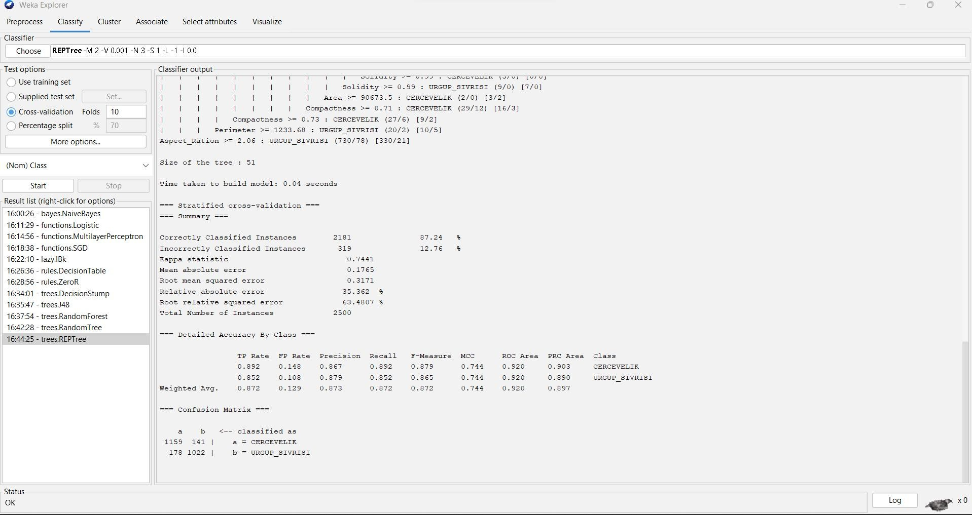

=== Run information ===

Scheme: weka.classifiers.trees.REPTree -M 2 -V 0.001 -N 3 -S 1 -L -1 -I 0.0 Relation: Pumpkin_Seeds_Dataset

Instances: 2500

Attributes: 13

Area Perimeter

Major_Axis_Length Minor_Axis_Length Convex_Area Equiv_Diameter Eccentricity Solidity

Extent Roundness Aspect_Ration Compactness Class

Test mode: 10-fold cross-validation

=== Classifier model (full training set) ===

REPTree

============

Aspect_Ration < 2.06

| Aspect_Ration < 1.86

| | Area < 107398.5

| | | Area < 54969.5 : URGUP_SIVRISI (2/0) [0/0]

| | | Area >= 54969.5

| | | | Extent < 0.65 : CERCEVELIK (8/3) [4/1]

| | | | Extent >= 0.65

| | | | | Major_Axis_Length < 482.18 : CERCEVELIK (521/14) [292/26]

| | | | | Major_Axis_Length >= 482.18

| | | | | | Minor_Axis_Length < 268.83 : URGUP_SIVRISI (4/1) [3/1]

| | | | | | Minor_Axis_Length >= 268.83 : CERCEVELIK (6/0) [5/0]

| | Area >= 107398.5 : URGUP_SIVRISI (5/0) [2/0]

| Aspect_Ration >= 1.86

| | Solidity < 0.99

| | | Minor_Axis_Length < 202.24 : URGUP_SIVRISI (9/1) [8/3]

| | | Minor_Axis_Length >= 202.24

| | | | Roundness < 0.78

| | | | | Minor_Axis_Length < 216.75 : CERCEVELIK (8/0) [3/1]

| | | | | Minor_Axis_Length >= 216.75

| | | | | | Extent < 0.67 : URGUP_SIVRISI (6/0) [3/0]

| | | | | | Extent >= 0.67 : CERCEVELIK (9/3) [3/0]

| | | | Roundness >= 0.78

| | | | | Major_Axis_Length < 508.24 : CERCEVELIK (211/23) [107/17]

| | | | | Major_Axis_Length >= 508.24 : URGUP_SIVRISI (6/2) [2/0]

| | Solidity >= 0.99

| | | Perimeter < 1233.68

| | | | Compactness < 0.73

| | | | | Area < 59138.5 : URGUP_SIVRISI (5/0) [2/0]

| | | | | Area >= 59138.5

| | | | | | Solidity < 0.99

| | | | | | | Extent < 0.67 : CERCEVELIK (8/0) [3/1]

| | | | | | | Extent >= 0.67

| | | | | | | | Extent < 0.74 : URGUP_SIVRISI (7/1) [7/3]

| | | | | | | | Extent >= 0.74 : CERCEVELIK (9/2) [2/0]

| | | | | | Solidity >= 0.99

| | | | | | | Eccentricity < 0.85 : URGUP_SIVRISI (5/0) [3/2]

|  |  |  |  |  |  |  |  |  |
| --- | --- | --- | --- | --- | --- | --- | --- | --- |
| | | | | | | | | | | | | | | Eccentricity >= 0.85 | |
| | | | | | | | | | | | | | | | | Compactness < 0.71 |
| | | | | | | | | | | | | | | | | | Area < 90673.5 |
| | | | | | | | | | | | | | | | | | | Solidity < 0.99 |
| | | | | | | | | | | | | | | | | | | | Solidity < 0.99 |
| | | | | | | | | | | | | | | | | | | | | Extent < 0.66 : CERCEVELIK (5/2) [2/0] |
| | | | | | | | | | | | | | | | | | | | | Extent >= 0.66 : URGUP_SIVRISI (12/0) [8/3] |
| | | | | | | | | | | | | | | | | | | | Solidity >= 0.99 : CERCEVELIK (3/0) [0/0] |
| | | | | | | | | | | | | | | | | | | Solidity >= 0.99 : URGUP_SIVRISI (9/0) [7/0] |
| | | | | | | | | | | | | | | | | | Area >= 90673.5 : CERCEVELIK (2/0) [3/2] |
| | | | | | | | | | | | | | | | | Compactness >= 0.71 : CERCEVELIK (29/12) [16/3] |
| | | | | | | | | Compactness >= 0.73 : CERCEVELIK (27/6) [9/2] | | | | |

| | | Perimeter >= 1233.68 : URGUP_SIVRISI (20/2) [10/5] Aspect_Ration >= 2.06 : URGUP_SIVRISI (730/78) [330/21]

Size of the tree : 51

Time taken to build model: 0.04 seconds

=== Stratified cross-validation ===

=== Summary ===

|  |  |  |  |
| --- | --- | --- | --- |
| Correctly Classified Instances | | 2181 | 87.24 % |
| Incorrectly Classified Instances | | 319 | 12.76 % |
| Kappa statistic | 0.7441 | | |
| Mean absolute error | 0.1765 | | |
| Root mean squared error | 0.3171 | | |
| Relative absolute error | 35.362 % | | |
| Root relative squared error | 63.4807 % | | |
| Total Number of Instances | 2500 | | |

=== Detailed Accuracy By Class ===

TP Rate FP Rate Precision Recall F-Measure MCC ROC Area PRC Area Class

|  |  |  |  |  |  |  |  |  |
| --- | --- | --- | --- | --- | --- | --- | --- | --- |
| 0.892 | 0.148 | 0.867 | 0.892 | 0.879 | 0.744 | 0.920 | 0.903 | CERCEVELIK |
| 0.852 | 0.108 | 0.879 | 0.852 | 0.865 | 0.744 | 0.920 | 0.890 | URGUP_SIVRISI |
| Weighted Avg. | 0.872 | 0.129 | 0.873 | 0.872 | 0.872 | 0.744 | 0.920 | 0.897 |

=== Confusion Matrix ===

a b <-- classified as

1159 141 | a = CERCEVELIK

178 1022 | b = URGUP_SIVRISI

**PERCENTAGE SPLIT 70%TRAINING and 30% TESTING**

1. **NaiveBayes:**

To classify the data set, using the Naive Bayes Classification Go to Classify Tab

Under Classifier go to Choose >Classifiers>bayes>NaiveBayes

Test Options: Percentage split % 70

**ACCURACY : 87.8667%**

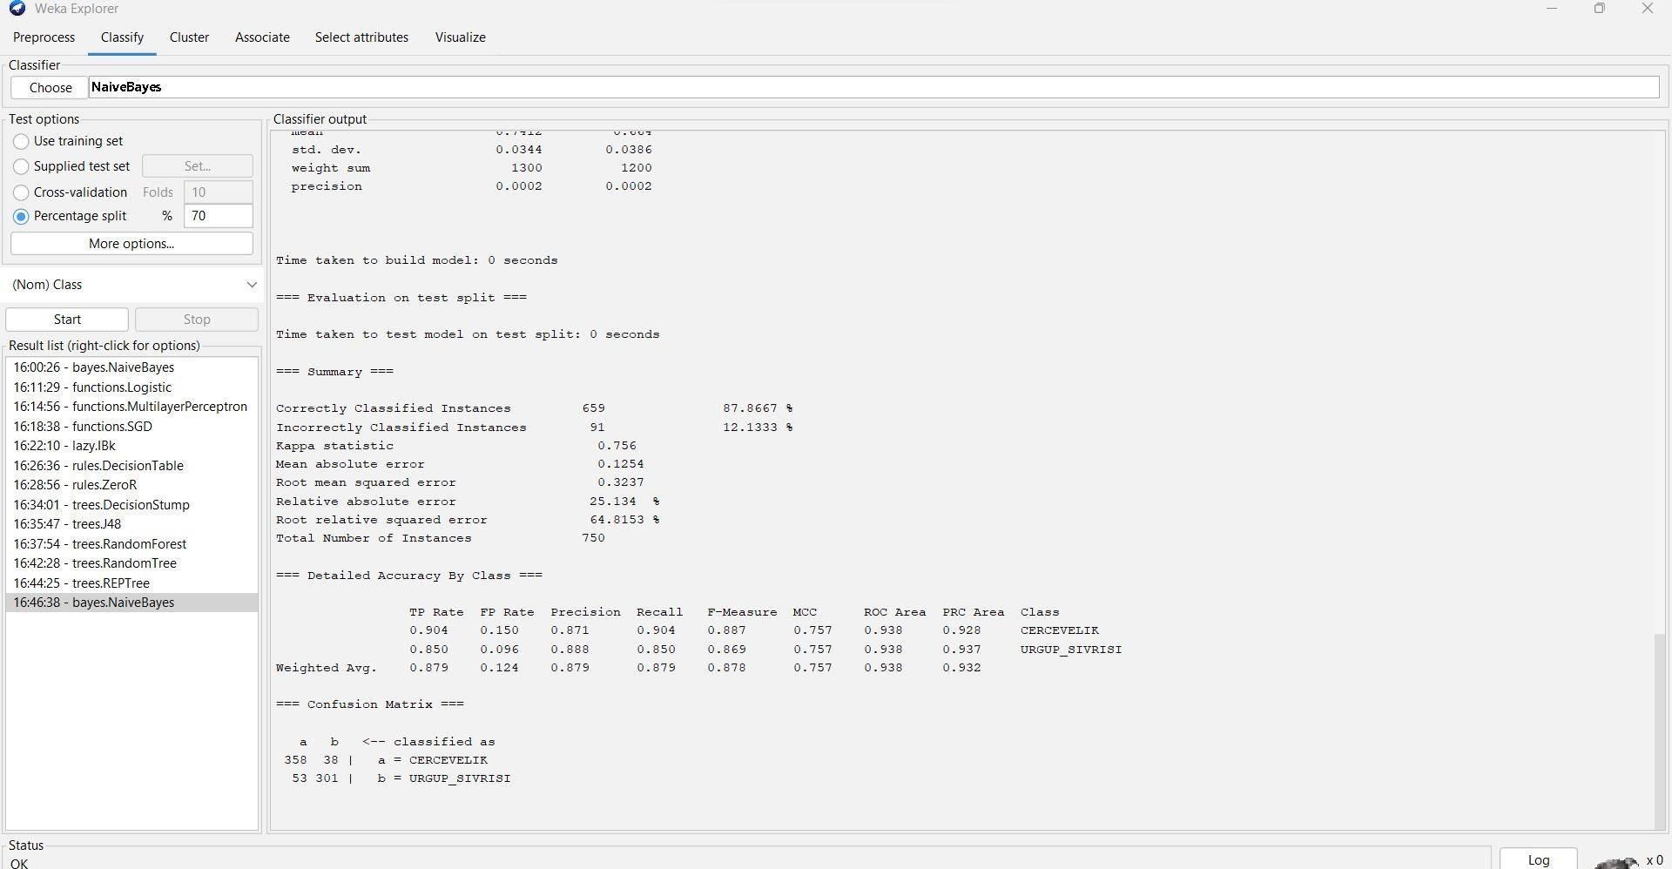

=== Run information ===

Scheme: weka.classifiers.bayes.NaiveBayes Relation: Pumpkin_Seeds_Dataset Instances: 2500

Attributes: 13

Area Perimeter

Major_Axis_Length Minor_Axis_Length Convex_Area Equiv_Diameter Eccentricity Solidity

Extent Roundness Aspect_Ration Compactness Class

Test mode: split 70.0% train, remainder test

=== Classifier model (full training set) ===

Naive Bayes Classifier

Class

Attribute CERCEVELIK URGUP_SIVRISI (0.52) (0.48)

================================================

Area

|  |  |  |
| --- | --- | --- |
| mean | 78422.6576 | 83079.3389 |
| std. dev. | 11241.6199 | 15512.9004 |
| weight sum | 1300 | 1200 |
| precision | 36.5807 | 36.5807 |

Perimeter

mean 1089.5237 1174.4284

std. dev. 83.0966 116.7463

weight sum 1300 1200

precision 0.2776 0.2776

Major_Axis_Length

|  |  |  |
| --- | --- | --- |
| mean | 426.2707 | 489.4595 |
| std. dev. | 37.1811 | 54.883 |
| weight sum | 1300 | 1200 |
| precision | 0.1365 | 0.1365 |

Minor_Axis_Length

|  |  |  |
| --- | --- | --- |
| mean | 234.7771 | 216.0645 |
| std. dev. | 19.493 | 23.164 |
| weight sum | 1300 | 1200 |
| precision | 0.0616 | 0.0616 |

Convex_Area

|  |  |  |
| --- | --- | --- |
| mean | 79286.4162 | 83914.9589 |
| std. dev. | 11345.8192 | 15618.404 |
| weight sum | 1300 | 1200 |
| precision | 36.8322 | 36.8322 |

Equiv_Diameter

|  |  |  |
| --- | --- | --- |
| mean | 315.1933 | 323.8198 |
| std. dev. | 22.4645 | 30.3414 |
| weight sum | 1300 | 1200 |
| precision | 0.0701 | 0.0701 |

Eccentricity

|  |  |  |
| --- | --- | --- |
| mean | 0.8305 | 0.8938 |
| std. dev. | 0.0363 | 0.0272 |
| weight sum | 1300 | 1200 |
| precision | 0.0004 | 0.0004 |

|  |  |  |
| --- | --- | --- |
| Solidity |  | |
| mean | 0.9891 | 0.9899 |
| std. dev. | 0.0034 | 0.0035 |
| weight sum | 1300 | 1200 |
| precision | 0.0005 | 0.0005 |

|  |  |  |
| --- | --- | --- |
| Extent |  | |
| mean | 0.707 | 0.6782 |
| std. dev. | 0.0407 | 0.0742 |
| weight sum | 1300 | 1200 |
| precision | 0.0003 | 0.0003 |

Roundness

|  |  |  |
| --- | --- | --- |
| mean | 0.8275 | 0.7526 |
| std. dev. | 0.0375 | 0.0455 |
| weight sum | 1300 | 1200 |
| precision | 0.0003 | 0.0003 |

Aspect_Ration

|  |  |  |
| --- | --- | --- |
| mean | 1.8226 | 2.2791 |
| std. dev. | 0.1684 | 0.2624 |
| weight sum | 1300 | 1200 |
| precision | 0.0009 | 0.0009 |

Compactness

|  |  |  |
| --- | --- | --- |
| mean | 0.7412 | 0.664 |
| std. dev. | 0.0344 | 0.0386 |
| weight sum | 1300 | 1200 |
| precision | 0.0002 | 0.0002 |

Time taken to build model: 0 seconds

=== Evaluation on test split ===

Time taken to test model on test split: 0 seconds

=== Summary ===

|  |  |
| --- | --- |
| Correctly Classified Instances 659 | 87.8667 % |
| Incorrectly Classified Instances 91 | 12.1333 % |
| Kappa statistic 0.756 |  |

|  |  |
| --- | --- |
| Mean absolute error | 0.1254 |
| Root mean squared error | 0.3237 |
| Relative absolute error | 25.134 % |
| Root relative squared error | 64.8153 % |
| Total Number of Instances | 750 |

=== Detailed Accuracy By Class ===

TP Rate FP Rate Precision Recall F-Measure MCC ROC Area PRC Area Class

|  |  |  |  |  |  |  |  |  |
| --- | --- | --- | --- | --- | --- | --- | --- | --- |
| 0.904 | 0.150 | 0.871 | 0.904 | 0.887 | 0.757 | 0.938 | 0.928 | CERCEVELIK |
| 0.850 | 0.096 | 0.888 | 0.850 | 0.869 | 0.757 | 0.938 | 0.937 | URGUP_SIVRISI |
| Weighted Avg. | 0.879 | 0.124 | 0.879 | 0.879 | 0.878 | 0.757 | 0.938 | 0.932 |

=== Confusion Matrix ===

a b <-- classified as 358 38 | a = CERCEVELIK

53 301 | b = URGUP_SIVRISI

1. **Functions.logistic :**

To classify the data set, using the Logistic Classification Go to Classify Tab

Under Classifier go to Choose >Classifiers>Functions>Logistic

Test Options: Percentage split %70

**ACCURACY : 90%**

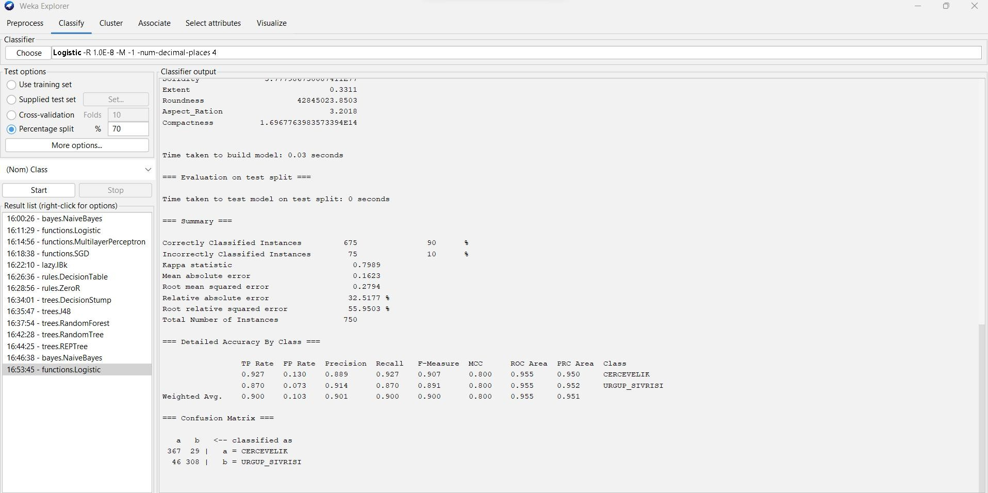

=== Run information ===

Scheme: weka.classifiers.functions.Logistic -R 1.0E-8 -M -1 -num-decimal-places 4 Relation: Pumpkin_Seeds_Dataset

Instances: 2500

Attributes: 13

Area Perimeter

Major_Axis_Length Minor_Axis_Length Convex_Area Equiv_Diameter Eccentricity Solidity

Extent Roundness Aspect_Ration Compactness Class

Test mode: split 70.0% train, remainder test

=== Classifier model (full training set) ===

Logistic Regression with ridge parameter of 1.0E-8 Coefficients...

Class

Variable CERCEVELIK

==========================================

|  |  |
| --- | --- |
| Area | -0.007 |
| Perimeter | 0.014 |
| Major_Axis_Length | -0.3118 |
| Minor_Axis_Length | -0.5838 |
| Convex_Area | 0.0059 |
| Equiv_Diameter | 1.3416 |
| Eccentricity | -20.9669 |
| Solidity | 179.0531 |
| Extent | -1.1054 |
| Roundness | 17.5731 |
| Aspect_Ration | 1.1637 |
| Compactness | 32.7649 |
| Intercept | -282.2696 |

Odds Ratios...

Class

Variable CERCEVELIK

==========================================

|  |  |
| --- | --- |
| Area | 0.993 |
| Perimeter | 1.0141 |
| Major_Axis_Length | 0.7321 |
| Minor_Axis_Length | 0.5578 |
| Convex_Area | 1.0059 |

Equiv_Diameter 3.8251

Eccentricity 0

Solidity 5.777986750087411E77

Extent 0.3311

Roundness 42845023.8503

Aspect_Ration 3.2018

Compactness 1.6967763983573394E14

Time taken to build model: 0.03 seconds

=== Evaluation on test split ===

Time taken to test model on test split: 0 seconds

=== Summary ===

|  |  |  |  |  |
| --- | --- | --- | --- | --- |
| Correctly Classified Instances | | 675 | 90 | % |
| Incorrectly Classified Instances | | 75 | 10 | % |
| Kappa statistic | 0.7989 | | | |
| Mean absolute error | 0.1623 | | | |
| Root mean squared error | 0.2794 | | | |
| Relative absolute error | 32.5177 % | | | |
| Root relative squared error | 55.9503 % | | | |
| Total Number of Instances | 750 | | | |

=== Detailed Accuracy By Class ===

TP Rate FP Rate Precision Recall F-Measure MCC ROC Area PRC Area Class

|  |  |  |  |  |
| --- | --- | --- | --- | --- |
| 0.927 0.130 0.889 | 0.927 0.907 | 0.800 0.955 | 0.950 | CERCEVELIK |
| 0.870 0.073 0.914 | 0.870 0.891 | 0.800 0.955 | 0.952 | URGUP_SIVRISI |

Weighted Avg. 0.900 0.103 0.901 0.900 0.900 0.800 0.955 0.951

=== Confusion Matrix ===

a b <-- classified as 367 29 | a = CERCEVELIK

46 308 | b = URGUP_SIVRISI

1. **Multilayer Perceptron:**

To classify the data set, using the MultilayerPerceptron Classification Go to Classify Tab

Under Classifier go to Choose >Classifiers>Functions> MultilayerPerceptron

Test Options: Percentage spilt % 70

**ACCURACY : 88.8%**

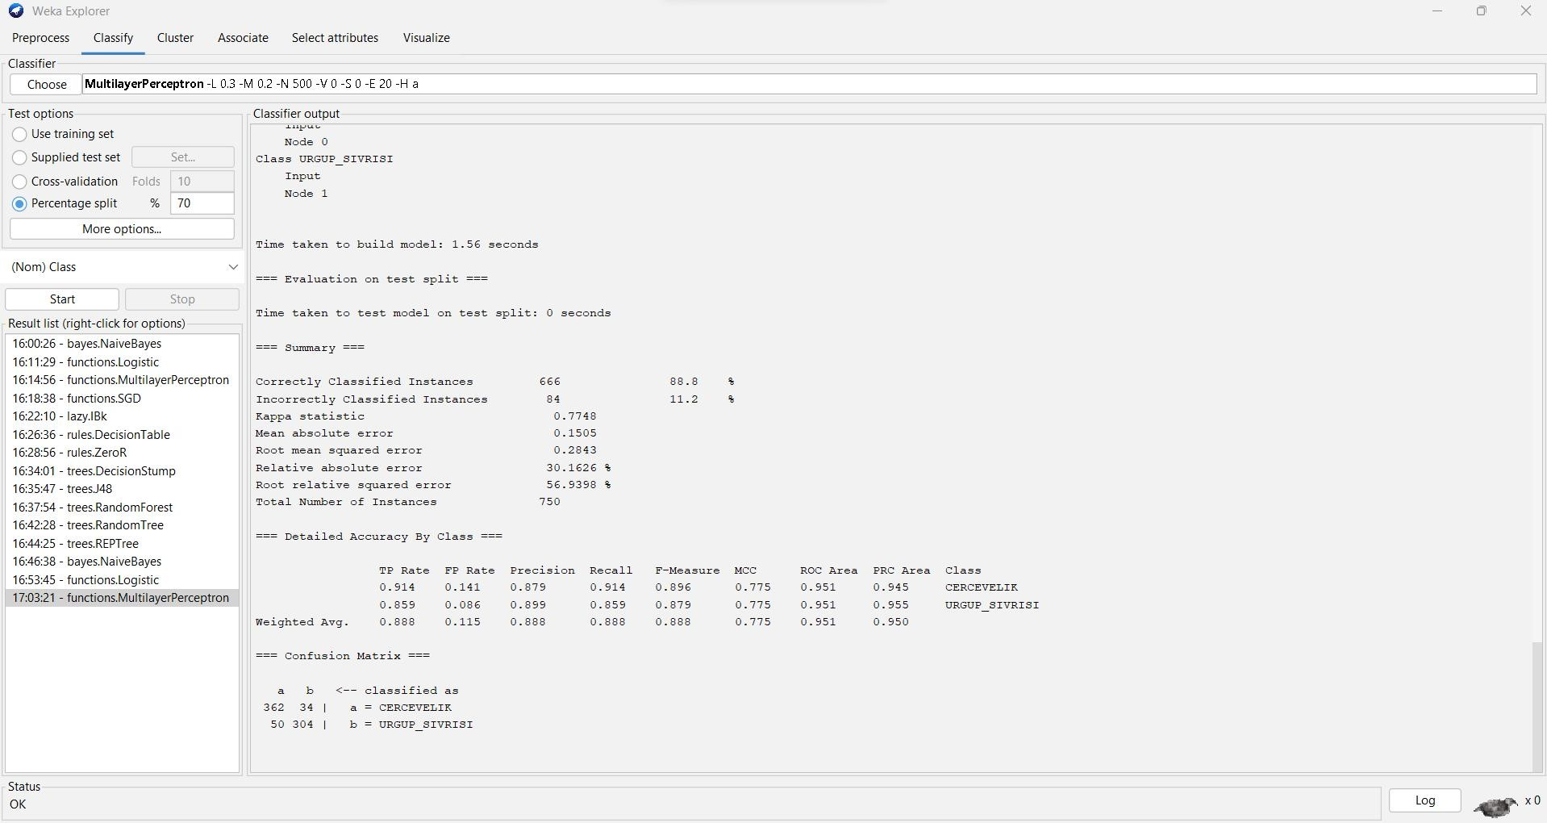

=== Run information ===

Scheme: weka.classifiers.functions.MultilayerPerceptron -L 0.3 -M 0.2 -N 500 -V 0 -S 0 -E 20 -H a Relation: Pumpkin_Seeds_Dataset

Instances: 2500

Attributes: 13

Area

Perimeter Major_Axis_Length Minor_Axis_Length Convex_Area Equiv_Diameter Eccentricity Solidity

Extent Roundness Aspect_Ration Compactness Class

Test mode: split 70.0% train, remainder test

=== Classifier model (full training set) ===

Sigmoid Node 0 Inputs Weights

Threshold -3.595490311186832

|  |  |
| --- | --- |
| Node 2 | 4.300540892376024 |
| Node 3 | 2.1824055560433075 |
| Node 4 | 1.3621371677089633 |
| Node 5 | -3.5382722455499986 |
| Node 6 | 1.2765901404006328 |
| Node 7 | -2.833202791332686 |
| Node 8 | -1.8882921237557697 |

Sigmoid Node 1 Inputs Weights

Threshold 3.595519507682398

Node 2 -4.300579158814876

Node 3 -2.182589704453731

|  |  |
| --- | --- |
| Node 4 | -1.3619918177093868 |
| Node 5 | 3.5383442828099425 |
| Node 6 | -1.2766168998388803 |
| Node 7 | 2.835040953813802 |
| Node 8 | 1.8880366690469699 |

Sigmoid Node 2 Inputs Weights

Threshold 11.381380808779928

Attrib Area 1.3907094788237673

Attrib Perimeter 3.315041319990196

Attrib Major_Axis_Length -2.997451874959911

Attrib Minor_Axis_Length 7.876121859501484

Attrib Convex_Area 2.491137054805032

Attrib Equiv_Diameter 6.185196825284903

Attrib Eccentricity 4.875591874021104

Attrib Solidity -7.741785656490237

Attrib Extent -1.2529345810224028

Attrib Roundness 1.9255354838571885

Attrib Aspect_Ration -7.18747936382351

Attrib Compactness 6.364972665945947

Sigmoid Node 3 Inputs Weights

Threshold 4.357907659949007

Attrib Area 4.3488880031925765

Attrib Perimeter 1.5581581218900182

Attrib Major_Axis_Length -0.2669209751284783

Attrib Minor_Axis_Length 6.790398976965309

Attrib Convex_Area 4.995634978861881

Attrib Equiv_Diameter 6.060312603897644

Attrib Eccentricity 1.1513589218214644

Attrib Solidity -7.0975286850563855

Attrib Extent 0.637932641689001

Attrib Roundness 7.193198666010584

Attrib Aspect_Ration -5.121208942641536

Attrib Compactness 4.823374503494573

Sigmoid Node 4 Inputs Weights

Threshold -0.7957574438826517

Attrib Area 0.4032822768959458

Attrib Perimeter -0.9002049358467858

Attrib Major_Axis_Length -1.3105500060053903

Attrib Minor_Axis_Length -0.3346462086041467

Attrib Convex_Area 0.583694958205666

Attrib Equiv_Diameter 1.52246664458544

Attrib Eccentricity -0.4787780695935083

Attrib Solidity -2.0267015042694543

Attrib Extent -2.561495224888639

Attrib Roundness 6.762737384642206

Attrib Aspect_Ration -0.555235183280251

Attrib Compactness 3.8019972561993383

Sigmoid Node 5 Inputs Weights

Threshold -14.239906958644841

Attrib Area 6.724183274839269

Attrib Perimeter -8.352873564848698

Attrib Major_Axis_Length 7.095467473408265

Attrib Minor_Axis_Length -3.9147221069234726

Attrib Convex_Area 5.002425249605707

Attrib Equiv_Diameter -0.8441576601673831

Attrib Eccentricity -5.23086391446063

Attrib Solidity 15.505062604731014

Attrib Extent -0.6833339103085704

Attrib Roundness 17.56795472150609

Attrib Aspect_Ration 14.228380046065215

Attrib Compactness -9.424379876599865

Sigmoid Node 6 Inputs Weights

Threshold 0.6317208501544459

Attrib Area -2.8440121222626153

Attrib Perimeter -4.302184616985027

Attrib Major_Axis_Length -4.115137685966828

Attrib Minor_Axis_Length -3.7468933231641732

Attrib Convex_Area -2.151202528045587

Attrib Equiv_Diameter -1.5926066510467671

Attrib Eccentricity 0.11586419481907043

Attrib Solidity -9.43924550826829

Attrib Extent 4.094643206034529

Attrib Roundness 6.692321874557361

Attrib Aspect_Ration -1.0321776377196756

Attrib Compactness 4.787499965308465

Sigmoid Node 7 Inputs Weights

Threshold -0.33963892751624025

Attrib Area 1.2768063364332822

Attrib Perimeter 2.2019395081728574

Attrib Major_Axis_Length 1.5032904912875449

Attrib Minor_Axis_Length 1.507530766758988

Attrib Convex_Area 1.5200247811410228

Attrib Equiv_Diameter 1.0770499786512302

Attrib Eccentricity -0.5318185985957871

Attrib Solidity -3.483560202391647

Attrib Extent 3.079532749128028

Attrib Roundness -2.848620818308142

Attrib Aspect_Ration 0.1979183295571494

Attrib Compactness -0.7253334334550989

Sigmoid Node 8 Inputs Weights

Threshold 1.9578230664154876

Attrib Area 2.6283377039999745

Attrib Perimeter 4.655377537202776

Attrib Major_Axis_Length 1.7354332758712092

Attrib Minor_Axis_Length 4.393811861123899

Attrib Convex_Area 2.8989134036691424

Attrib Equiv_Diameter 1.3552147448193648

Attrib Eccentricity 0.6925145709102509

Attrib Solidity -2.9447059163107308

Attrib Extent -3.290943993693713

Attrib Roundness -8.168380241201064

Attrib Aspect_Ration -0.6699110023358965

Attrib Compactness -2.3981669767655793 Class CERCEVELIK

Input Node 0

Class URGUP_SIVRISI

Input Node 1

Time taken to build model: 1.56 seconds

=== Evaluation on test split ===

Time taken to test model on test split: 0 seconds

=== Summary ===

|  |  |  |  |
| --- | --- | --- | --- |
| Correctly Classified Instances | | 666 | 88.8 % |
| Incorrectly Classified Instances | | 84 | 11.2 % |
| Kappa statistic | 0.7748 | | |
| Mean absolute error | 0.1505 | | |
| Root mean squared error | 0.2843 | | |
| Relative absolute error | 30.1626 % | | |
| Root relative squared error | 56.9398 % | | |
| Total Number of Instances | 750 | | |

=== Detailed Accuracy By Class ===

TP Rate FP Rate Precision Recall F-Measure MCC ROC Area PRC Area Class

|  |  |  |  |  |  |  |  |  |
| --- | --- | --- | --- | --- | --- | --- | --- | --- |
| 0.914 | 0.141 | 0.879 | 0.914 | 0.896 | 0.775 | 0.951 | 0.945 | CERCEVELIK |
| 0.859 | 0.086 | 0.899 | 0.859 | 0.879 | 0.775 | 0.951 | 0.955 | URGUP_SIVRISI |
| Weighted Avg. | 0.888 | 0.115 | 0.888 | 0.888 | 0.888 | 0.775 | 0.951 | 0.950 |

=== Confusion Matrix === a b <-- classified as

362 34 | a = CERCEVELIK

50 304 | b = URGUP_SIVRISI

1. **SGD:**

To classify the data set, using the SGD Classification Go to Classify Tab

Under Classifier go to Choose >Classifiers>Function>SGD

Test Options: Percentage split % 70

**ACCURACY : 88.2667%**

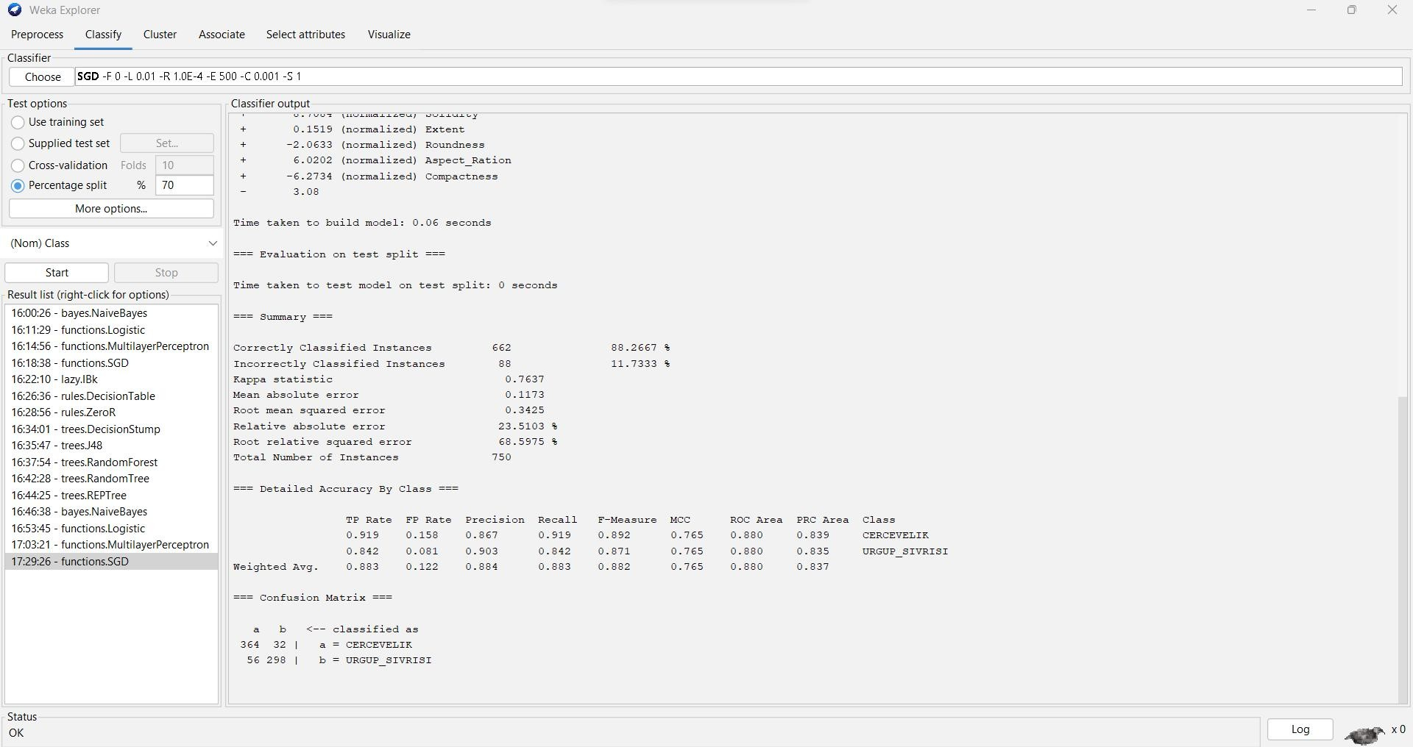

=== Run information ===

Scheme: weka.classifiers.functions.SGD -F 0 -L 0.01 -R 1.0E-4 -E 500 -C 0.001 -S 1 Relation: Pumpkin_Seeds_Dataset

Instances: 2500

Attributes: 13

Area Perimeter

Major_Axis_Length Minor_Axis_Length Convex_Area Equiv_Diameter Eccentricity Solidity

Extent Roundness Aspect_Ration Compactness Class

Test mode: split 70.0% train, remainder test

=== Classifier model (full training set) ===

Loss function: Hinge loss (SVM)

Class =

5.9809 (normalized) Area

+ -3.5693 (normalized) Perimeter

+ 0.7 (normalized) Major_Axis_Length

+ -4.5707 (normalized) Minor_Axis_Length

+ 4.8867 (normalized) Convex_Area

+ -4.1267 (normalized) Equiv_Diameter

+ -4.0315 (normalized) Eccentricity

+ 8.7084 (normalized) Solidity

+ 0.1519 (normalized) Extent

+ -2.0633 (normalized) Roundness

+ 6.0202 (normalized) Aspect_Ration

+ -6.2734 (normalized) Compactness

- 3.08

Time taken to build model: 0.06 seconds

=== Evaluation on test split ===

Time taken to test model on test split: 0 seconds

=== Summary ===

|  |  |  |  |  |
| --- | --- | --- | --- | --- |
| Correctly Classified Instances | | 662 | 88.2667 % | |
| Incorrectly Classified Instances | | 88 | 11.7333 % | |
| Kappa statistic | 0.7637 | | |
| Mean absolute error | 0.1173 | | |
| Root mean squared error | 0.3425 | | |
| Relative absolute error | 23.5103 % | | |
| Root relative squared error | 68.5975 % | | |
| Total Number of Instances | 750 | | |

=== Detailed Accuracy By Class ===

TP Rate FP Rate Precision Recall F-Measure MCC ROC Area PRC Area Class

|  |  |  |  |  |  |  |  |  |
| --- | --- | --- | --- | --- | --- | --- | --- | --- |
| 0.919 | 0.158 | 0.867 | 0.919 | 0.892 | 0.765 | 0.880 | 0.839 | CERCEVELIK |
| 0.842 | 0.081 | 0.903 | 0.842 | 0.871 | 0.765 | 0.880 | 0.835 | URGUP_SIVRISI |
| Weighted Avg. | 0.883 | 0.122 | 0.884 | 0.883 | 0.882 | 0.765 | 0.880 | 0.837 |

=== Confusion Matrix ===

a b <-- classified as 364 32 | a = CERCEVELIK

56 298 | b = URGUP_SIVRISI

1. **IBk :**

To classify the data set, using the lBK Classification Go to Classify Tab

Under Classifier go to Choose >Classifiers>lazy>lBk

Test Options: Percentage split % 70

**ACCURACY : 83.0667%**

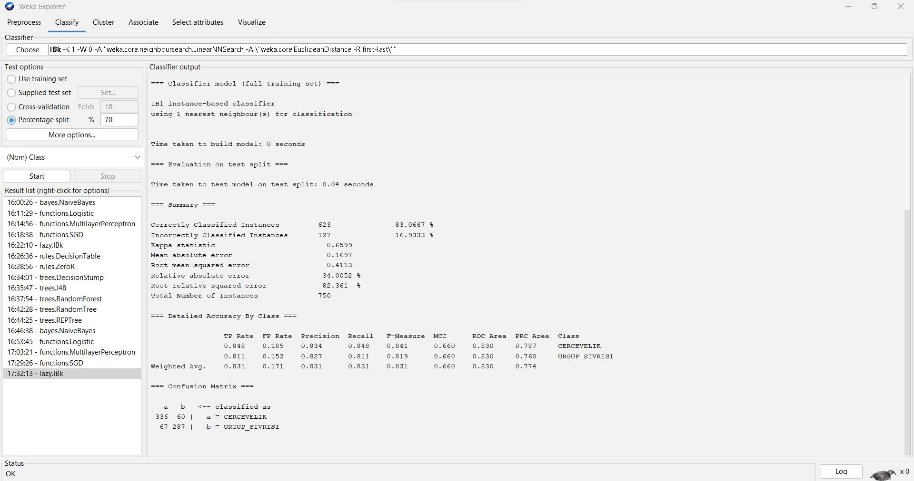

=== Run information ===

Scheme: weka.classifiers.lazy.IBk -K 1 -W 0 -A "weka.core.neighboursearch.LinearNNSearch -A

\"weka.core.EuclideanDistance -R first-last\"" Relation: Pumpkin_Seeds_Dataset Instances: 2500

Attributes: 13

Area Perimeter

Major_Axis_Length Minor_Axis_Length Convex_Area Equiv_Diameter Eccentricity Solidity

Extent Roundness Aspect_Ration Compactness Class

Test mode: split 70.0% train, remainder test

=== Classifier model (full training set) ===

IB1 instance-based classifier

using 1 nearest neighbour(s) for classification

Time taken to build model: 0 seconds

=== Evaluation on test split ===

Time taken to test model on test split: 0.04 seconds

=== Summary ===

|  |  |  |  |
| --- | --- | --- | --- |
| Correctly Classified Instances | | 623 | 83.0667 % |
| Incorrectly Classified Instances | | 127 | 16.9333 % |
| Kappa statistic | 0.6599 | | |
| Mean absolute error | 0.1697 | | |
| Root mean squared error | 0.4113 | | |
| Relative absolute error | 34.0052 % | | |
| Root relative squared error | 82.361 % | | |
| Total Number of Instances | 750 | | |

== Detailed Accuracy By Class ===

TP Rate FP Rate Precision Recall F-Measure MCC ROC Area PRC Area Class

|  |  |  |  |  |  |  |  |  |
| --- | --- | --- | --- | --- | --- | --- | --- | --- |
| 0.848 | 0.189 | 0.834 | 0.848 | 0.841 | 0.660 | 0.830 | 0.787 | CERCEVELIK |
| 0.811 | 0.152 | 0.827 | 0.811 | 0.819 | 0.660 | 0.830 | 0.760 | URGUP_SIVRISI |
| Weighted Avg. | 0.831 | 0.171 | 0.831 | 0.831 | 0.831 | 0.660 | 0.830 | 0.774 |

=== Confusion Matrix ===

a b <-- classified as 336 60 | a = CERCEVELIK

67 287 | b = URGUP_SIVRISI

1. **DecisionTable :**

To classify the data set, using the Decision Table Classification Go to Classify Tab

Under Classifier go to Choose Classifiers>Rules>Decision Table

Test Options: Percentage split % 70

**ACCURACY : 87.0667%**

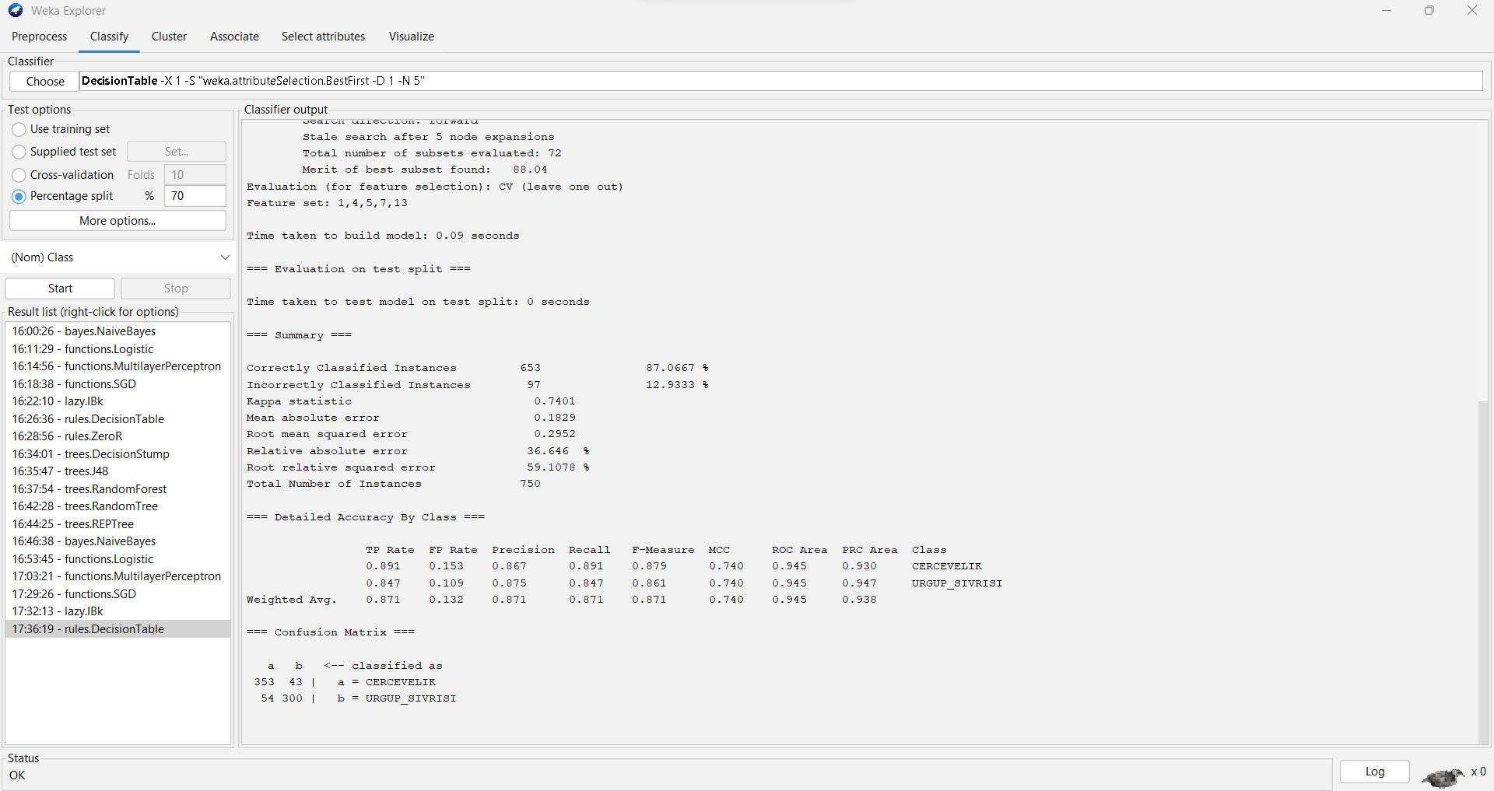

=== Run information ===

Scheme: weka.classifiers.rules.DecisionTable -X 1 -S "weka.attributeSelection.BestFirst -D 1 -N 5" Relation: Pumpkin_Seeds_Dataset

Instances: 2500

Attributes: 13

Area Perimeter

Major_Axis_Length

Minor_Axis_Length Convex_Area Equiv_Diameter Eccentricity Solidity

Extent Roundness Aspect_Ration Compactness Class

Test mode: split 70.0% train, remainder test

=== Classifier model (full training set) ===

Decision Table:

Number of training instances: 2500 Number of Rules : 62

Non matches covered by Majority class.

Best first.

Start set: no attributes Search direction: forward

Stale search after 5 node expansions Total number of subsets evaluated: 72 Merit of best subset found: 88.04

Evaluation (for feature selection): CV (leave one out) Feature set: 1,4,5,7,13

Time taken to build model: 0.09 seconds

=== Evaluation on test split ===

Time taken to test model on test split: 0 seconds

=== Summary ===

|  |  |  |  |
| --- | --- | --- | --- |
| Correctly Classified Instances | | 653 | 87.0667 % |
| Incorrectly Classified Instances | | 97 | 12.9333 % |
| Kappa statistic | 0.7401 | | |
| Mean absolute error | 0.1829 | | |
| Root mean squared error | 0.2952 | | |
| Relative absolute error | 36.646 % | | |
| Root relative squared error | 59.1078 % | | |
| Total Number of Instances | 750 | | |

=== Detailed Accuracy By Class ===

TP Rate FP Rate Precision Recall F-Measure MCC ROC Area PRC Area Class

|  |  |  |  |  |  |  |  |  |
| --- | --- | --- | --- | --- | --- | --- | --- | --- |
| 0.891 | 0.153 | 0.867 | 0.891 | 0.879 | 0.740 | 0.945 | 0.930 | CERCEVELIK |
| 0.847 | 0.109 | 0.875 | 0.847 | 0.861 | 0.740 | 0.945 | 0.947 | URGUP_SIVRISI |
| Weighted Avg. | 0.871 | 0.132 | 0.871 | 0.871 | 0.871 | 0.740 | 0.945 | 0.938 |

=== Confusion Matrix ===

a b <-- classified as 353 43 | a = CERCEVELIK

54 300 | b = URGUP_SIVRISI

1. **ZeroR:**

To classify the data set, using the ZeroR Classification Go to Classify Tab

Under Classifier go to Choose >Classifiers>trees>ZeroR

options: Percentage split % 70

**ACCURACY : 52.8%**

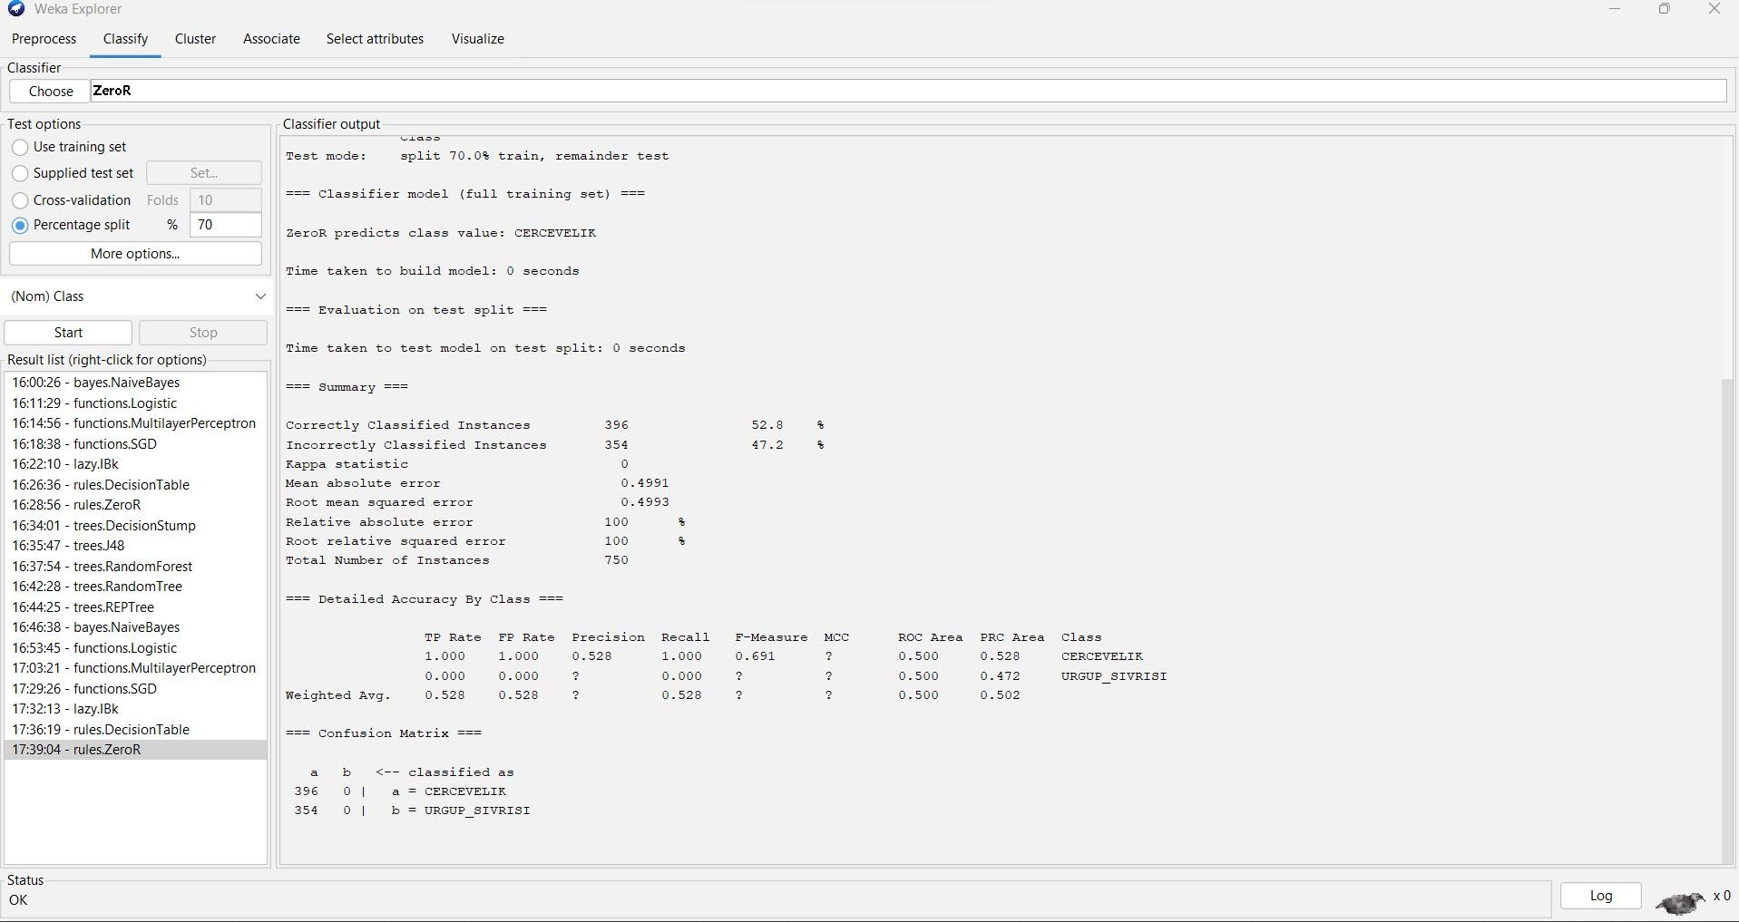

=== Run information ===

Scheme: weka.classifiers.rules.ZeroR Relation: Pumpkin_Seeds_Dataset Instances: 2500

Attributes: 13

Area Perimeter

Major_Axis_Length Minor_Axis_Length Convex_Area

Equiv_Diameter Eccentricity Solidity

Extent Roundness Aspect_Ration Compactness Class

Test mode: split 70.0% train, remainder test

=== Classifier model (full training set) ===

ZeroR predicts class value: CERCEVELIK

Time taken to build model: 0 seconds

=== Evaluation on test split ===

Time taken to test model on test split: 0 seconds

=== Summary ===

|  |  |  |  |  |
| --- | --- | --- | --- | --- |
| Correctly Classified Instances | 396 | | 52.8 | % |
| Incorrectly Classified Instances | 354 | | 47.2 | % |
| Kappa statistic 0 |  | |  |  |
| Mean absolute error | 0.4991 | |  |  |
| Root mean squared error | 0.4993 | |  |  |
| Relative absolute error | 100 % |  | | |
| Root relative squared error | 100 | % | | |
| Total Number of Instances | 750 |  | | |

=== Detailed Accuracy By Class ===

TP Rate FP Rate Precision Recall F-Measure MCC ROC Area PRC Area Class 1.000 1.000 0.528 1.000 0.691 ? 0.500 0.528 CERCEVELIK

0.000 0.000 ? 0.000 ? ? 0.500 0.472 URGUP_SIVRISI

Weighted Avg. 0.528 0.528 ? 0.528 ? ? 0.500 0.502

=== Confusion Matrix ===

a b <-- classified as

396 0 | a = CERCEVELIK

354 0 | b = URGUP_SIVRISI

1. **Decision Stump**

To classify the data set, using the DecisionStump Classification Go to Classify Tab

Under Classifier go to Choose >Classifiers>Trees>DecisionStump

Test Options:Percentage split % 70

**ACCURACY : 87.4667%**

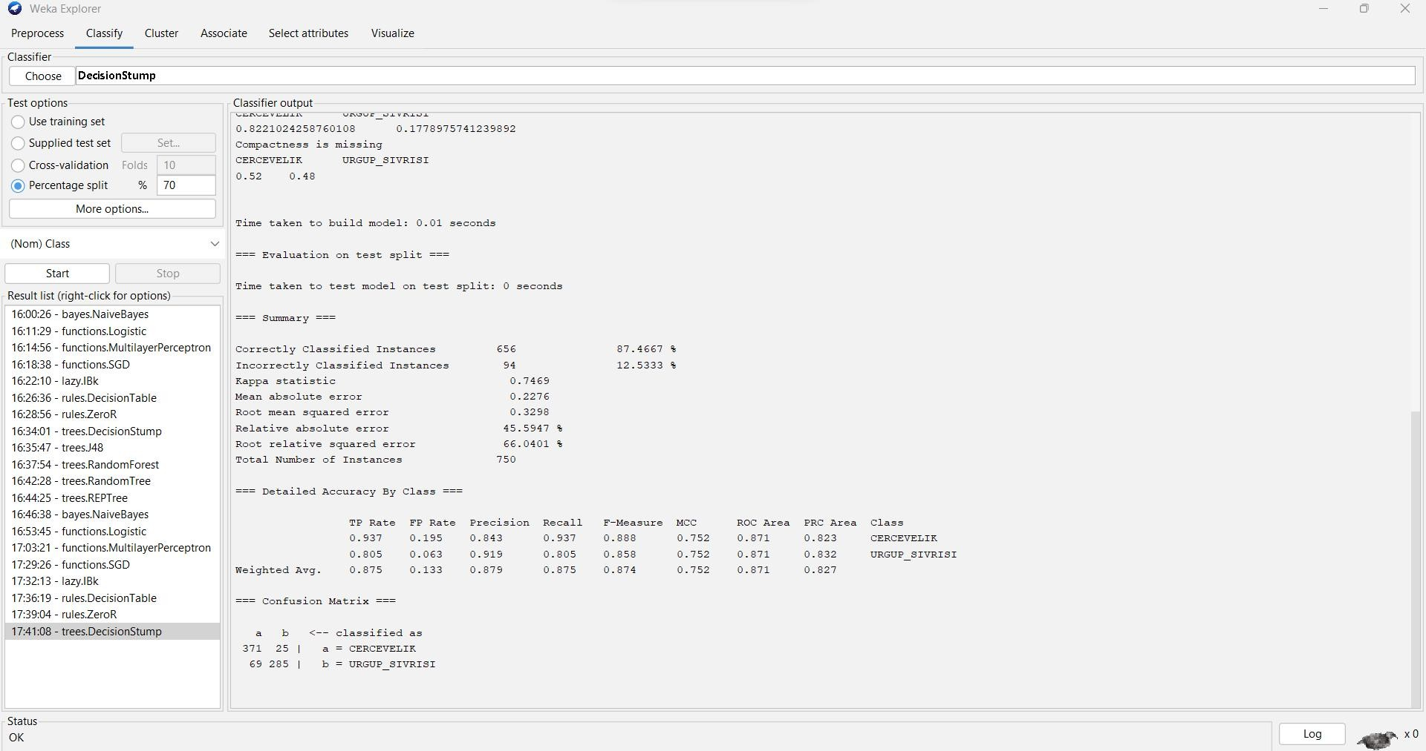

=== Run information ===Scheme: weka.classifiers.trees.DecisionStump Relation: Pumpkin_Seeds_Dataset

Instances: 2500

Attributes: 13

Area Perimeter

Major_Axis_Length Minor_Axis_Length Convex_Area Equiv_Diameter Eccentricity Solidity

Extent Roundness Aspect_Ration Compactness Class

Test mode: split 70.0% train, remainder test

=== Classifier model (full training set) ===

Decision Stump

Classifications

Compactness <= 0.69205 : URGUP_SIVRISI Compactness > 0.69205 : CERCEVELIK Compactness is missing : CERCEVELIK

Class distributions

Compactness <= 0.69205 CERCEVELIK URGUP_SIVRISI

0.07874015748031496 0.9212598425196851

Compactness > 0.69205 CERCEVELIK URGUP_SIVRISI

0.8221024258760108 0.1778975741239892

Compactness is missing CERCEVELIK URGUP_SIVRISI 0.52 0.48

Time taken to build model: 0.01 seconds

=== Evaluation on test split ===

Time taken to test model on test split: 0 seconds

=== Summary ===

|  |  |  |  |
| --- | --- | --- | --- |
| Correctly Classified Instances | | 656 | 87.4667 % |
| Incorrectly Classified Instances | | 94 | 12.5333 % |
| Kappa statistic | 0.7469 | | |
| Mean absolute error | 0.2276 | | |
| Root mean squared error | 0.3298 | | |
| Relative absolute error | 45.5947 % | | |
| Root relative squared error | 66.0401 % | | |
| Total Number of Instances | 750 | | |

=== Detailed Accuracy By Class ===

TP Rate FP Rate Precision Recall F-Measure MCC ROC Area PRC Area Class

|  |  |  |  |  |  |  |  |  |
| --- | --- | --- | --- | --- | --- | --- | --- | --- |
| 0.937 | 0.195 | 0.843 | 0.937 | 0.888 | 0.752 | 0.871 | 0.823 | CERCEVELIK |
| 0.805 | 0.063 | 0.919 | 0.805 | 0.858 | 0.752 | 0.871 | 0.832 | URGUP_SIVRISI |
| Weighted Avg. | 0.875 | 0.133 | 0.879 | 0.875 | 0.874 | 0.752 | 0.871 | 0.827 |

=== Confusion Matrix ===

a b <-- classified as 371 25 | a = CERCEVELIK

69 285 | b = URGUP_SIVRISI

1. **J48 :**

To classify the data set, using the J48 Classification Go to Classify Tab

Under Classifier go to Choose >Classifiers>Trees>J48

Test Options: Percentage split % 70

**ACCURACY : 87.7333%**

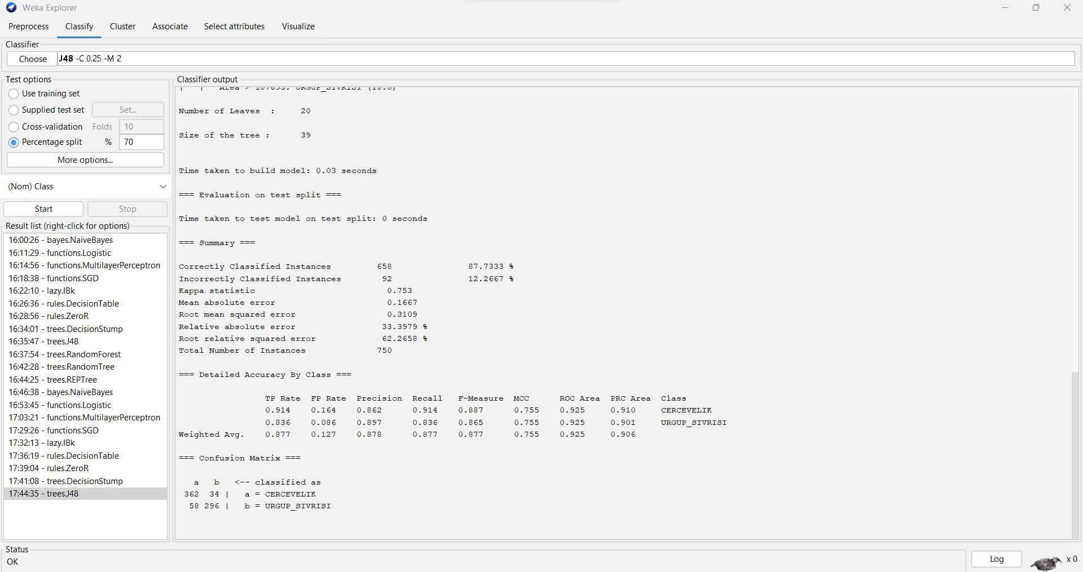

=== Run information ===

Scheme: weka.classifiers.trees.J48 -C 0.25 -M 2 Relation: Pumpkin_Seeds_Dataset

Instances: 2500

Attributes: 13

Area Perimeter

Major_Axis_Length Minor_Axis_Length Convex_Area Equiv_Diameter Eccentricity Solidity

Extent Roundness Aspect_Ration Compactness Class

Test mode: split 70.0% train, remainder test

=== Classifier model (full training set) ===

J48 pruned tree

Compactness <= 0.692: URGUP_SIVRISI (1016.0/80.0)

Compactness > 0.692

| Major_Axis_Length <= 492.3956

| | Minor_Axis_Length <= 202.9421

| | | Minor_Axis_Length <= 191.091: URGUP_SIVRISI (13.0)

| | | Minor_Axis_Length > 191.091

| | | | Perimeter <= 937.288: CERCEVELIK (3.0)

| | | | Perimeter > 937.288: URGUP_SIVRISI (28.0/7.0)

| | Minor_Axis_Length > 202.9421

| | | Compactness <= 0.7326

| | | | Solidity <= 0.9906

| | | | | Roundness <= 0.778

| | | | | | Minor_Axis_Length <= 214.398: CERCEVELIK (9.0)

| | | | | | Minor_Axis_Length > 214.398: URGUP_SIVRISI (31.0/12.0)

| | | | | Roundness > 0.778: CERCEVELIK (342.0/39.0)

| | | | Solidity > 0.9906

| | | | | Eccentricity <= 0.8647

|  |  |  |  |  |  |  |  |  |  |  |
| --- | --- | --- | --- | --- | --- | --- | --- | --- | --- | --- |
| | | | | | | | | | | | | Solidity <= 0.992: CERCEVELIK (79.0/18.0) | | | | |
| | | | | | | | | | | | | Solidity > 0.992 | | | | |
| | | | | | | | | | | | | | Roundness <= 0.8335 | | | | |
| | | | | | | | | | | | | | | Major_Axis_Length <= 482.075 | | | | |
| | | | | | | | | | | | | | | | Extent <= 0.6814: URGUP_SIVRISI (8.0) | | | | |
| | | | | | | | | | | | | | | | Extent > 0.6814 | | | | |
| | | | | | | | | | | | | | | | | | | | | Extent <= 0.7085: CERCEVELIK (4.0) |
| | | | | | | | | | | | | | | | | | | | | Extent > 0.7085 |
| | | | | | | | | | | | | | | | | | | | | | Extent <= 0.7392: URGUP_SIVRISI (9.0) |
| | | | | | | | | | | | | | | | | | | | | | Extent > 0.7392: CERCEVELIK (5.0/1.0) |
| | | | | | | | | | | | | | | | | Major_Axis_Length > 482.075: CERCEVELIK (4.0) | | |
| | | | | | | | | | | | | | | Roundness > 0.8335: CERCEVELIK (11.0/1.0) | | | |

| | | | | Eccentricity > 0.8647: URGUP_SIVRISI (60.0/16.0)

| | | Compactness > 0.7326: CERCEVELIK (803.0/42.0)

| Major_Axis_Length > 492.3956

| | Area <= 107695

| | | Solidity <= 0.9917: CERCEVELIK (38.0/15.0)

| | | Solidity > 0.9917

| | | | Major_Axis_Length <= 495.6917: CERCEVELIK (2.0)

| | | | Major_Axis_Length > 495.6917: URGUP_SIVRISI (17.0/1.0)

| | Area > 107695: URGUP_SIVRISI (18.0)

Number of Leaves : 20

Size of the tree : 39

Time taken to build model: 0.03 seconds

=== Evaluation on test split ===

Time taken to test model on test split: 0 seconds

=== Summary ===

|  |  |  |  |
| --- | --- | --- | --- |
| Correctly Classified Instances | | 658 | 87.7333 % |
| Incorrectly Classified Instances | | 92 | 12.2667 % |
| Kappa statistic | 0.753 | | |
| Mean absolute error | 0.1667 | | |
| Root mean squared error | 0.3109 | | |
| Relative absolute error | 33.3979 % | | |
| Root relative squared error | 62.2658 % | | |
| Total Number of Instances | 750 | | |

=== Detailed Accuracy By Class ===

TP Rate FP Rate Precision Recall F-Measure MCC ROC Area PRC Area Class

|  |  |  |  |  |  |  |  |  |
| --- | --- | --- | --- | --- | --- | --- | --- | --- |
| 0.914 | 0.164 | 0.862 | 0.914 | 0.887 | 0.755 | 0.925 | 0.910 | CERCEVELIK |
| 0.836 | 0.086 | 0.897 | 0.836 | 0.865 | 0.755 | 0.925 | 0.901 | URGUP_SIVRISI |
| Weighted Avg. | 0.877 | 0.127 | 0.878 | 0.877 | 0.877 | 0.755 | 0.925 | 0.906 |

=== Confusion Matrix ===

a b <-- classified as 362 34 | a = CERCEVELIK

58 296 | b = URGUP_SIVRISI

1. **RandomForest:**

To classify the data set, using the RandomForest Classification Go to Classify Tab

Under Classifier go to Choose >Classifiers>Trees>RandomForest Test Options

Percentage split % 70

**ACCURACY : 89.8667%**

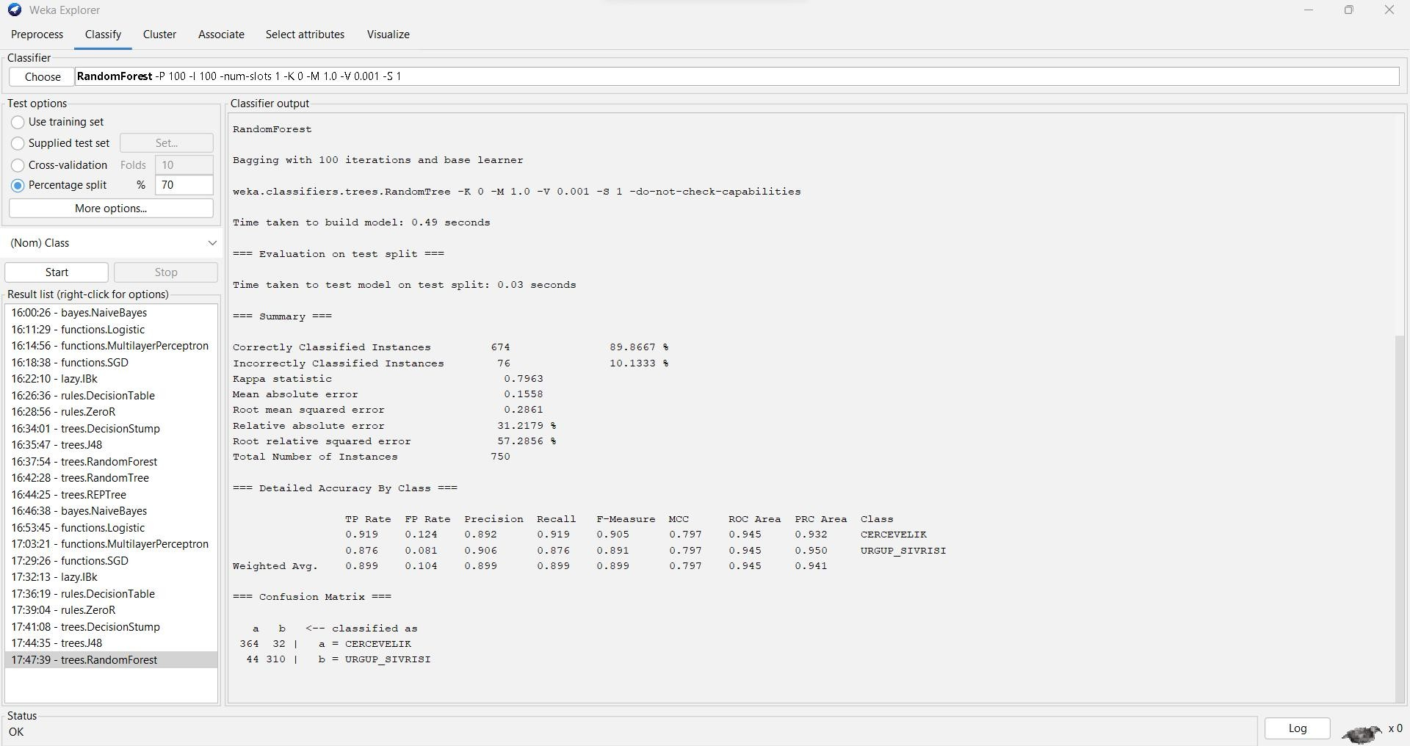

=== Run information ===

Scheme: weka.classifiers.trees.RandomForest -P 100 -I 100 -num-slots 1 -K 0 -M 1.0 -V 0.001 -S 1 Relation: Pumpkin_Seeds_Dataset

Instances: 2500

Attributes: 13

Area PerimeteMajor_Axis_Length Minor_Axis_Length Convex_Area Equiv_Diameter Eccentricity Solidity

Extent Roundness Aspect_Ration Compactness Class

Test mode: split 70.0% train, remainder test

=== Classifier model (full training set) ===

RandomForest

Bagging with 100 iterations and base learner

weka.classifiers.trees.RandomTree -K 0 -M 1.0 -V 0.001 -S 1 -do-not-check-capabilities

Time taken to build model: 0.49 seconds

=== Evaluation on test split ===

Time taken to test model on test split: 0.03 seconds

=== Summary ===

|  |  |  |  |  |
| --- | --- | --- | --- | --- |
| Correctly Classified Instances | | 674 | 89.8667 % | |
| Incorrectly Classified Instances | | 76 | 10.1333 % | |
| Kappa statistic | 0.7963 | | |
| Mean absolute error | 0.1558 | | |
| Root mean squared error | 0.2861 | | |
| Relative absolute error | 31.2179 % | | |
| Root relative squared error | 57.2856 % | | |
| Total Number of Instances | 750 | | |

=== Detailed Accuracy By Class ===

TP Rate FP Rate Precision Recall F-Measure MCC ROC Area PRC Area Class

|  |  |  |  |  |  |  |  |  |
| --- | --- | --- | --- | --- | --- | --- | --- | --- |
| 0.919 | 0.124 | 0.892 | 0.919 | 0.905 | 0.797 | 0.945 | 0.932 | CERCEVELIK |
| 0.876 | 0.081 | 0.906 | 0.876 | 0.891 | 0.797 | 0.945 | 0.950 | URGUP_SIVRISI |
| Weighted Avg. | 0.899 | 0.104 | 0.899 | 0.899 | 0.899 | 0.797 | 0.945 | 0.941 |

=== Confusion Matrix ===

a b <-- classified as 364 32 | a = CERCEVELIK

44 310 | b = URGUP_SIVRISI

1. **RandomTree:**

To classify the data set, using the RandomTree Classification Go to Classify Tab

Under Classifier go to Choose >Classifiers>Tree>RandomTree

Test Options: Percentage split % 70

**ACCURACY : 83.0667%**

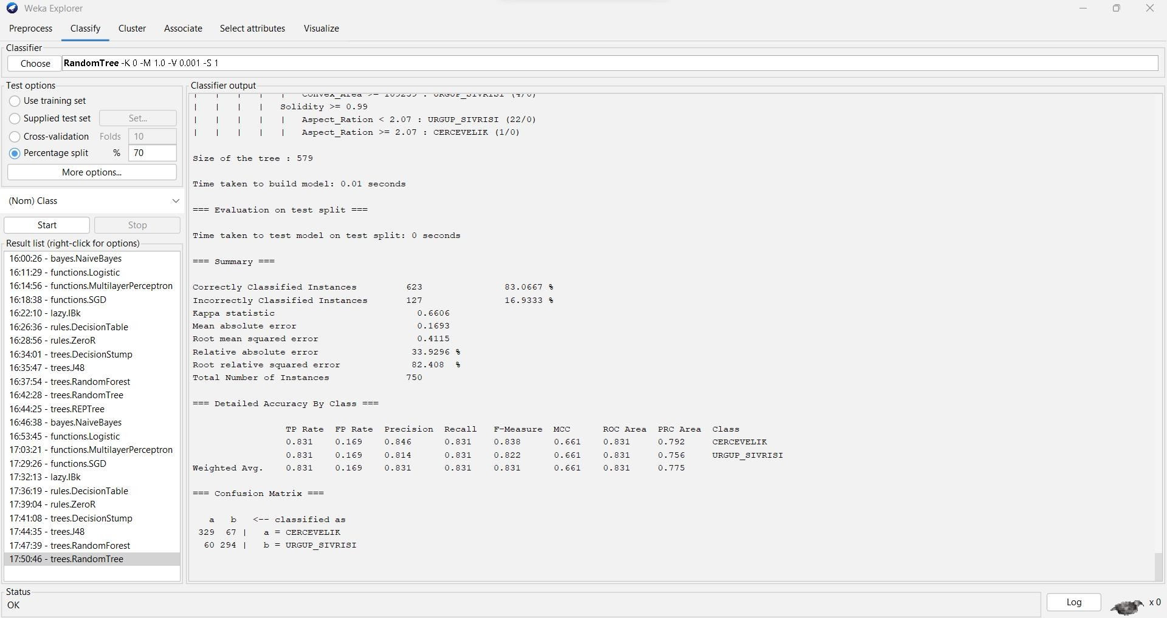

=== Run information ===

Scheme: weka.classifiers.trees.RandomTree -K 0 -M 1.0 -V 0.001 -S 1 Relation: Pumpkin_Seeds_Dataset

Instances: 2500

Attributes: 13

Area Perimeter

Major_Axis_Length Minor_Axis_Length Convex_Area Equiv_Diameter Eccentricity Solidity

Extent Roundness Aspect_Ration Compactness Class

Test mode: split 70.0% train, remainder test

=== Classifier model (full training set) ===

RandomTree

==========

Compactness < 0.69

| Compactness < 0.67

| | Solidity < 0.98

| | | Aspect_Ration < 2.47

| | | | Extent < 0.68

| | | | | Major_Axis_Length < 404.86 : URGUP_SIVRISI (1/0)

| | | | | Major_Axis_Length >= 404.86

| | | | | | Minor_Axis_Length < 201.98

| | | | | | | Major_Axis_Length < 454.1 : CERCEVELIK (1/0)

| | | | | | | Major_Axis_Length >= 454.1 : URGUP_SIVRISI (1/0)

| | | | | | Minor_Axis_Length >= 201.98 : CERCEVELIK (3/0)

| | | | Extent >= 0.68 : URGUP_SIVRISI (5/0)

| | | Aspect_Ration >= 2.47 : URGUP_SIVRISI (4/0)

| | Solidity >= 0.98

| | | Eccentricity < 0.91

| | | | Aspect_Ration < 2.39

|  |  |  |  |  |  |  |  |  |  |
| --- | --- | --- | --- | --- | --- | --- | --- | --- | --- |
| | | | | | | | | | | Roundness < 0.73 | | | | |
| | | | | | | | | | | | | Eccentricity < 0.91 | | | |
| | | | | | | | | | | | | | Solidity < 0.99 | | | |
| | | | | | | | | | | | | | | Major_Axis_Length < 475.74 | | | |
| | | | | | | | | | | | | | | | Area < 62685 : CERCEVELIK (1/0) | | | |
| | | | | | | | | | | | | | | | Area >= 62685 : URGUP_SIVRISI (4/0) | | | |
| | | | | | | | | | | | | | | Major_Axis_Length >= 475.74 : CERCEVELIK (3/0) | | | |
| | | | | | | | | | | | | | Solidity >= 0.99 : URGUP_SIVRISI (7/0) | | | |
| | | | | | | | | | | | Eccentricity >= 0.91 : URGUP_SIVRISI (11/0) | | | | | |
| | | | | | | | | | | Roundness >= 0.73 | | | | | |
| | | | | | | | | | | | Minor_Axis_Length < 223.84 | | | | | |
| | | | | | | | | | | | | Minor_Axis_Length < 223.42 | | | | | |
| | | | | | | | | | | | | | Perimeter < 1231.26 | | | | | |
| | | | | | | | | | | | | | | | | | | Aspect_Ration < 2.31 | |
| | | | | | | | | | | | | | | | | | | | Extent < 0.62 | |
| | | | | | | | | | | | | | | | | | | | | Eccentricity < 0.9 | |
| | | | | | | | | | | | | | | | | | | | | | Solidity < 0.99 : URGUP_SIVRISI (22/0) | |
| | | | | | | | | | | | | | | | | | | | | | Solidity >= 0.99 | |
| | | | | | | | | | | | | | | | | | | | | | | Major_Axis_Length < 473.64 : URGUP_SIVRISI (3/0) | |
| | | | | | | | | | | | | | | | | | | | | | | Major_Axis_Length >= 473.64 | |
| | | | | | | | | | | | | | | | | | | | | | | | Perimeter < 1169.06 : CERCEVELIK (2/0) | |
| | | | | | | | | | | | | | | | | | | | | | | | Perimeter >= 1169.06 : URGUP_SIVRISI (1/0) | |
| | | | | | | | | | | | | | | | | | | | | Eccentricity >= 0.9 : CERCEVELIK (1/0) | |
| | | | | | | | | | | | | | | | | | | | Extent >= 0.62 : URGUP_SIVRISI (78/0) | |
| | | | | | | | | | | | | | | | | | | Aspect_Ration >= 2.31 : URGUP_SIVRISI (71/0) | |
| | | | | | | | | | | | | | | | | Perimeter >= 1231.26 | | |

| | | | | | | | | Eccentricity < 0.91 : CERCEVELIK (1/0)

| | | | | | | | | Eccentricity >= 0.91 : URGUP_SIVRISI (2/0)

| | | | | | | Minor_Axis_Length >= 223.42 : CERCEVELIK (1/0)

| | | | | | Minor_Axis_Length >= 223.84 : URGUP_SIVRISI (104/0)

| | | | Aspect_Ration >= 2.39 : CERCEVELIK (1/0)

|  |  |  |  |
| --- | --- | --- | --- |
| | | | | | | Eccentricity >= 0.91 |
| | | | | | | | Roundness < 0.64 |
| | | | | | | | | Area < 100633.5 : URGUP_SIVRISI (7/0) |
| | | | | | | | | Area >= 100633.5 : CERCEVELIK (1/0) |
| | | | | | | | Roundness >= 0.64 : URGUP_SIVRISI (386/0) |

| Compactness >= 0.67

| | Equiv_Diameter < 350.1

| | | Minor_Axis_Length < 202.14

|  |  |  |  |  |  |  |  |  |  |  |  |  |  |  |  |
| --- | --- | --- | --- | --- | --- | --- | --- | --- | --- | --- | --- | --- | --- | --- | --- |
| | | | | | | | | Eccentricity < 0.88 : URGUP_SIVRISI (21/0) | | | | | | | | | | | |
| | | | | | | | | Eccentricity >= 0.88 | | | | | | | | | | | |
| | | | | | | | | | Aspect_Ration < 2.14 | | | | | | | | | | | |
| | | | | | | | | | | Area < 59602 : URGUP_SIVRISI (1/0) | | | | | | | | | | | |
| | | | | | | | | | | Area >= 59602 : CERCEVELIK (2/0) | | | | | | | | | | | |
| | | | | | | | | | Aspect_Ration >= 2.14 : URGUP_SIVRISI (20/0) | | | | | | | | | | | |
| | | | | | | Minor_Axis_Length >= 202.14 | | | | | | | | | | | | |
| | | | | | | | Solidity < 0.99 | | | | | | | | | | | | |
| | | | | | | | | Eccentricity < 0.88 | | | | | | | | | | | | |
| | | | | | | | | | Perimeter < 1229.04 | | | | | | | | | | | | |
| | | | | | | | | | | Convex_Area < 90035.5 | | | | | | | | | | | | |
| | | | | | | | | | | | Compactness < 0.69 | | | | | | | | | | | | |
| | | | | | | | | | | | | Eccentricity < 0.88 : CERCEVELIK (4/0) | | | | | | | | | | | | |
| | | | | | | | | | | | | Eccentricity >= 0.88 | | | | | | | | | | | | |
| | | | | | | | | | | | | | Roundness < 0.78 | | | | | | | | | | | | |
| | | | | | | | | | | | | | | Equiv_Diameter < 307.76 | | | | | | | | | | | | |
| | | | | | | | | | | | | | | | | | | | | | | | | Minor_Axis_Length < 210.42 | | | |
| | | | | | | | | | | | | | | | | | | | | | | | | | Extent < 0.62 : URGUP_SIVRISI (2/0) | | | |
| | | | | | | | | | | | | | | | | | | | | | | | | | Extent >= 0.62 : CERCEVELIK (4/0) | | | |
| | | | | | | | | | | | | | | | | | | | | | | | | Minor_Axis_Length >= 210.42 : URGUP_SIVRISI (3/0) | | | |
| | | | | | | | | | | | | | | | | | | | | | | Equiv_Diameter >= 307.76 | | | | |
| | | | | | | | | | | | | | | | | | | | | | | | Convex_Area < 87864 : CERCEVELIK (11/0) | | | | |
| | | | | | | | | | | | | | | | | | | | | | | | Convex_Area >= 87864 | | | | |
| | | | | | | | | | | | | | | | | | | | | | | | | Minor_Axis_Length < 230.61 : URGUP_SIVRISI (1/0) | | | | |
| | | | | | | | | | | | | | | | | | | | | | | | | Minor_Axis_Length >= 230.61 : CERCEVELIK (1/0) | | | | |
| | | | | | | | | | | | | | | | | | | | | Roundness >= 0.78 | | | | | |
| | | | | | | | | | | | | | | | | | | | | | Eccentricity < 0.88 : URGUP_SIVRISI (3/0) | | | | | |
| | | | | | | | | | | | | | | | | | | | | | Eccentricity >= 0.88 | | | | | |
| | | | | | | | | | | | | | | | | | | | | | | Roundness < 0.78 : URGUP_SIVRISI (2/0) | | | | | |
| | | | | | | | | | | | | | | | | | | | | | | Roundness >= 0.78 | | | | | |
| | | | | | | | | | | | | | | | | | | | | | | | Area < 86055 | | | | | |
| | | | | | | | | | | | | | | | | | | | | | | | | | | | | Extent < 0.74 : CERCEVELIK (5/0) |
| | | | | | | | | | | | | | | | | | | | | | | | | | | | | Extent >= 0.74 |
| | | | | | | | | | | | | | | | | | | | | | | | | | | | | | Perimeter < 1152.62 : URGUP_SIVRISI (2/0) |
| | | | | | | | | | | | | | | | | | | | | | | | | | | | | | Perimeter >= 1152.62 : CERCEVELIK (1/0) |
| | | | | | | | | | | | | | | | | | | | | | | | | | | Area >= 86055 : URGUP_SIVRISI (2/0) | |

| | | | | | | | Compactness >= 0.69 : URGUP_SIVRISI (4/0)

| | | | | | | Convex_Area >= 90035.5 : URGUP_SIVRISI (5/0)

| | | | | | Perimeter >= 1229.04 : CERCEVELIK (5/0)

|  |  |  |  |  |  |  |  |  |  |  |  |  |  |  |  |
| --- | --- | --- | --- | --- | --- | --- | --- | --- | --- | --- | --- | --- | --- | --- | --- |
| | | | | | | | | | | Eccentricity >= 0.88 | | | | | | | | | | |
| | | | | | | | | | | | Aspect_Ration < 2.14 : URGUP_SIVRISI (6/0) | | | | | | | | | | |
| | | | | | | | | | | | Aspect_Ration >= 2.14 | | | | | | | | | | |
| | | | | | | | | | | | | Area < 71042.5 : CERCEVELIK (2/0) | | | | | | | | | | |
| | | | | | | | | | | | | Area >= 71042.5 | | | | | | | | | | |
| | | | | | | | | | | | | | Roundness < 0.78 | | | | | | | | | | |
| | | | | | | | | | | | | | | | | | | Extent < 0.75 | | | | | | |
| | | | | | | | | | | | | | | | | | | | Major_Axis_Length < 492.31 | | | | | | |
| | | | | | | | | | | | | | | | | | | | | Area < 80573 | | | | | | |
| | | | | | | | | | | | | | | | | | | | | | Area < 79171 | | | | | | |
| | | | | | | | | | | | | | | | | | | | | | | Area < 78991.5 | | | | | | |
| | | | | | | | | | | | | | | | | | | | | | | | Roundness < 0.77 : URGUP_SIVRISI (12/0) | | | | | | |
| | | | | | | | | | | | | | | | | | | | | | | | Roundness >= 0.77 | | | | | | |
| | | | | | | | | | | | | | | | | | | | | | | | | Area < 76606 : CERCEVELIK (3/0) | | | | | | |
| | | | | | | | | | | | | | | | | | | | | | | | | Area >= 76606 : URGUP_SIVRISI (1/0) | | | | | | |
| | | | | | | | | | | | | | | | | | | | | | | Area >= 78991.5 : CERCEVELIK (2/0) | | | | | | |
| | | | | | | | | | | | | | | | | | | | | | Area >= 79171 : URGUP_SIVRISI (7/0) | | | | | | |
| | | | | | | | | | | | | | | | | | | | | Area >= 80573 | | | | | | |
| | | | | | | | | | | | | | | | | | | | | | Eccentricity < 0.89 | | | | | | |
| | | | | | | | | | | | | | | | | | | | | | | Roundness < 0.74 : CERCEVELIK (3/0) | | | | | | |
| | | | | | | | | | | | | | | | | | | | | | | Roundness >= 0.74 | | | | | | |
| | | | | | | | | | | | | | | | | | | | | | | | Convex_Area < 82033.5 : CERCEVELIK (2/0) | | | | | | |
| | | | | | | | | | | | | | | | | | | | | | | | Convex_Area >= 82033.5 | | | | | | |
| |  | | |  | | |  | | |  | | |  | | |  | | |  | | |  | | |  | | |  | | |  | | |  | | |  | | |  | | |  | | Extent < 0.7 : URGUP_SIVRISI (5/0)  Extent >= 0.7 | |
| | | | | | | | | | | | | | | | | | | | | | | | | | | | | | | | Perimeter < 1171.27 : URGUP_SIVRISI (1/0) | |
| | | | | | | | | | | | | | | | | | | | | | | | | | | | | | | | Perimeter >= 1171.27 : CERCEVELIK (3/0) | |
| | | | | | | | | | | | | | | | | | | | | | | | | Eccentricity >= 0.89 : CERCEVELIK (4/0) | | | | |

| | | | | | | | | | Major_Axis_Length >= 492.31

| | | | | | | | | | | Equiv_Diameter < 347.49 : URGUP_SIVRISI (13/0)

| | | | | | | | | | | Equiv_Diameter >= 347.49 : CERCEVELIK (1/0)

|  |  |  |  |  |  |  |  |  |  |
| --- | --- | --- | --- | --- | --- | --- | --- | --- | --- |
| | | | | | | | | | | | | | | | | | | Extent >= 0.75 |
| | | | | | | | | | | | | | | | | | | | Area < 89917 : CERCEVELIK (5/0) |
| | | | | | | | | | | | | | | | | | | | Area >= 89917 |
| | | | | | | | | | | | | | | | | | | | | Area < 92918.5 : URGUP_SIVRISI (1/0) |
| | | | | | | | | | | | | | | | | | | | | Area >= 92918.5 : CERCEVELIK (1/0) |

| | | | | | | | Roundness >= 0.78 : URGUP_SIVRISI (4/0)

|  |  |  |  |  |
| --- | --- | --- | --- | --- |
| | | | | | | | | Solidity >= 0.99 |
| | | | | | | | | | Minor_Axis_Length < 212.46 |
| | | | | | | | | | | Roundness < 0.79 |
| | | | | | | | | | | | Minor_Axis_Length < 212.2 |
| | | | | | | | | | | | | Roundness < 0.78 : URGUP_SIVRISI (9/0) |
| | | | | | | | | | | | | Roundness >= 0.78 |
| | | | | | | | | | | | | | Convex_Area < 73494.5 : URGUP_SIVRISI (1/0) |
| | | | | | | | | | | | | | Convex_Area >= 73494.5 : CERCEVELIK (1/0) |
| | | | | | | | | | | | Minor_Axis_Length >= 212.2 : CERCEVELIK (1/0) |
| | | | | | | | | | | Roundness >= 0.79 : CERCEVELIK (2/0) |
| | | | | | | | | | Minor_Axis_Length >= 212.46 |
| | | | | | | | | | | Eccentricity < 0.88 |
| | | | | | | | | | | | Roundness < 0.79 |
| | | | | | | | | | | | | Extent < 0.7 : URGUP_SIVRISI (4/0) |
| | | | | | | | | | | | | Extent >= 0.7 |
| | | | | | | | | | | | | | Solidity < 0.99 : URGUP_SIVRISI (2/0) |
| | | | | | | | | | | | | | Solidity >= 0.99 : CERCEVELIK (2/0) |

| | | | | | | Roundness >= 0.79 : URGUP_SIVRISI (10/0)

| | | | | | Eccentricity >= 0.88 : URGUP_SIVRISI (36/0)

| | Equiv_Diameter >= 350.1 : URGUP_SIVRISI (51/0) Compactness >= 0.69

| Eccentricity < 0.85

| | Major_Axis_Length < 492.03

| | | Area < 54969.5 : URGUP_SIVRISI (3/0)

| | | Area >= 54969.5

| | | | Roundness < 0.85

|  |  |  |  |  |  |  |  |  |  |  |  |  |  |  |  |  |  |  |  |  |  |
| --- | --- | --- | --- | --- | --- | --- | --- | --- | --- | --- | --- | --- | --- | --- | --- | --- | --- | --- | --- | --- | --- |
| | | | | | | | | | | Solidity < 0.99 | | | | | | | | | | | | | | | | |
| | | | | | | | | | | | | Minor_Axis_Length < 264.38 | | | | | | | | | | | | | | | |
| | | | | | | | | | | | | | Minor_Axis_Length < 263.65 | | | | | | | | | | | | | | | |
| | | | | | | | | | | | | | | Roundness < 0.78 | | | | | | | | | | | | | | | |
| | | | | | | | | | | | | | | | Eccentricity < 0.83 : CERCEVELIK (10/0) | | | | | | | | | | | | | | | |
| | | | | | | | | | | | | | | | Eccentricity >= 0.83 | | | | | | | | | | | | | | | |
| | | | | | | | | | | | | | | | | Convex_Area < 65455 : CERCEVELIK (2/0) | | | | | | | | | | | | | | | |
| | | | | | | | | | | | | | | | | Convex_Area >= 65455 | | | | | | | | | | | | | | | |
| | | | | | | | | | | | | | | | | | Eccentricity < 0.85 | | | | | | | | | | | | | | | |
| | | | | | | | | | | | | | | | | | | Solidity < 0.97 : CERCEVELIK (1/0) | | | | | | | | | | | | | | | |
| | | | | | | | | | | | | | | | | | | Solidity >= 0.97 : URGUP_SIVRISI (7/0) | | | | | | | | | | | | | | | |
| | | | | | | | | | | | | | | | | | Eccentricity >= 0.85 | | | | | | | | | | | | | | | |
| | | | | | | | | | | | | | | | | | | Area < 75527 : URGUP_SIVRISI (1/0) | | | | | | | | | | | | | | | |
| | | | | | | | | | | | | | | | | | | Area >= 75527 : CERCEVELIK (3/0) | | | | | | | | | | | | | | | |
| | | | | | | | | | | | | | | Roundness >= 0.78 | | | | | | | | | | | | | | | |
| | | | | | | | | | | | | | | | Equiv_Diameter < 278.09 | | | | | | | | | | | | | | | |
| | | | | | | | | | | | | | | | | Roundness < 0.83 | | | | | | | | | | | | | | | |
| | | | | | | | | | | | | | | | | | Major_Axis_Length < 362.3 : CERCEVELIK (1/0) | | | | | | | | | | | | | | | |
| | | | | | | | | | | | | | | | | | Major_Axis_Length >= 362.3 | | | | | | | | | | | | | | | |
| | | | | | | | | | | | | | | | | | | | | | | | | | Area < 58693 : URGUP_SIVRISI (3/0) | | | | | | | | |
| | | | | | | | | | | | | | | | | | | | | | | | | | Area >= 58693 | | | | | | | | |
| | | | | | | | | | | | | | | | | | | | | | | | | | | Eccentricity < 0.82 : URGUP_SIVRISI (1/0) | | | | | | | | |
| | | | | | | | | | | | | | | | | | | | | | Eccentricity >= 0.82 | | | | | | | | | | | | | | |
| | | | | | | | | | | | | | | | | | | | | | | Area < 59695 : CERCEVELIK (1/0) | | | | | | | | | | | | | | |
| | | | | | | | | | | | | | | | | | | | | | | Area >= 59695 : URGUP_SIVRISI (1/0) | | | | | | | | | | | | | | |
| | | | | | | | | | | | | | | | | | | Roundness >= 0.83 : CERCEVELIK (7/0) | | | | | | | | | | | | | | |
| | | | | | | | | | | | | | | | | | Equiv_Diameter >= 278.09 | | | | | | | | | | | | | | |
| | | | | | | | | | | | | | | | | | | Solidity < 0.99 | | | | | | | | | | | | | | |
| | | | | | | | | | | | | | | | | | | | Extent < 0.75 | | | | | | | | | | | | | | |
| | | | | | | | | | | | | | | | | | | | | Major_Axis_Length < 360.69 : URGUP_SIVRISI (1/0) | | | | | | | | | | | | | | |
| | | | | | | | | | | | | | | | | | | | | Major_Axis_Length >= 360.69 | | | | | | | | | | | | | | |
| | | | | | | | | | | | | | | | | | | | | | Convex_Area < 96925.5 | | | | | | | | | | | | | | |
| | | | | | | | | | | | | | | | | | | | | | | Eccentricity < 0.84 | | | | | | | | | | | | | | |
| | | | | | | | | | | | | | | | | | | | | | | | Eccentricity < 0.84 | | | | | | | | | | | | | | |
| | | | | | | | | | | | | | | | | | | | | | | | | | | | | | | | | | Extent < 0.64 | | | | | |
| | | | | | | | | | | | | | | | | | | | | | | | | | | | | | | | | | | Perimeter < 1095.57 : URGUP_SIVRISI (1/0) | | | | | |
| | | | | | | | | | | | | | | | | | | | | | | | | | | | | | | | | | | Perimeter >= 1095.57 : CERCEVELIK (1/0) | | | | | |
| | | | | | | | | | | | | | | | | | | | | | | | | | | | | | | | | | Extent >= 0.64 | | | | | |
| | | | | | | | | | | | | | | | | | | | | | | | | | | | | | | | | | | Extent < 0.68 : CERCEVELIK (48/0) | | | | | |
| | | | | | | | | | | | | | | | | | | | | | | | | | | | | | | | | | | Extent >= 0.68 | | | | | |
| | | | | | | | | | | | | | | | | | | | | | | | | | | | | | | | | | | | Eccentricity < 0.82 : CERCEVELIK (39/0) | | | | | |
| | | | | | | | | | | | | | | | | | | | | | | | | | | | | | | | | | | | Eccentricity >= 0.82 | | | | | |
| | | | | | | | | | | | | | | | | | | | | | | | | | | | | | | | | | | | | Eccentricity < 0.82 : URGUP_SIVRISI (1/0) | | | | | |
| | | | | | | | | | | | | | | | | | | | | | | | | | | | | | | | | | | | | Eccentricity >= 0.82 | | | | | |
| | | | | | | | | | | | | | | | | | | | | | | | | | | | | | | | | | | | | | | | | | Eccentricity < 0.84 | |

| | | | | | | | | | | | | | | | | | | | | Extent < 0.68 : URGUP_SIVRISI (1/0)

| | | | | | | | | | | | | | | | | | | | | Extent >= 0.68

| | | | | | | | | | | | | | | | | | | | | | Aspect_Ration < 1.77 : CERCEVELIK (38/0)

| | | | | | | | | | | | | | | | | | | | | | Aspect_Ration >= 1.77

| | | | | | | | | | | | | | | | | | | | | | | Compactness < 0.75

| | | | | | | | | | | | | | | | | | | | | | | | Compactness < 0.75

| | | | | | | | | | | | | | | | | | | | | | | | | Aspect_Ration < 1.78 : URGUP_SIVRISI (1/0)

| | | | | | | | | | | | | | | | | | | | | | | | | Aspect_Ration >= 1.78

| | | | | | | | | | | | | | | | | | | | | | | | | | Roundness < 0.83 : CERCEVELIK (25/0)

| | | | | | | | | | | | | | | | | | | | | | | | | | Roundness >= 0.83

| | | | | | | | | | | | | | | | | | | | | | | | | | | Compactness < 0.74

| | | | | | | | | | | | | | | | | | | | | | | | | | | | Extent < 0.72 : CERCEVELIK (9/0)

| | | | | | | | | | | | | | | | | | | | | | | | | | | | Extent >= 0.72

| | | | | | | | | | URGUP_SIVRISI (2/0)

|  |  |  |  |  |  |  |  |  |  |  |  |  |  |  |  |  |  |  |  |
| --- | --- | --- | --- | --- | --- | --- | --- | --- | --- | --- | --- | --- | --- | --- | --- | --- | --- | --- | --- |
| | | | | | | | | | | | | | | | | | | | | | | | | | | | | | | | | | | | | | | Roundness < 0.83 : |
| | | | | | | | | | | | | | | | | | | | | | | | | | | | | | | | | | | | | | | Roundness >= 0.83 |
| | | | | | | | | | | | | | | | | | | | | | | | | | | | | | | | | | | | | | | | Aspect_Ration < |
| | | | | | | | | | | | | | | | | | | | | | | | | | | | | | | | | | | | | | | | |

| | | | | | | | | |

| | | | | | | | | |

1.81 : URGUP_SIVRISI (1/0)

| | | | | | | | | |

Aspect_Ration >= 1.81 : CERCEVELIK (12/0)

| | | | | | | | CERCEVELIK (16/0)

| | | | | | | | CERCEVELIK (20/0)

| | | | | | | | URGUP_SIVRISI (1/0)

| | | | | | | |

| | | | | | | | CERCEVELIK (1/0)

| | | | | | | | URGUP_SIVRISI (1/0)| | | | | | | Compactness >= 0.74 :

| | | | Compactness >= 0.75 :

|  |  |  |  |  |  |  |  |  |  |  |  |
| --- | --- | --- | --- | --- | --- | --- | --- | --- | --- | --- | --- |
| | | | | | | | | | | | | | | | | | | | | | | | |
| | | | | | | | | | | | | | | | | | | | | | | | |
| | | | | | | | | | | | | | | | | | | | | | | | |
| | | | | | | | | | | | | | | | | | | | | | | | |
| | | | | | | | | | | | | | | | | | | | | | | | |
| | | | | | | | | | | | | | | | | | | | | | | | |

| | | Compactness >= 0.75 : Eccentricity >= 0.84

| Minor_Axis_Length < 238.92 :

| Minor_Axis_Length >= 238.92 :

| Eccentricity >= 0.84 : CERCEVELIK (66/0) Eccentricity >= 0.84

|  |  |  |  |  |  |  |  |  |  |  |  |  |  |
| --- | --- | --- | --- | --- | --- | --- | --- | --- | --- | --- | --- | --- | --- |
| | | | | | | | | | | | | | | | | | | | | | | | | | | | |
| | | | | | | | | | | | | | | | | | | | | | | | | | | | |
| | | | | | | | | | | | | | | | | | | | | | | | | | | | |
| | | | | | | | | | | | | | | | | | | | | | | | | | | | |
| | | | | | | | | | | | | | | | | | | | | | | | | | | | |
| | | | | | | | | | | | | | | | | | | | | | | | | | | | |
| | | | | | | | | | | | | | | | | | | | | | | | | | | | |
| | | | | | | | | | | | | | | | | | | | | | | | | | | | |

| Roundness < 0.84

| | Minor_Axis_Length < 247.42

| | | Roundness < 0.81

| | | | Roundness < 0.8

| | | | | Area < 64825 : URGUP_SIVRISI (1/0)

| | | | | Area >= 64825 : CERCEVELIK (16/0)| | | | | | | | | | | | | | | | | | Roundness >= 0.8

| | | | | | | | | | | | | | | | | | | Major_Axis_Length < 405.23 : CERCEVELIK (1/0)

| | | | | | | | | | | | | | | | | | | Major_Axis_Length >= 405.23 : URGUP_SIVRISI (2/0)

|  |  |  |  |  |  |  |  |  |  |  |  |  |  |  |  |  |  |  |  |  |  |
| --- | --- | --- | --- | --- | --- | --- | --- | --- | --- | --- | --- | --- | --- | --- | --- | --- | --- | --- | --- | --- | --- |
| | | | | | | | | | | | | | | | | | | | | | | | | | | | | | | | | | | Roundness >= 0.81 | | | | |
| | | | | | | | | | | | | | | | | | | | | | | | | | | | | | | | | | | | Perimeter < 1024.44 : CERCEVELIK (22/0) | | | | |
| | | | | | | | | | | | | | | | | | | | | | | | | | | | | | | | | | | | Perimeter >= 1024.44 | | | | |
| | | | | | | | | | | | | | | | | | | | | | | | | | | | | | | | | | | | | Major_Axis_Length < 408.52 : URGUP_SIVRISI | | | | |
| (1/0) | | | | | | | | | | | | | | | | | | | | | |
| | | | | | | | | | | | | | | | | | | | | | | | | | | | | | | | | | | | | | | Major_Axis_Length >= 408.52 | | |
| | | | | | | | | | | | | | | | | | | | | | | | | | | | | | | | | | | | | | | | Solidity < 0.99 | | |
| | | | | | | | | | | | | | | | | | | | | | | | | | | | | | | | | | | | | | | | | Extent < 0.69 : CERCEVELIK (3/0) | | |
| | | | | | | | | | | | | | | | | | | | | | | | | | | | | | | | | | | | | | | | | Extent >= 0.69 : URGUP_SIVRISI (1/0) | | |
| | | | | | | | | | | | | | | | | | | | | | | | | | | | | | | | | | | | | | | | Solidity >= 0.99 | | |
| | | | | | | | | | | | | | | | | | | | | | | | | | | | | | | | | | | | | | | | | | | Equiv_Diameter < 320.77 : CERCEVELIK |

(31/0)

| | | | | | | | | | | | | | | | | | | | | Equiv_Diameter >= 320.77

| | | | | | | | | | | | | | | | | | | | | | Minor_Axis_Length < 234.69 : URGUP_SIVRISI (1/0)

| | | | | | | | | | | | | | | | | | | | | | Minor_Axis_Length >= 234.69 : CERCEVELIK (14/0)

|  |  |  |  |  |  |  |  |  |  |  |  |  |  |  |  |  |
| --- | --- | --- | --- | --- | --- | --- | --- | --- | --- | --- | --- | --- | --- | --- | --- | --- |
| | | | | | | | | | | | | | | | | | | | | | | | | | | | | | | | | Minor_Axis_Length >= 247.42 |
| | | | | | | | | | | | | | | | | | | | | | | | | | | | | | | | | | Perimeter < 1194.37 |
| | | | | | | | | | | | | | | | | | | | | | | | | | | | | | | | | | | Extent < 0.66 : CERCEVELIK (1/0) |
| | | | | | | | | | | | | | | | | | | | | | | | | | | | | | | | | | | Extent >= 0.66 : URGUP_SIVRISI (2/0) |
| | | | | | | | | | | | | | | | | | | | | | | | | | | | | | | | | | Perimeter >= 1194.37 : CERCEVELIK (5/0) |

| | | | | | | | | | | | | | | Roundness >= 0.84 : URGUP_SIVRISI (2/0)

| | | | | | | | | | | | | Convex_Area >= 96925.5

Convex_Area < 97116.5 : URGUP_SIVRISI (2/0)

|  |  |  |  |  |  |  |  |  |  |  |  |  |  |
| --- | --- | --- | --- | --- | --- | --- | --- | --- | --- | --- | --- | --- | --- |
| | | | | | | | | | | | | | | | | | | | | | | | | | | | |
| | | | | | | | | | | | | | | | | | | | | | | | | | | | |
| | | | | | | | | | | | | | | | | | | | | | | | | | | | |
| | | | | | | | | | | | | | | | | | | | | | | | | | | | |
| | | | | | | | | | | | | | | | | | | | | | | | | | | | |

Convex_Area >= 97116.5

| Area < 98610.5 : CERCEVELIK (7/0)

| Area >= 98610.5

| | Major_Axis_Length < 484.98 : URGUP_SIVRISI 1/0)

|  |  |  |  |  |  |  |  |  |  |  |  |  |  |  |  |  |
| --- | --- | --- | --- | --- | --- | --- | --- | --- | --- | --- | --- | --- | --- | --- | --- | --- |
| | | | | | | | | | | | | | | | | | | | | | | | | | | | Major_Axis_Length >= 484.98 : CERCEVELIK (2/0) | | | | | |
| | | | | | | | | | | | | | | | | | | | | | | Extent >= 0.75 | | | | | |
| | | | | | | | | | | | | | | | | | | | | | | | Eccentricity < 0.82 | | | | | |
| | | | | | | | | | | | | | | | | | | | | | | | | Solidity < 0.99 | | | | | |
| | | | | | | | | | | | | | | | | | | | | | | | | | Major_Axis_Length < 369.75 : URGUP_SIVRISI (1/0) | | | | | |
| | | | | | | | | | | | | | | | | | | | | | | | | | Major_Axis_Length >= 369.75 | | | | | |
| | | | | | | | | | | | | | | | | | | | | | | | | | | Extent < 0.75 : URGUP_SIVRISI (1/0) | | | | | |
| | | | | | | | | | | | | | | | | | | | | | | | | | | Extent >= 0.75 : CERCEVELIK (4/0) | | | | | |
| | | | | | | | | | | | | | | | | | | | | | | | | Solidity >= 0.99 : URGUP_SIVRISI (2/0) | | | | | |
| | | | | | | | | | | | | | | | | | | | | | | | Eccentricity >= 0.82 | | | | | |
| | | | | | | | | | | | | | | | | | | | | | | | | Perimeter < 1109.15 : CERCEVELIK (10/0) | | | | | |
| | | | | | | | | | | | | | | | | | | | | | | | | Perimeter >= 1109.15 | | | | | |
| | | | | | | | | | | | | | | | | | | | | | | | | | Aspect_Ration < 1.88 | | | | | |
| | | | | | | | | | | | | | | | | | | | | | | | | | | | | | | Major_Axis_Length < 459.55 | |
| | | | | | | | | | | | | | | | | | | | | | | | | | | | | | | | Perimeter < 1123.76 : URGUP_SIVRISI (1/0) | |
| | | | | | | | | | | | | | | | | | | | | | | | | | | | | | | | Perimeter >= 1123.76 : CERCEVELIK (2/0) | |
| | | | | | | | | | | | | | | | | | | | | | | | | | | | | | | Major_Axis_Length >= 459.55 : URGUP_SIVRISI (2/0) | |
| | | | | | | | | | | | | | | | | | | | | | | | | | | | | Aspect_Ration >= 1.88 : CERCEVELIK (3/0) | | |
| | | | | | | | | | | | | | | | | | | | | Solidity >= 0.99 | | | | | | |
| | | | | | | | | | | | | | | | | | | | | | Minor_Axis_Length < 232.3 | | | | | | |
| | | | | | | | | | | | | | | | | | | | | | | Solidity < 0.99 | | | | | | |
| | | | | | | | | | | | | | | | | | | | | | | | Equiv_Diameter < 307.79 | | | | | | |
| | | | | | | | | | | | | | | | | | | | | | | | | Eccentricity < 0.84 : CERCEVELIK (5/0) | | | | | | |
| | | | | | | | | | | | | | | | | | | | | | | | | Eccentricity >= 0.84 | | | | | | |
| | | | | | | | | | | | | | | | | | | | | | | | | | Eccentricity < 0.84 : URGUP_SIVRISI (2/0) | | | | | | |
| | | | | | | | | | | | | | | | | | | | | | | | | | Eccentricity >= 0.84 | | | | | | |
| | | | | | | | | | | | | | | | | | | | | | | | | | | Eccentricity < 0.85 : CERCEVELIK (2/0) | | | | | | |
| | | | | | | | | | | | | | | | | | | | | | | | | | | Eccentricity >= 0.85 | | | | | | |
| | | | | | | | | | | | | | | | | | | | | | | | | | | | Area < 65703.5 : CERCEVELIK (1/0) | | | | | | |
| | | | | | | | | | | | | | | | | | | | | | | | | | | | Area >= 65703.5 : URGUP_SIVRISI (2/0) | | | | | | |
| | | | | | | | | | | | | | | | | | | | | | | | Equiv_Diameter >= 307.79 : URGUP_SIVRISI (4/0) | | | | | | |
| | | | | | | | | | | | | | | | | | | | | | | | Solidity >= 0.99 : CERCEVELIK (5/0) | | | | |
| | | | | | | | | | | | | | | | | | | | | | | Minor_Axis_Length >= 232.3 | | | | |
| | | | | | | | | | | | | | | | | | | | | | | | Aspect_Ration < 1.87 : CERCEVELIK (16/0) | | | | |
| | | | | | | | | | | | | | | | | | | | | | | | Aspect_Ration >= 1.87 | | | | |
| | | | | | | | | | | | | | | | | | | | | | | | | Area < 84482.5 : CERCEVELIK (3/0) | | | | |
| | | | | | | | | | | | | | | | | | | | | | | | | Area >= 84482.5 | | | | |
| | | | | | | | | | | | | | | | | | | | | | | | | | Eccentricity < 0.85 | | | | |
| | | | | | | | | | | | | | | | | | | | | | | | | | | Roundness < 0.83 : URGUP_SIVRISI (3/0) | | | | |
| | | | | | | | | | | | | | | | | | | | | | | | | | | Roundness >= 0.83 : CERCEVELIK (1/0) | | | | |
| | | | | | | | | | | | | | | | | | | | | | | | | | Eccentricity >= 0.85 : CERCEVELIK (2/0) | | | | |
| | | | | | | | | | | | | | | Minor_Axis_Length >= 263.65 : URGUP_SIVRISI (2/0) | | | | | | | | |

| | | | | | Minor_Axis_Length >= 264.38 : CERCEVELIK (31/0)

| | | | | Solidity >= 0.99 : URGUP_SIVRISI (3/0)

|  |  |  |  |  |  |  |  |  |  |  |  |  |  |  |  |  |  |
| --- | --- | --- | --- | --- | --- | --- | --- | --- | --- | --- | --- | --- | --- | --- | --- | --- | --- |
| | | | | | | | | Roundness >= 0.85 | | | | | | | | | | | | | |
| | | | | | | | | | Roundness < 0.85 : CERCEVELIK (81/0) | | | | | | | | | | | | | |
| | | | | | | | | | Roundness >= 0.85 | | | | | | | | | | | | | |
| | | | | | | | | | | Major_Axis_Length < 378.88 : CERCEVELIK (86/0) | | | | | | | | | | | | | |
| | | | | | | | | | | Major_Axis_Length >= 378.88 | | | | | | | | | | | | | |
| | | | | | | | | | | | Eccentricity < 0.83 | | | | | | | | | | | | | |
| | | | | | | | | | | | | | | | | Perimeter < 1124.32 | | | | | | | | | |
| | | | | | | | | | | | | | | | | | Extent < 0.67 | | | | | | | | | |
| | | | | | | | | | | | | | | | | | | Minor_Axis_Length < 224.87 : URGUP_SIVRISI (1/0) | | | | | | | | | |
| | | | | | | | | | | | | | | | | | | Minor_Axis_Length >= 224.87 | | | | | | | | | |
| | | | | | | | | | | | | | | | | | | | Area < 74605 : CERCEVELIK (2/0) | | | | | | | | | |
| | | | | | | | | | | | | | | | | | | | Area >= 74605 : URGUP_SIVRISI (1/0) | | | | | | | | | |
| | | | | | | | | | | | | | | | | | Extent >= 0.67 | | | | | | | | | |
| | | | | | | | | | | | | | | | | | | Area < 87172 | | | | | | | | | |
| | | | | | | | | | | | | | | | | | | | Roundness < 0.86 : CERCEVELIK (55/0) | | | | | | | | | |
| | | | | | | | | | | | | | | | | | | | Roundness >= 0.86 | | | | | | | | | |
| | | | | | | | | | | | | | | | | | | | | Roundness < 0.86 : URGUP_SIVRISI (1/0) | | | | | | | | | |
| | | | | | | | | | | | | | | | | | | | | Roundness >= 0.86 | | | | | | | | | |
| |  |  | | |  |  | | |  |  | | |  |  | | |  |  | | |  |  | | |  |  | | |  |  | | |  |  | | |  |  | | |  |  | | |  |  | | |  |  | | Area < 65472.5 : URGUP_SIVRISI (1/0)  Area >= 65472.5  | Extent < 0.77 | | | | | |
| | | | | | | | | | | | | | | | | | | | | | | | | | | | | Compactness < 0.78 : CERCEVELIK (68/0) | | | | | |
| | | | | | | | | | | | | | | | | | | | | | | | | | | | | Compactness >= 0.78 | | | | | |
| | | | | | | | | | | | | | | | | | | | | | | | | | | | | | Equiv_Diameter < 314.18 | | | | | |
| | | | | | | | | | | | | | | | | | | | | | | | | | | | | | | | | | | Major_Axis_Length < 401.66 | |
| | | | | | | | | | | | | | | | | | | | | | | | | | | | | | | | | | | | Minor_Axis_Length < 246.48 : CERCEVELIK (14/0) | |
| | | | | | | | | | | | | | | | | | | | | | | | | | | | | | | | | | | | Minor_Axis_Length >= 246.48 | |
| | | | | | | | | | | | | | | | | | | | | | | | | | | | | | | | | | | | | Equiv_Diameter < 309.05 : URGUP_SIVRISI (1/0) | |
| | | | | | | | | | | | | | | | | | | | | | | | | | | | | | | | | | | | | Equiv_Diameter >= 309.05 : CERCEVELIK (7/0) | |
| | | | | | | | | | | | | | | | | | | | | | | | | | | | | | | | | | | Major_Axis_Length >= 401.66 : URGUP_SIVRISI (1/0) | |
| | | | | | | | | | | | | | | | | | | | | | | | | | | | | | | | | Equiv_Diameter >= 314.18 : CERCEVELIK (29/0) | | |
| | | | | | | | | | | | | | | | | | | | | | | | | | | | | Extent >= 0.77 | | | | |

| | | | | | | | | | | | | | | Area < 78542.5 : CERCEVELIK (1/0)

| | | | | | | | | | | | | | | Area >= 78542.5 : URGUP_SIVRISI (1/0)

|  |  |  |  |  |  |  |  |  |  |  |
| --- | --- | --- | --- | --- | --- | --- | --- | --- | --- | --- |
| | | | | | | | | | | | | | | | | | | | | Area >= 87172 |
| | | | | | | | | | | | | | | | | | | | | | Major_Axis_Length < 423.91 : CERCEVELIK (4/0) |
| | | | | | | | | | | | | | | | | | | | | | Major_Axis_Length >= 423.91 |
| | | | | | | | | | | | | | | | | | | | | | | Area < 87694 : URGUP_SIVRISI (1/0) |
| | | | | | | | | | | | | | | | | | | | | | | Area >= 87694 |
| | | | | | | | | | | | | | | | | | | | | | | | Eccentricity < 0.78 : URGUP_SIVRISI (1/0) |
| | | | | | | | | | | | | | | | | | | | | | | | Eccentricity >= 0.78 : CERCEVELIK (2/0) |
| | | | | | | | | Perimeter >= 1124.32 : CERCEVELIK (69/0) | | | | | | | | | | |
| | | | | | | | | | | | | | | Eccentricity >= 0.83 | | | |
| | | | | | | | | | | | | | | | Perimeter < 1075.91 | | | |
| | | | | | | | | | | | | | | | | Aspect_Ration < 1.8 | | | |
| | | | | | | | | | | | | | | | | | Perimeter < 1023.51 : CERCEVELIK (1/0) | | | |
| | | | | | | | | | | | | | | | | | Perimeter >= 1023.51 : URGUP_SIVRISI (1/0) | | | |
| | | | | | | | | | | | | | | | | Aspect_Ration >= 1.8 : CERCEVELIK (5/0) | | | |
| | | | | | | | | | | | | | | | Perimeter >= 1075.91 : URGUP_SIVRISI (2/0) | | | |

| | Major_Axis_Length >= 492.03

| | | Area < 107447

| | | | Solidity < 0.99 : CERCEVELIK (4/0)

| | | | Solidity >= 0.99

| | | | | Convex_Area < 107133.5 : URGUP_SIVRISI (3/0)

| | | | | Convex_Area >= 107133.5 : CERCEVELIK (1/0)

| | | Area >= 107447 : URGUP_SIVRISI (7/0)

| Eccentricity >= 0.85

| | Perimeter < 981.57

| | | Major_Axis_Length < 387.37 : URGUP_SIVRISI (14/0)

| | | Major_Axis_Length >= 387.37

| | | | Area < 57951.5 : CERCEVELIK (1/0)

| | | | Area >= 57951.5

| | | | | Major_Axis_Length < 388.35

| | | | | | Perimeter < 961.55 : CERCEVELIK (1/0)

| | | | | | Perimeter >= 961.55 : URGUP_SIVRISI (1/0)

| | | | | Major_Axis_Length >= 388.35 : URGUP_SIVRISI (9/0)

| | Perimeter >= 981.57

| | | Major_Axis_Length < 495.45

| | | | Compactness < 0.7

| | | | | Area < 66006 : URGUP_SIVRISI (5/0)

|  |  |  |  |  |  |  |  |  |  |  |  |
| --- | --- | --- | --- | --- | --- | --- | --- | --- | --- | --- | --- |
| | | | | | | | | | | Area >= 66006 | | | | | | |
| | | | | | | | | | | | | Area < 71643.5 | | | | | |
| | | | | | | | | | | | | | Roundness < 0.8 : CERCEVELIK (14/0) | | | | | |
| | | | | | | | | | | | | | Roundness >= 0.8 | | | | | |
| | | | | | | | | | | | | | | Major_Axis_Length < 415.97 : CERCEVELIK (1/0) | | | | | |
| | | | | | | | | | | | | | | Major_Axis_Length >= 415.97 : URGUP_SIVRISI (4/0) | | | | | |
| | | | | | | | | | | | | Area >= 71643.5 | | | | | |
| | | | | | | | | | | | | | Solidity < 0.99 | | | | | |
| | | | | | | | | | | | | | | Convex_Area < 72585 : URGUP_SIVRISI (2/0) | | | | | |
| | | | | | | | | | | | | | | Convex_Area >= 72585 | | | | | |
| | | | | | | | | | | | | | | | | | | Perimeter < 1199.56 | | | | |
| | | | | | | | | | | | | | | | | | | | Extent < 0.67 | | | | |
| | | | | | | | | | | | | | | | | | | | | Compactness < 0.69 : CERCEVELIK (2/0) | | | | |
| | | | | | | | | | | | | | | | | | | | | Compactness >= 0.69 | | | | |
| | | | | | | | | | | | | | | | | | | | | | Eccentricity < 0.87 : CERCEVELIK (1/0) | | | | |
| | | | | | | | | | | | | | | | | | | | | | Eccentricity >= 0.87 : URGUP_SIVRISI (7/0) | | | | |
| | | | | | | | | | | | | | | | | | | | Extent >= 0.67 | | | | |
| | | | | | | | | | | | | | | | | | | | | Convex_Area < 74546 | | | | |
| | | | | | | | | | | | | | | | | | | | | | Major_Axis_Length < 437.27 : CERCEVELIK (1/0) | | | | |
| | | | | | | | | | | | | | | | | | | | | | Major_Axis_Length >= 437.27 : URGUP_SIVRISI (2/0) | | | | |
| | | | | | | | | | | | | | | | | | | | | Convex_Area >= 74546 | | | | |
| | | | | | | | | | | | | | | | | | | | | | Convex_Area < 81074.5 : CERCEVELIK (12/0) | | | | |
| | | | | | | | | | | | | | | | | | | | | | Convex_Area >= 81074.5 | | | | |
| | | | | | | | | | | | | | | | | | | | | | | Extent < 0.68 : CERCEVELIK (1/0) | | | | |
| | | | | | | | | | | | | | | | | | | | | | | Extent >= 0.68 : URGUP_SIVRISI (2/0) | | | | |
| | | | | | | | | | | | | | | | | | | Perimeter >= 1199.56 : CERCEVELIK (4/0) | | | | |
| | | | | | | | | | | | | | | Solidity >= 0.99 | | | | | | |
| | | | | | | | | | | | | | | | Area < 90923.5 | | | | | | |
| | | | | | | | | | | | | | | | | Eccentricity < 0.87 | | | | | | |
| | | | | | | | | | | | | | | | | | Eccentricity < 0.87 | | | | | | |
| | | | | | | | | | | | | | | | | | | Perimeter < 1102.88 : URGUP_SIVRISI (6/0) | | | | | | |
| | | | | | | | | | | | | | | | | | | Perimeter >= 1102.88 | | | | | | |
| | | | | | | | | | | | | | | | | | | | Perimeter < 1111.88 : CERCEVELIK (1/0) | | | | | | |
| | | | | | | | | | | | | | | | | | | | Perimeter >= 1111.88 | | | | | | |
| | | | | | | | | | | | | | | | | | | | | Area < 84391.5 | | | | | | |
| | | | | | | | | | | | | | | | | | | | | | Major_Axis_Length < 465.33 : URGUP_SIVRISI (3/0) | | | | | | |
| | | | | | | | | | | | | | | | | | | | | | Major_Axis_Length >= 465.33 : CERCEVELIK (1/0) | | | | | | |
| | | | | | | | | | | | | | | | | | | | | Area >= 84391.5 : URGUP_SIVRISI (5/0) | | | | | | |
| | | | | | | | | | | | | | | | | | Eccentricity >= 0.87 : CERCEVELIK (1/0) | | | | | | |
| | | | | | | | | | | | | | | | | Eccentricity >= 0.87 : URGUP_SIVRISI (11/0) | | | | | | |
| | | | | | | | | | | | | | | | Area >= 90923.5 : CERCEVELIK (2/0) | | | | | | |
| | | | | | | | | Compactness >= 0.7 | | | | | | | | |
| | | | | | | | | | Area < 74233 | | | | | | | | |
| | | | | | | | | | | Roundness < 0.8 | | | | | | | | |
| | | | | | | | | | | | Extent < 0.69 | | | | | | | | |
| | | | | | | | | | | | | Perimeter < 1091.18 | | | | | | | | |
| | | | | | | | | | | | | | Major_Axis_Length < 419.91 | | | | | | | | |
| | | | | | | | | | | | | | | Major_Axis_Length < 413.36 : CERCEVELIK (8/0) | | | | | | | | |
| | | | | | | | | | | | | | | Major_Axis_Length >= 413.36 | | | | | | | | |
| | | | | | | | | | | | | | | | Area < 68211 : URGUP_SIVRISI (1/0) | | | | | | | | |
| | | | | | | | | | | | | | | | Area >= 68211 | | | | | | | | |
| | | | | | | | | | | | | | | | | Area < 70179 : CERCEVELIK (3/0) | | | | | | | | |
| | | | | | | | | | | | | | | | | Area >= 70179 : URGUP_SIVRISI (1/0) | | | | | | | | |
| | | | | | | | | | | | | | Major_Axis_Length >= 419.91 : CERCEVELIK (15/0) | | | | | | | | |
| | | | | | | | | | | | | Perimeter >= 1091.18 : URGUP_SIVRISI (2/0) | | | | | | | | |
| | | | | | | | | | | | Extent >= 0.69 : CERCEVELIK (29/0) | | | | | | | | |
| | | | | | | | | | | Roundness >= 0.8 | | | | | | | | |
| | | | | | | | | | | | Perimeter < 1030.45 | | | | | | | | |
| | | | | | | | | | | | | Roundness < 0.81 : URGUP_SIVRISI (2/0) | | | | | | | | |
| | | | | | | | | | | | | Roundness >= 0.81 | | | | | | | | |
| | | | | | | | | | | | | | Extent < 0.7 | | | | | | | | |
| | | | | | | | | | | | | | | Area < 64737.5 | | | | | | | | |
| | | | | | | | | | | | | | | | | | | | | | | Minor_Axis_Length < 203.06 : CERCEVELIK (3/0) | |
| | | | | | | | | | | | | | | | | | | | | | | Minor_Axis_Length >= 203.06 | |
| | | | | | | | | | | | | | | | | | | | | | | | Equiv_Diameter < 285.4 : URGUP_SIVRISI (1/0) | |
| | | | | | | | | | | | | | | | | | | | | | | | Equiv_Diameter >= 285.4 | |
| | | | | | | | | | | | | | | | | | | | | | | | | Convex_Area < 65196 : URGUP_SIVRISI (1/0) | |
| | | | | | | | | | | | | | | | | | | | | | | | | Convex_Area >= 65196 : CERCEVELIK (1/0) | |
| | | | | | | | | | | | | | | | | | | | | Area >= 64737.5 : CERCEVELIK (7/0) | | |

| | | | | | | | | Extent >= 0.7

| | | | | | | | | | Compactness < 0.71 : URGUP_SIVRISI (3/0)

| | | | | | | | | | Compactness >= 0.71

|  |  |  |  |  |  |  |  |  |  |  |  |  |  |  |  |  |
| --- | --- | --- | --- | --- | --- | --- | --- | --- | --- | --- | --- | --- | --- | --- | --- | --- |
| | | | | | | | | | | | | | | | | | | | | | | Major_Axis_Length < 411.73 | | | | | |
| | | | | | | | | | | | | | | | | | | | | | | | Area < 67625.5 | | | | | |
| | | | | | | | | | | | | | | | | | | | | | | | | Convex_Area < 66409 : URGUP_SIVRISI (1/0) | | | | | |
| | | | | | | | | | | | | | | | | | | | | | | | | Convex_Area >= 66409 : CERCEVELIK (3/0) | | | | | |
| | | | | | | | | | | | | | | | | | | | | | | | Area >= 67625.5 : URGUP_SIVRISI (2/0) | | | | | |
| | | | | | | | | | | | | | | | | | | | | | | Major_Axis_Length >= 411.73 : CERCEVELIK (2/0) | | | | | |
| | | | | | | | | | | | | | | Perimeter >= 1030.45 | | | | | | | | | |
| | | | | | | | | | | | | | | | Extent < 0.7 : CERCEVELIK (19/0) | | | | | | | | | |
| | | | | | | | | | | | | | | | Extent >= 0.7 | | | | | | | | | |
| | | | | | | | | | | | | | | | | Aspect_Ration < 1.92 : URGUP_SIVRISI (2/0) | | | | | | | | | |
| | | | | | | | | | | | | | | | | Aspect_Ration >= 1.92 | | | | | | | | | |
| | | | | | | | | | | | | | | | | | Eccentricity < 0.86 : CERCEVELIK (7/0) | | | | | | | | | |
| | | | | | | | | | | | | | | | | | Eccentricity >= 0.86 | | | | | | | | | |
| | | | | | | | | | | | | | | | | | | | | | | Minor_Axis_Length < 217.63 | | | | | |
| | | | | | | | | | | | | | | | | | | | | | | | Convex_Area < 70803 | | | | | |
| | | | | | | | | | | | | | | | | | | | | | | | | Area < 69071 : CERCEVELIK (1/0) | | | | | |
| | | | | | | | | | | | | | | | | | | | | | | | | Area >= 69071 | | | | | |
| | | | | | | | | | | | | | | | | | | | | | | | | | Perimeter < 1039.13 : CERCEVELIK (1/0) | | | | | |
| | | | | | | | | | | | | | | | | | | | | | | | | | Perimeter >= 1039.13 : URGUP_SIVRISI (2/0) | | | | | |
| | | | | | | | | | | | | | | | | | | | | | | | Convex_Area >= 70803 : CERCEVELIK (7/0) | | | | | |
| | | | | | | | | | | | | | | | | | | | | | | Minor_Axis_Length >= 217.63 : URGUP_SIVRISI (2/0) | | | | | |
| | | | | | | | | | | Area >= 74233 | | | | | | | | | | | |
| | | | | | | | | | | | Roundness < 0.81 | | | | | | | | | | | |
| | | | | | | | | | | | | Roundness < 0.76 : URGUP_SIVRISI (3/0) | | | | | | | | | | | |
| | | | | | | | | | | | | Roundness >= 0.76 | | | | | | | | | | | |
| | | | | | | | | | | | | | Area < 90711 | | | | | | | | | | | |
| | | | | | | | | | | | | | | Major_Axis_Length < 478.84 | | | | | | | | | | | |
| | | | | | | | | | | | | | | | | | | | | Solidity < 0.99 | | | | | | |
| | | | | | | | | | | | | | | | | | | | | | Roundness < 0.78 | | | | | | |
| | | | | | | | | | | | | | | | | | | | | | | Major_Axis_Length < 444.02 : URGUP_SIVRISI (1/0) | | | | | | |
| | | | | | | | | | | | | | | | | | | | | | | Major_Axis_Length >= 444.02 | | | | | | |
| | | | | | | | | | | | | | | | | | | | | | | | | Extent < 0.74 : CERCEVELIK (2/0) | | | | | | | | |
| | | | | | | | | | | | | | | | | | | | | | | | | Extent >= 0.74 : URGUP_SIVRISI (1/0) | | | | | | | | |
| | | | | | | | | | | | | | | | | | | | | | | Roundness >= 0.78 | | | | | | | | |
| | | | | | | | | | | | | | | | | | | | | | | | Extent < 0.73 | | | | | | | | |
| | | | | | | | | | | | | | | | | | | | | | | | | Convex_Area < 81756.5 | | | | | | | | |
| | | | | | | | | | | | | | | | | | | | | | | | | | Area < 80657 | | | | | | | | |
| | | | | | | | | | | | | | | | | | | | | | | | | | | | | | | Aspect_Ration < 2 : CERCEVELIK (16/0) | | | | |
| | | | | | | | | | | | | | | | | | | | | | | | | | | | | | | Aspect_Ration >= 2 | | | | |
| | | | | | | | | | | | | | | | | | | | | | | | | | | | | | | | Aspect_Ration < 2 : URGUP_SIVRISI (1/0) | | | | |
| | | | | | | | | | | | | | | | | | | | | | | | | | | | | | | | Aspect_Ration >= 2 | | | | |
| | | | | | | | | | | | | | | | | | | | | | | | | | | | | | | | | Roundness < 0.79 : URGUP_SIVRISI (1/0) | | | | |
| | | | | | | | | | | | | | | | | | | | | | | | | | | | | | | | | Roundness >= 0.79 : CERCEVELIK (8/0) | | | | |
| | | | | | | | | | | | | | | | | | | | | | | | | | | | | Area >= 80657 : URGUP_SIVRISI (1/0) | | | | | |
| | | | | | | | | | | | | | Convex_Area >= 81756.5 : CERCEVELIK (24/0) | | | | | | | | | | | | | | | | | | | |
| | | | | | | | | | | | | | | | | | | | | | | | | Extent >= 0.73 | | | | | | | |
| | | | | | | | | | | | | | | | | | | | | | | | | | Perimeter < 1086.46 : URGUP_SIVRISI (2/0) | | | | | | | |
| | | | | | | | | | | | | | | | | | | | | | | | | | Perimeter >= 1086.46 | | | | | | | |
| | | | | | | | | | | | | | | | | | | | | | | | | | | Solidity < 0.99 | | | | | | | |
| | | | | | | | | | | | | | | | | | | | | | | | | | | | Convex_Area < 91509 : CERCEVELIK (14/0) | | | | | | | |
| | | | | | | | | | | | | | | | | | | | | | | | | | | | Convex_Area >= 91509 : URGUP_SIVRISI (1/0) | | | | | | | |
| | | | | | | | | | | | | | | | | | | | | | | | | | | Solidity >= 0.99 | | | | | | | |
| | | | | | | | | | | | | | | | | | | | | | | | | | | | Perimeter < 1122.34 : CERCEVELIK (4/0) | | | | | | | |
| | | | | | | | | | | | | | | | | | | | | | | | | | | | Perimeter >= 1122.34 | | | | | | | |
| | | | | | | | | | | | | | | | | | | | | | | | | | | | | | | | | Area < 85193.5 : URGUP_SIVRISI (3/0) | | | |
| | | | | | | | | | | | | | | | | | | | | | | | | | | | | | | | | Area >= 85193.5 | | | |
| | | | | | | | | | | | | | | | | | | | | | | | | | | | | | | | | | Minor_Axis_Length < 236.1 : URGUP_SIVRISI (1/0) | | | |
| | | | | | | | | | | | | | | | | | | | | | | | | | | | | | | | | | Minor_Axis_Length >= 236.1 : CERCEVELIK (1/0) | | | |
| | | | | | | | | | | | | | | | | | | | | Solidity >= 0.99 | | | | | | | | | |
| | | | | | | | | | | | | | | | | | | | | | Area < 76698.5 : URGUP_SIVRISI (2/0) | | | | | | | | | |
| | | | | | | | | | | | | | | | | | | | | | Area >= 76698.5 | | | | | | | | | |
| | | | | | | | | | | | | | | | | | | | | | | Minor_Axis_Length < 224.81 : CERCEVELIK (2/0) | | | | | | | | | |
| | | | | | | | | | | | | | | | | | | | | | | | | Minor_Axis_Length >= 224.81 | | | | | |
| | | | | | | | | | | | | | | | | | | | | | | | | | Area < 78375 : URGUP_SIVRISI (1/0) | | | | | |
| | | | | | | | | | | | | | | | | | | | | | | | | | Area >= 78375 | | | | | |
| | | | | | | | | | | | | | | | | | | | | | | | | | | Compactness < 0.7 | | | | | |
| | | | | | | | | | | | | | | | | | | | | | | | | | | | Aspect_Ration < 2.03 : URGUP_SIVRISI (3/0) | | | | | |
| | | | | | | | | | | | | | | | | | | | | | | | | | | | Aspect_Ration >= 2.03 : CERCEVELIK (1/0) | | | | | |
| | | | | | | | | | | | | | | | | | | | | | | | | | | Compactness >= 0.7 | | | | | |
| | | | | | | | | | | | | | | | | | | | | | | | | | | | Perimeter < 1113.03 | | | | | |
| | | | | | | | | | | | | | | | | | | | | | | | | | | | | Perimeter < 1107.61 : CERCEVELIK (1/0) | | | | | |
| | | | | | | | | | | | | | | | | | | | | | | | | | | | | Perimeter >= 1107.61 : URGUP_SIVRISI (1/0) | | | | | |
| | | | | | | | | | | | | | | | | | | | | | | | | | | | Perimeter >= 1113.03 : CERCEVELIK (3/0) | | | | | |
| | | | | | | | | | | | | | | | | | | Major_Axis_Length >= 478.84 : URGUP_SIVRISI (3/0) | | | | | | | | |
| | | | | | | | | | | | | | | | | Area >= 90711 | | | | | | | | | |
| | | | | | | | | | | | | | | | | | Equiv_Diameter < 350.06 : CERCEVELIK (24/0) | | | | | | | | | |
| | | | | | | | | | | | | | | | | | Equiv_Diameter >= 350.06 | | | | | | | | | |
| | | | | | | | | | | | | | | | | | | Equiv_Diameter < 351.74 : URGUP_SIVRISI (1/0) | | | | | | | | | |
| | | | | | | | | | | | | | | | | | | Equiv_Diameter >= 351.74 : CERCEVELIK (4/0) | | | | | | | | | |
| | | | | | | | | | | | | Roundness >= 0.81 | | | | | | | | | | | |
| | | | | | | | | | | | | | Major_Axis_Length < 465.32 | | | | | | | | | | | |
| | | | | | | | | | | | | | | Solidity < 0.99 | | | | | | | | | | | |
| | | | | | | | | | | | | | | | Extent < 0.68 | | | | | | | | | | | |
| | | | | | | | | | | | | | | | | Area < 77969.5 | | | | | | | | | | | |
| | | | | | | | | | | | | | | | | | Convex_Area < 76385 : CERCEVELIK (1/0) | | | | | | | | | | | |
| | | | | | | | | | | | | | | | | | Convex_Area >= 76385 : URGUP_SIVRISI (2/0) | | | | | | | | | | | |
| | | | | | | | | | | | | | | | | Area >= 77969.5 : CERCEVELIK (2/0) | | | | | | | | | | | |
| | | | | | | | | | | | | | | | Extent >= 0.68 : CERCEVELIK (15/0) | | | | | | | | | | | |
| | | | | | | | | | | | | | | Solidity >= 0.99 | | | | | | | | | | | |
| | | | | | | | | | | | | | | | Extent < 0.74 | | | | | | | | | | | |
| | | | | | | | | | | | | | | | | Equiv_Diameter < 327.95 | | | | | | | | | | | |
| | | | | | | | | | | | | | | | | | Area < 81616 | | | | | | | | | | | |
| | | | | | | | | | | | | | | | | | | Solidity < 0.99 : URGUP_SIVRISI (3/0) | | | | | | | | | | | |
| |  |  | | |  |  | | |  |  | | |  |  | | |  |  | | |  |  | | |  |  | | |  |  | | |  |  | | |  |  | | |  |  | | |  |  | | Solidity >= 0.99  | Eccentricity < 0.86  | | Eccentricity < 0.86 | | | | | | |
| | | | | | | | | | | | | | | | | | | | | | | | | | | | Minor_Axis_Length < 231.55 : URGUP_SIVRISI (3/0) | | | | | | |
| | | | | | | | | | | | | | | | | | | | | | | | | | | | Minor_Axis_Length >= 231.55 : CERCEVELIK (1/0) | | | | | | |
| | | | | | | | | | | | | | | | | | | | | | | | | | | Eccentricity >= 0.86 : CERCEVELIK (3/0) | | | | | | |
| | | | | | | | | | | | | | | | | | | | | | | | | | Eccentricity >= 0.86 : URGUP_SIVRISI (2/0) | | | | | | |
| | | | | | | | | | | | | | | | | | | | | | | Area >= 81616 : URGUP_SIVRISI (6/0) | | | | | | | |

| | | | | | | | | | Equiv_Diameter >= 327.95

| | | | | | | | | | | Extent < 0.74 : CERCEVELIK (4/0)

| | | | | | | | | | | Extent >= 0.74 : URGUP_SIVRISI (1/0)

| | | | | | | | | Extent >= 0.74 : CERCEVELIK (7/0)

|  |  |  |  |  |  |  |  |
| --- | --- | --- | --- | --- | --- | --- | --- |
| | | | | | | | | | | | | | | Major_Axis_Length >= 465.32 |
| | | | | | | | | | | | | | | | Aspect_Ration < 1.93 : URGUP_SIVRISI (4/0) |
| | | | | | | | | | | | | | | | Aspect_Ration >= 1.93 |
| | | | | | | | | | | | | | | | | Eccentricity < 0.86 : CERCEVELIK (2/0) |
| | | | | | | | | | | | | | | | | Eccentricity >= 0.86 : URGUP_SIVRISI (4/0) |
| | | | | | | Major_Axis_Length >= 495.45 | | | | |
| | | | | | | | Solidity < 0.99 | | | | |
| | | | | | | | | Convex_Area < 109259 | | | | |
| | | | | | | | | | Extent < 0.75 | | | | |
| | | | | | | | | | | Aspect_Ration < 2.02 | | | | |
| | | | | | | | | | | | Eccentricity < 0.85 : CERCEVELIK (1/0) | | | | |
| | | | | | | | | | | | Eccentricity >= 0.85 | | | | |
| | | | | | | | | | | | | Solidity < 0.99 : URGUP_SIVRISI (9/0) | | | | |
| | | | | | | | | | | | | Solidity >= 0.99 : CERCEVELIK (2/0) | | | | |
| | | | | | | | | | | Aspect_Ration >= 2.02 | | | | |
| | | | | | | | | | | | Compactness < 0.69 | | | | |
| | | | | | | | | | | | | Minor_Axis_Length < 244.72 : URGUP_SIVRISI (2/0) | | | | |
| | | | | | | | | | | | | Minor_Axis_Length >= 244.72 | | | | |
| | | | | | | | | | | | | | Area < 100185 : CERCEVELIK (1/0) | | | | |

| | | | | | | | | | Area >= 100185 : URGUP_SIVRISI (1/0)

| | | | | | | | Compactness >= 0.69 : CERCEVELIK (7/0)

| | | | | | Extent >= 0.75 : CERCEVELIK (4/0)

| | | | | Convex_Area >= 109259 : URGUP_SIVRISI (4/0)

| | | | Solidity >= 0.99

| | | | | Aspect_Ration < 2.07 : URGUP_SIVRISI (22/0)

| | | | | Aspect_Ration >= 2.07 : CERCEVELIK (1/0)

Size of the tree : 579

Time taken to build model: 0.01 seconds

=== Evaluation on test split ===

Time taken to test model on test split: 0 seconds

=== Summary ===

|  |  |  |  |
| --- | --- | --- | --- |
| Correctly Classified Instances | | 623 | 83.0667 % |
| Incorrectly Classified Instances | | 127 | 16.9333 % |
| Kappa statistic | 0.6606 | | |
| Mean absolute error | 0.1693 | | |
| Root mean squared error | 0.4115 | | |
| Relative absolute error | 33.9296 % | | |
| Root relative squared error | 82.408 % | | |
| Total Number of Instances | 750 | | |

=== Detailed Accuracy By Class ===

TP Rate FP Rate Precision Recall F-Measure MCC ROC Area PRC Area Class 0.831 0.169 0.846 0.831 0.838 0.661 0.8310.792 CERCEVELIK

0.831 0.169 0.814 0.831 0.822 0.661 0.831 0.756 URGUP_SIVRISI

Weighted Avg. 0.831 0.169 0.831 0.831 0.831 0.661 0.831 0.775

=== Confusion Matrix ===

a b <-- classified as 329 67 | a = CERCEVELIK

60 294 | b = URGUP_SIVRISI

1. **REPTree :**

To classify the data set, using the REPTree Classification Go to Classify Tab

Under Classifier go to Choose >Classifiers>tree>REPTrees

Test Options: Percentage split 70%

**ACCURACY : 87.4667%**

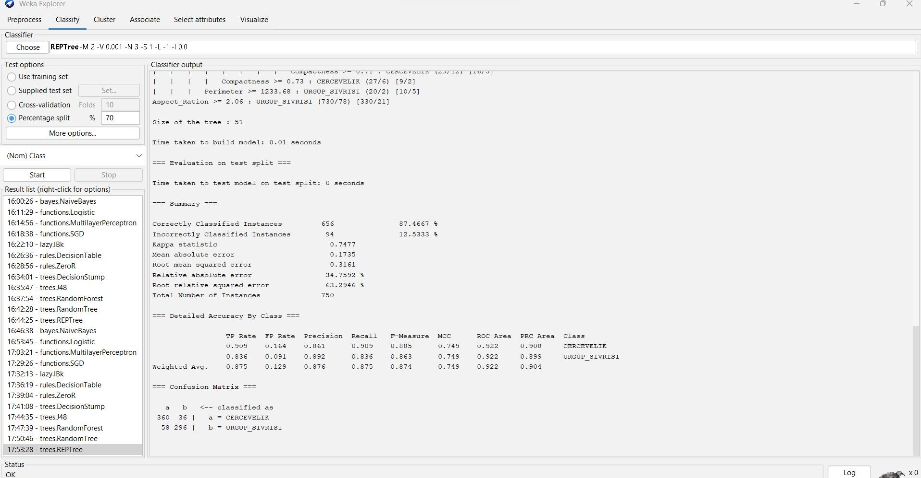

=== Run information ===

Scheme: weka.classifiers.trees.REPTree -M 2 -V 0.001 -N 3 -S 1 -L -1 -I 0.0 Relation: Pumpkin_Seeds_Dataset

Instances: 2500

Attributes: 13

Area Perimeter

Major_Axis_Length Minor_Axis_Length Convex_Area Equiv_Diameter Eccentricity Solidity

Extent Roundness Aspect_Ration Compactness Class

Test mode: split 70.0% train, remainder test

=== Classifier model (full training set) ===

REPTree

============

Aspect_Ration < 2.06

| Aspect_Ration < 1.86

| | Area < 107398.5

| | | Area < 54969.5 : URGUP_SIVRISI (2/0) [0/0]

| | | Area >= 54969.5

| | | | Extent < 0.65 : CERCEVELIK (8/3) [4/1]

| | | | Extent >= 0.65

| | | | | Major_Axis_Length < 482.18 : CERCEVELIK (521/14) [292/26]

| | | | | Major_Axis_Length >= 482.18

| | | | | | Minor_Axis_Length < 268.83 : URGUP_SIVRISI (4/1) [3/1]

| | | | | | Minor_Axis_Length >= 268.83 : CERCEVELIK (6/0) [5/0]

| | Area >= 107398.5 : URGUP_SIVRISI (5/0) [2/0]

| Aspect_Ration >= 1.86

| | Solidity < 0.99

| | | Minor_Axis_Length < 202.24 : URGUP_SIVRISI (9/1) [8/3]

| | | Minor_Axis_Length >= 202.24

|  |  |  |  |  |  |
| --- | --- | --- | --- | --- | --- |
| | | | | | | | | Roundness < 0.78 | |
| | | | | | | | | | | Minor_Axis_Length < 216.75 : CERCEVELIK (8/0) [3/1] |
| | | | | | | | | | | Minor_Axis_Length >= 216.75 |
| | | | | | | | | | | | Extent < 0.67 : URGUP_SIVRISI (6/0) [3/0] |
| | | | | | | | | | | | Extent >= 0.67 : CERCEVELIK (9/3) [3/0] |
| | | | | | | | | Roundness >= 0.78 | |

| | | | | Major_Axis_Length < 508.24 : CERCEVELIK (211/23) [107/17]

| | | | | Major_Axis_Length >= 508.24 : URGUP_SIVRISI (6/2) [2/0]

| | Solidity >= 0.99

| | | Perimeter < 1233.68

| | | | Compactness < 0.73

| | | | | Area < 59138.5 : URGUP_SIVRISI (5/0) [2/0]

| | | | | Area >= 59138.5

| | | | | | Solidity < 0.99

| | | | | | | Extent < 0.67 : CERCEVELIK (8/0) [3/1]

| | | | | | | Extent >= 0.67

| | | | | | | | Extent < 0.74 : URGUP_SIVRISI (7/1) [7/3]

| | | | | | | | Extent >= 0.74 : CERCEVELIK (9/2) [2/0]

| | | | | | Solidity >= 0.99

| | | | | | | Eccentricity < 0.85 : URGUP_SIVRISI (5/0) [3/2]

| | | | | | | Eccentricity >= 0.85

|  |  |  |  |  |  |  |  |  |
| --- | --- | --- | --- | --- | --- | --- | --- | --- |
| | | | | | | | | | | | | | | | | Compactness < 0.71 |
| | | | | | | | | | | | | | | | | | Area < 90673.5 |
| | | | | | | | | | | | | | | | | | | Solidity < 0.99 |
| | | | | | | | | | | | | | | | | | | | Solidity < 0.99 |

| | | | | | | | | | | | Extent < 0.66 : CERCEVELIK (5/2) [2/0]

| | | | | | | | | | | | Extent >= 0.66 : URGUP_SIVRISI (12/0) [8/3]

| | | | | | | | | | | Solidity >= 0.99 : CERCEVELIK (3/0) [0/0]

| | | | | | | | | | Solidity >= 0.99 : URGUP_SIVRISI (9/0) [7/0]

| | | | | | | | | Area >= 90673.5 : CERCEVELIK (2/0) [3/2]

| | | | | | | | Compactness >= 0.71 : CERCEVELIK (29/12) [16/3]

| | | | Compactness >= 0.73 : CERCEVELIK (27/6) [9/2]

| | | Perimeter >= 1233.68 : URGUP_SIVRISI (20/2) [10/5] Aspect_Ration >= 2.06 : URGUP_SIVRISI (730/78) [330/21]

Size of the tree : 51

Time taken to build model: 0.01 seconds

=== Evaluation on test split ===

Time taken to test model on test split: 0 seconds

=== Summary ===

|  |  |  |  |
| --- | --- | --- | --- |
| Correctly Classified Instances | | 656 | 87.4667 % |
| Incorrectly Classified Instances | | 94 | 12.5333 % |
| Kappa statistic | 0.7477 | | |
| Mean absolute error | 0.1735 | | |
| Root mean squared error | 0.3161 | | |
| Relative absolute error | 34.7592 % | | |
| Root relative squared error | 63.2946 % | | |
| Total Number of Instances | 750 | | |

=== Detailed Accuracy By Class ===

TP Rate FP Rate Precision Recall F-Measure MCC ROC Area PRC Area Class

|  |  |  |  |  |  |  |  |  |
| --- | --- | --- | --- | --- | --- | --- | --- | --- |
| 0.909 | 0.164 | 0.861 | 0.909 | 0.885 | 0.749 | 0.922 | 0.908 | CERCEVELIK |
| 0.836 | 0.091 | 0.892 | 0.836 | 0.863 | 0.749 | 0.922 | 0.899 | URGUP_SIVRISI |
| Weighted Avg. | 0.875 | 0.129 | 0.876 | 0.875 | 0.874 | 0.749 | 0.922 | 0.904 |

=== Confusion Matrix ===

a b <-- classified as 360 36 | a = CERCEVELIK

58 296 | b = URGUP_SIVRISI

**Cluster:**

**EM**

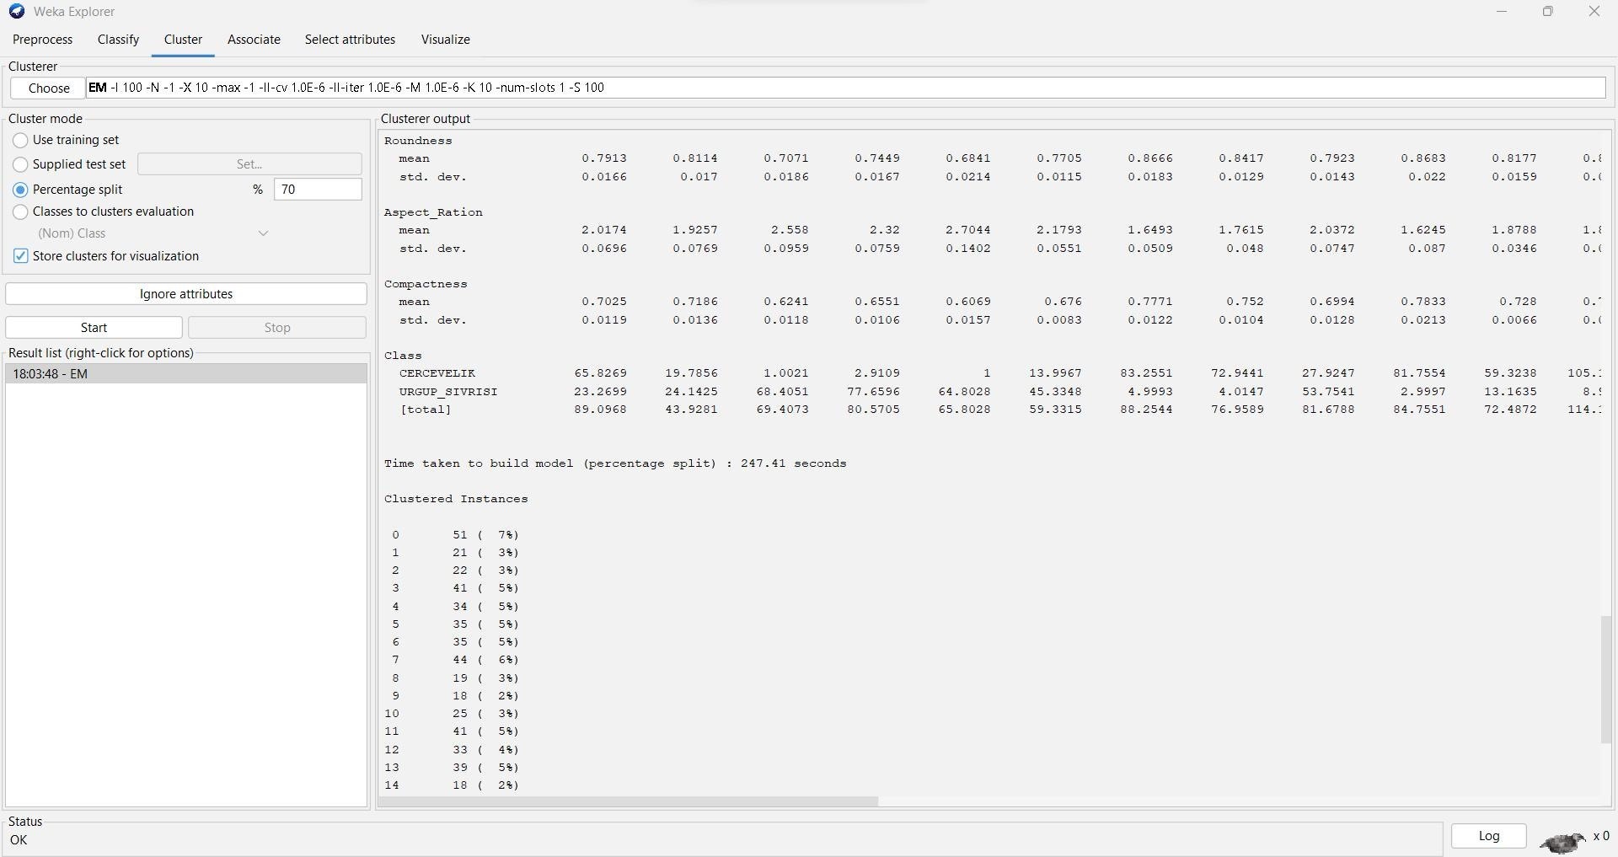

=== Run information ===

Scheme: weka.clusterers.EM -I 100 -N -1 -X 10 -max -1 -ll-cv 1.0E-6 -ll-iter 1.0E-6 -M 1.0E-6 -K 10 - num-slots 1 -S 100

Relation: Pumpkin_Seeds_Dataset Instances: 2500

Attributes: 13

Area

Perimeter Major_Axis_Length Minor_Axis_Length Convex_Area Equiv_Diameter Eccentricity Solidity

Extent Roundness Aspect_Ration Compactness Class

Test mode: split 70% train, remainder test

=== Clustering model (full training set) ===

EM

==

Number of clusters selected by cross validation: 31 Number of iterations performed: 79

Cluster

Attribute 0 1 2 3 4 5 6 7 8 9 10

11 12 13 14 15 16 17 18 19 20 21 22 23

24 25 26 27 28 29 30

(0.03) (0.03) (0.03) (0.04) (0.04) (0.03) (0.04) (0.04) (0.03)

|  |  |  |  |  |  |  |  |  |  |  |
| --- | --- | --- | --- | --- | --- | --- | --- | --- | --- | --- |
| (0.04) | (0.02) | (0.05) | (0.02) | (0.03) | (0.04) | (0.04) | (0.03) | (0.03) | (0.03) | (0.02) |
| (0.03) | (0.03) | (0.06) | (0.04) | (0.03) | (0.03) | (0.04) | (0.01) | (0.01) | (0.02) | (0.03) |

==================================================================================

==================================================================================

==================================================================================

==================================================================================

================================================================

Area

mean 62296.857 78760.8882 75440.2576 67426.7312 92694.0077 64048.1086

69146.9727 96122.2653 59479.3508 93634.6837 100711.3572 72553.9131 73357.9922

81344.4182 91234.2803 82953.6339 85914.2354 107111.1951 86334.9563 56555.4472

66498.166 81162.3582 73708.7218 102908.813 93225.0536 85408.856 74589.9352 73876.9481

121563.446 72552.5066 79388.7474

std. dev. 4060.7375 1938.6475 2285.989 1418.7554 6363.3114 1798.2429 1287.2795

|  |  |  |  |
| --- | --- | --- | --- |
| 3045.9964 | 2949.629 2427.3529 6256.3823 1976.0359 1609.6045 | 1940.4784 | 2264.422 |
| 2928.2002 | 1462.7395 3302.9052 1505.336 4137.0567 1868.2728 | 1664.8036 | 2045.8955 |
| 3941.5922 | 3279.2501 2161.8573 2899.1439 8760.1409 6475.007 | 3105.9231 | 1669.7489 |

Perimeter

|  |  |  |  |  |  |  |  |  |  |
| --- | --- | --- | --- | --- | --- | --- | --- | --- | --- |
| mean | 946.4693 1114.9484 1045.015 1019.3993 1155.5759 978.5263 1009.1851 | | | | | | | | |
| 1260.0498 | 966.2728 1191.1821 1359.0976 1067.6013 1093.6902 1119.1502 1207.2225 | | | | | | | | |
| 1222.2108 | 1162.9851 1337.3619 | | 1138.6901 | 988.9707 1050.6762 | | 1101.6554 | | 1053.9509 | |
| 1262.0986 | 1273.7599 1195.5313 | | 1129.4598 | 1112.8429 1434.331 | | 1154.7417 | | 1139.3513 | |
| std. dev. | 30.1997 | 16.542 | 19.1927 | 12.5175 | 43.6617 | 16.0712 | 10.8929 | | 23.0156 |

|  |  |  |  |  |  |  |  |  |
| --- | --- | --- | --- | --- | --- | --- | --- | --- |
| 26.7402 | 18.3851 | 41.2183 | 15.5668 | 15.9893 | 17.1484 | 13.9685 | 27.5196 | 12.1418 |
| 23.7826 | 14.7197 | 45.7666 | 19.2136 | 12.7399 | 16.4064 | 25.2989 | 24.7457 | 17.6131 |
| 24.3771 | 82.7808 | 45.2695 | 27.8316 | 14.9066 |  |  |  |  |

Major_Axis_Length

mean 356.6202 450.9442 396.5144 406.0206 435.5227 381.9083 390.2123

|  |  |  |  |  |
| --- | --- | --- | --- | --- |
| 523.3966 389.8014 | | 466.1175 588.1109 | 427.6148 449.8053 443.4382 489.1021 | |
| 526.859 469.4565 | | 557.793 442.2042 | 417.52 438.0725 426.8789 413.2726 500.8085 | |
| 541.0318 | 499.1799 | 477.1453 401.6282 | 601.1441 | 500.55 470.8304 |

std. dev. 11.5167 6.777 7.8535 6.6166 19.263 7.2906 7.0408 10.8179

13.4033 8.2482 20.1725 6.6539 8.152 6.645 9.3335 15.7245 7.933 13.8624

8.497 22.7032 11.9576 6.8682 7.2076 15.3899 10.8396 9.4541 11.7242

40.6516 28.5548 15.4752 6.9038

Minor_Axis_Length

mean 223.5621 223.3908 243.3466 212.5337 271.9668 214.7044 226.8334

234.8491 195.4708 257.1073 219.2253 217.2581 208.8063 234.5668 238.7498

|  |  |  |  |  |  |  |  |  |  |
| --- | --- | --- | --- | --- | --- | --- | --- | --- | --- |
| 201.5829 | 234.1855 245.697 249.9208 173.4905 | | | | | 194.336 243.3048 228.2066 263.0419 | | | |
| 220.5154 | 218.9216 199.9864 237.9599 259.0026 | | | | | 186.0291 215.6548 | | | |
| std. dev. |  | 10.5117 | 3.7546 | 5.996 | 4.0897 | 10.7819 | 4.4114 | 4.2698 | 5.4163 |
| 6.8282 | 5.6245 | 9.7839 | 4.5429 | 3.9684 | 3.3582 | 6.1046 | 6.6867 | 4.9731 | 7.5885 |
| 4.5965 | 9.1913 | 6.1866 | 4.3829 | 4.4784 | 9.6656 | 5.1598 | 4.5376 | 4.3985 | 21.9806 |

15.9509 6.1681 3.677

Convex_Area

mean 62976.2424 79581.9379 76175.9785 68153.8082 93602.9381 64748.1868

69831.076 97038.2979 60145.0103 94669.7697 101777.8882 73392.4848 74132.5809 82189.79

92202.0929 83811.3591 86765.0112 108092.8428 87255.5627 57209.0611 67195.1871

82043.0612 74484.8607 103926.2823 94170.4967 86263.2585 75343.5912 75426.2302

122625.9859 73492.7659 80188.5522

std. dev. 4067.1826 1968.8715 2333.5116 1425.8696 6430.5059 1814.7778 1279.6787

|  |  |  |
| --- | --- | --- |
| 3087.4855 | 2982.7856 | 2450.4675 6308.5614 1977.8457 1588.9833 1955.0488 2243.2373 |
| 2919.0508 | 1496.4642 | 3314.2731 1534.8464 4168.6443 1878.3262 1657.7937 2054.7334 |
| 3949.4458 | 3283.5967 | 2169.988 2915.0372 8710.5729 6579.9899 3013.9259 1692.2934 |

Equiv_Diameter

mean 281.4853 316.6485 309.8895 292.9861 343.3417 285.5388 296.7036

349.794 275.1081 345.2526 357.9183 303.9101 305.5994 321.8014 340.8009 324.9415

|  |  |  |  |  |  |  |  |  |
| --- | --- | --- | --- | --- | --- | --- | --- | --- |
| 330.7287 | 369.2501 331.5369 268.1613 | | | 290.9491 | 321.4471 | 306.3182 361.9116 | | |
| 344.4724 | 329.7401 308.1154 306.1609 | | | 393.2829 | 303.865 | 317.9147 | | |
| std. dev. | 9.2114 | 3.8965 | 4.6949 | 3.0843 | 11.7548 | 4.025 | 2.7607 5.5543 | |
| 6.8541 | 4.474 11.1429 4.1403 | | 3.3591 3.8421 4.222 | | | 5.7306 | 2.8164 | 5.705 |
| 2.8875 | 9.9071 4.091 3.3015 | | 4.247 6.8956 6.0503 | | | 4.1747 | 5.98 | 18.1256 |

10.3913 6.5402 3.3417

Eccentricity

|  |  |  |  |  |  |  |  |  |  |
| --- | --- | --- | --- | --- | --- | --- | --- | --- | --- |
| mean |  | 0.7778 | 0.8685 | 0.7889 | 0.8518 | 0.7793 | 0.8267 | 0.8132 | 0.8935 |
| 0.8644 | 0.8338 | 0.9276 | 0.8611 | 0.8855 | 0.8485 | 0.8724 | 0.9235 | 0.8663 | 0.8973 |
| 0.8244 | 0.9083 | 0.8956 | 0.8213 | 0.8335 | 0.8498 | 0.913 0.8985 0.9078 0.7907 | | | |
| 0.9003 | 0.928 | 0.8888 |  |  |  |  | | | |
| std. dev. |  | 0.0248 | 0.0057 | 0.0159 0.0091 0.0265 0.0106 0.0134 0.0068 | | | | | |
| 0.0143 | 0.0108 | 0.0073 | 0.0075 | 0.0072 0.0054 0.0104 0.0081 0.0098 0.0102 | | | | | |
| 0.0131 | 0.0142 | 0.0115 | 0.0111 | 0.009 | 0.0185 | 0.0048 | 0.0066 | 0.0051 | 0.0795 |
| 0.0218 | 0.0071 | 0.0055 |  |  |  |  |  |  |  |

Solidity

|  |  |  |  |  |  |  |  |  |  |
| --- | --- | --- | --- | --- | --- | --- | --- | --- | --- |
| mean |  | 0.9892 | 0.9897 | 0.9904 | 0.9893 | 0.9903 | 0.9892 | 0.9902 | 0.9906 |
| 0.9889 | 0.9891 | 0.9895 | 0.9886 | 0.9895 | 0.9897 | 0.9895 | 0.9897 | 0.9902 | 0.9909 |
| 0.9895 | 0.9886 | 0.9896 | 0.9893 | 0.9896 | 0.9902 | 0.99 | 0.9901 | 0.99 | 0.9791 |
| 0.9914 | 0.9872 | 0.99 |  |  |  |  |  |  |  |
| std. dev. |  | 0.0033 | 0.0026 | 0.0022 | 0.0023 | 0.0022 | 0.0023 | 0.0019 | 0.0024 |
| 0.0031 | 0.0032 | 0.0027 | 0.0024 | 0.0027 | 0.0024 | 0.0027 0.0024 0.0019 0.002 | | | |
| 0.0029 | 0.0042 | 0.0021 | 0.003 | 0.0025 | 0.0028 | 0.003 0.0029 0.0021 0.009 | | | |
| 0.0018 | 0.0103 | 0.002 |  |  |  |  | | | |

|  |  |  |  |  |  |  |  |  |  |
| --- | --- | --- | --- | --- | --- | --- | --- | --- | --- |
| Extent |  | | | | | | | | |
| mean |  | 0.7249 | 0.6972 | 0.7287 | 0.6935 | 0.7319 | 0.7091 | 0.7181 | 0.6886 |
| 0.6958 | 0.7125 | 0.6583 | 0.6848 | 0.6917 | 0.7045 | 0.6899 | 0.6691 | 0.7076 | 0.6737 |
| 0.7104 | 0.6647 | 0.6772 | 0.7177 | 0.7043 | 0.7001 | 0.6789 | 0.6712 | 0.6564 | 0.7037 |
| 0.6604 | 0.6473 | 0.6799 |  |  |  |  |  |  |  |
| std. dev. |  | 0.0244 | 0.0481 | 0.0197 | 0.0434 | 0.0172 | 0.0345 | 0.0282 | 0.0656 |
| 0.0528 | 0.0313 | 0.0974 | 0.0475 | 0.0621 | 0.0397 | 0.0567 0.0984 0.0394 | | | 0.0755 |
| 0.0318 | 0.0759 | 0.0724 | 0.0274 | 0.035 | 0.0443 | 0.0779 | 0.0718 | 0.0828 | 0.05 |
| 0.0754 | 0.0843 | 0.0643 |  |  |  |  |  |  |  |

Roundness

|  |  |  |  |  |  |  |  |  |  |
| --- | --- | --- | --- | --- | --- | --- | --- | --- | --- |
| mean |  | 0.8732 | 0.7962 | 0.8682 | 0.8154 | 0.8717 | 0.8406 | 0.8533 | 0.7608 |
| 0.8004 | 0.8293 | 0.6848 | 0.8 | 0.7708 | 0.8162 | 0.7867 | 0.6982 | 0.7983 | 0.7527 |
| 0.8369 | 0.7274 | 0.7572 | 0.8405 | 0.8339 | 0.8119 | 0.722 | 0.751 | 0.7347 | 0.753 |
| 0.7432 | 0.6839 | 0.7686 |  |  |  |  |  |  |  |
| std. dev. |  | 0.0234 | 0.0129 | 0.0185 | 0.0149 | 0.0203 | 0.0149 | 0.0144 | 0.0149 |
| 0.0194 | 0.0153 | 0.0205 | 0.0153 | 0.0166 | 0.0151 | 0.0169 | 0.0233 | 0.0139 | 0.0195 |
| 0.0174 | 0.0407 | 0.0211 | 0.0149 | 0.0156 | 0.0232 | 0.0152 | 0.0131 | 0.0124 | 0.0843 |
| 0.0376 | 0.0233 | 0.0138 |  |  |  |  |  |  |  |

Aspect_Ration

|  |  |  |  |  |  |  |  |  |  |
| --- | --- | --- | --- | --- | --- | --- | --- | --- | --- |
| mean |  | 1.5979 | 2.0191 | 1.6305 | 1.9113 | 1.6029 1.7795 1.7212 2.2298 | | | |
| 1.9965 | 1.8139 | 2.6873 | 1.969 | 2.1552 | 1.8907 | 2.0504 2.6176 2.006 2.2731 | | | |
| 1.7703 | 2.4142 | 2.2576 | 1.7552 | 1.8116 | 1.9072 | 2.4545 | 2.2813 | 2.3866 | 1.7058 |
| 2.333 | 2.6942 | 2.1839 |  |  |  |  |  |  |  |
| std. dev. |  | 0.0768 | 0.041 0.0528 0.0553 0.0747 0.0493 0.0555 0.0664 | | | | | | |
| 0.0956 | 0.0535 | 0.1388 | 0.0494 0.0647 0.0314 0.0776 0.1412 0.0692 0.1053 | | | | | | |
| 0.0587 | 0.1987 | 0.118 | 0.0483 | 0.0446 | 0.1058 | 0.0649 | 0.0705 | 0.0623 | 0.2573 |
| 0.2151 | 0.1333 | 0.0515 |  |  |  |  |  |  |  |

Compactness

|  |  |  |  |  |  |  |  |  |  |  |
| --- | --- | --- | --- | --- | --- | --- | --- | --- | --- | --- |
| mean |  | | 0.7895 | 0.7023 | 0.7817 | 0.7217 | 0.7889 | 0.7478 | 0.7606 | 0.6684 |
| 0.7062 | 0.7408 | | 0.6088 | 0.7108 | 0.6795 | 0.7257 | 0.697 | 0.6171 | 0.7047 | 0.6623 |
| 0.75 | 0.6433 | | 0.6646 | 0.7531 | 0.7413 | 0.7231 | 0.6368 | 0.6607 | 0.6459 | 0.767 |
| 0.6555 | 0.6074 | | 0.6753 |  |  |  |  |  |  |  |
| std. dev. | |  | 0.0192 | 0.0071 | 0.0128 | 0.0103 | 0.0193 | 0.0103 | 0.012 | 0.0099 |
| 0.0164 | | 0.0108 | 0.0152 | 0.0087 | 0.0099 | 0.006 | 0.013 | 0.0163 | 0.0121 | 0.0155 |
| 0.0126 | | 0.0253 | 0.0172 | 0.0105 | 0.0092 | 0.0201 | 0.0084 | 0.0102 | 0.0083 | 0.0581 |
| 0.0318 | | 0.0159 | 0.0078 |  |  |  |  |  |  |  |

Class

|  |  |  |  |  |  |  |  |  |  |  |  |
| --- | --- | --- | --- | --- | --- | --- | --- | --- | --- | --- | --- |
| CERCEVELIK | | 76.7627 | 49.6512 | | 70.5567 | 80.8204 | 96.397 64.1842 | | | 89.1556 | |
| 5.0522 20.1322 | | 79.206 | 2.0001 | | 108.3514 | 22.57 | 68.4574 46.3469 | | | 1 36.2447 | |
| 2.096 | 84.0597 | 1.9996 | 8.413 64.4931 130.3004 | | | | 54.62 | 3.711 | 10.3376 | | 3.9855 |
| 28.1117 | 1 | 1.0016 | 19.9821 | | | |  |  |  | |  |
| URGUP_SIVRISI | | 5.9877 | | 36.9592 | 5.9227 | 17.2405 | 2.9787 | 4.0123 | | 3.0432 | |
| 98.1341 | 54.7585 | 14.1522 | | 58.183 | 23.4099 | 41.686 | 13.5152 | 43.854 | | 93.3147 | |
| 30.1252 | 64.6657 | 4.6588 | | 60.3051 | 80.823 | 2.9461 | 11.9019 | 47.5429 | | 64.5604 | |
| 78.887 | 102.368 | 10.07 | | 32.3408 | 61.5099 | 61.1432 |  |  | |  | |

[total] 82.7504 86.6104 76.4795 98.0608 99.3757 68.1965 92.1988

|  |  |  |  |  |  |  |  |  |
| --- | --- | --- | --- | --- | --- | --- | --- | --- |
| 103.1863 | 74.8907 | 93.3582 | 60.1831 | 131.7613 | 64.256 | 81.9726 | 90.2009 | 94.3147 |
| 66.3699 | 66.7617 | 88.7185 | 62.3046 | 89.2359 | 67.4392 | 142.2023 | 102.1629 | 68.2714 |
| 89.2247 | 106.3534 | 38.1817 | 33.3408 | 62.5116 | 81.1253 |  |  |  |

Time taken to build model (full training data) : 593.63 seconds

=== Model and evaluation on test split ===

EM

==

Number of clusters selected by cross validation: 25 Number of iterations performed: 100

Cluster

Attribute 0 1 2 3 4 5 6 7 8 9 10

11 12 13 14 15 16 17 18 19 20 21 22 23

24

(0.05) (0.02) (0.04) (0.04) (0.04) (0.03) (0.05) (0.04) (0.05)

|  |  |  |  |  |  |  |  |  |  |  |
| --- | --- | --- | --- | --- | --- | --- | --- | --- | --- | --- |
| (0.05) | (0.04) | (0.06) | (0.05) | (0.05) | (0.03) | (0.02) | (0.04) | (0.04) | (0.04) | (0.03) |
| (0.04) | (0.04) | (0.02) | (0.05) | (0.03) |  |  |  |  |  |  |

==================================================================================

==================================================================================

==================================================================================

==========================================================================

Area

mean 73545.5826 59394.141 87928.8612 70631.0542 75563.5794 79981.4062

73471.7703 84367.3881 100523.6993 62724.6492 81519.7612 73855.842 88559.0414

109441.6878 79034.0618 73492.267 87874.0255 91736.7945 68252.9729 64114.9066

67038.9921 79548.4217 55306.4964 97729.3376 97210.7358

|  |  |
| --- | --- |
| std. dev. | 1675.3842 2772.941 3417.2629 3060.5597 5009.2738 2121.1104 3248.0515 |
| 2866.5176 | 4780.7484 3585.4112 2057.8804 2157.0003 2681.3527 8012.6416 1618.1468 |
| 8651.1043 | 2552.7143 6085.4665 1908.1869 2955.8249 1816.3392 2863.9603 3973.8415 |

5554.952 2642.1039

Perimeter

|  |  |  |  |  |  |  |  |
| --- | --- | --- | --- | --- | --- | --- | --- |
| mean | 1080.8033 959.0194 1250.0911 1091.4841 1178.1307 1142.1093 1032.0471 | | | | | | |
| 1122.2606 | 1262.4579 952.5359 1119.3435 1055.2278 1209.1512 1374.7919 1117.0013 | | | | | | |
| 1129.9801 | 1174.4014 1148.4802 1030.2335 1019.6283 1002.4651 1168.4142 980.9292 | | | | | | |
| 1217.3657 | 1278.0559 | | | | | | |
| std. dev. | 14.8921 | 25.6018 | 28.5017 | 24.3829 | 48.4777 | 16.7466 | 23.1579 |

|  |  |  |  |  |  |  |  |
| --- | --- | --- | --- | --- | --- | --- | --- |
| 20.3873 | 31.2325 26.4296 | 18.198 | 16.9869 | 18.4076 | 44.2777 | 13.2982 | 80.506 |
| 20.3303 | 41.1196 16.0941 | 24.5396 | 13.92 | 21.11 | 50.6124 | 35.4945 | 18.9892 |

Major_Axis_Length

mean 435.6779 382.7351 536.1668 457.7218 511.2845 472.1107 393.5273

|  |  |  |  |
| --- | --- | --- | --- |
| 435.8626 | 511.5708 360.7989 442.5237 413.7595 500.1694 | 581.6881 | 452.2396 |
| 420.4979 | 472.0417 433.1109 410.9806 419.7082 393.5814 | 494.1837 | 413.8214 |
| 475.0434 | 534.2293 |  |  |

std. dev. 8.4605 11.4005 14.1803 10.2677 24.7439 8.255 8.4994 10.512

15.178 11.3737 6.9572 6.9529 10.7114 22.9411 5.8655 53.7165 8.7932

19.1243 6.699 10.6004 6.9034 10.4319 25.0828 14.3948 10.9244

Minor_Axis_Length

|  |  |  |  |  |  |  |  |  |  |  |
| --- | --- | --- | --- | --- | --- | --- | --- | --- | --- | --- |
| mean | 216.1021 198.9217 209.7608 197.4468 189.1954 216.7075 238.7822 | | | | | | | | | |
| 247.5004 | 251.2895 222.5395 235.5741 | | | | 228.3945 | 226.5118 | 240.8189 223.4685 | | | |
| 228.1286 | 238.2252 270.7145 212.7294 | | | | 195.4585 | 217.8244 | 205.9622 171.1911 | | | |
| 263.3178 | 232.73 | | | |  |  |  | | | |
| std. dev. | 4.7237 | | 6.3977 | 5.8063 | 6.1693 | 6.3782 | 4.1434 | 7.5242 | | 4.7008 |
| 7.5624 10.2059 | | 3.7601 | 4.8211 | 5.7936 16.2707 3.6513 23.9697 | | | | | 5.3681 | |
| 10.9861 4.0734 | | 6.3121 | 4.6205 | 5.0198 8.509 8.5611 5.4097 | | | | |  | |

Convex_Area

mean 74355.5677 60080.1993 88794.3105 71369.8102 76396.8323 80764.0446

74182.9821 85207.4172 101504.191 63404.1609 82348.2489 74643.7183 89466.8634

110488.3598 79861.2349 75382.6547 88769.7608 92624.1636 69024.022 64801.451

67708.3517 80359.2678 55965.9812 98795.4566 98151.7149

|  |  |  |  |
| --- | --- | --- | --- |
| std. dev. | 1677.8175 | 2828.1 3455.4182 3081.7693 5053.0423 2130.1487 3285.969 | |
| 2875.7198 | 4817.0054 3598.501 2100.4258 2174.0746 2669.7327 8041.4223 | | 1623.452 |
| 8490.5404 | 2626.7403 6133.2531 1945.5823 2972.5493 1822.6646 2873.1605 | | 4017.0812 |
| 5523.4108 | 2628.4241 | |  |

Equiv_Diameter

|  |  |  |  |  |  |  |  |  |  |  |  |  |
| --- | --- | --- | --- | --- | --- | --- | --- | --- | --- | --- | --- | --- |
| mean | 305.9885 274.9206 | | | 334.533 299.8127 310.0088 319.0887 | | | | | | | 305.7802 | |
| 327.7023 | 357.6575 282.4852 322.1454 | | | | 306.6206 | | 335.7545 373.0459 317.2046 | | | | | |
| 305.3698 | 334.4565 341.5775 294.7632 | | | | 285.6395 | | 292.1318 318.2003 265.1923 | | | | | |
| 352.6104 | 351.7808 | | | |  | |  | | | | | |
| std. dev. | 3.4921 | | 6.4512 | 6.4964 | 6.5262 | | 10.25 | 4.2321 | 6.7571 | | 5.5755 | |
| 8.4761 | 8.0996 | 4.0663 | 4.4704 | 5.0771 | | 13.5004 | 3.247 | 17.9594 | | 4.8517 | | 11.3021 |
| 4.1276 | 6.6093 | 3.9622 | 5.7248 | 9.5624 | | 9.9395 | 4.7736 |  | |  | |  |

Eccentricity

|  |  |  |  |  |  |  |  |  |  |  |  |  |
| --- | --- | --- | --- | --- | --- | --- | --- | --- | --- | --- | --- | --- |
| mean | 0.8679 | | 0.8537 | 0.92 | 0.902 | 0.9285 | | 0.8883 | | 0.7944 0.8227 | | |
| 0.8706 | 0.7855 | 0.8464 | 0.8336 | 0.8913 | 0.9091 0.8693 | | | | 0.8197 | | 0.863 | 0.7785 |
| 0.8555 | 0.8847 | 0.8326 | 0.9089 | 0.9089 | 0.832 0.8998 | | | |  | |  |  |
| std. dev. |  | 0.0097 | 0.0128 | 0.0062 | 0.0067 | | 0.0072 | | 0.006 | 0.0148 | | 0.0109 |
| 0.0102 | 0.0272 | 0.0062 | 0.0089 | 0.0083 | 0.0161 | | 0.006 | | 0.0874 | 0.0086 | | 0.0286 |
| 0.0067 | 0.0085 | 0.0103 | 0.0054 | 0.0151 | 0.0103 | | 0.0073 | |  |  | |  |

Solidity

|  |  |  |  |  |  |  |  |  |  |
| --- | --- | --- | --- | --- | --- | --- | --- | --- | --- |
| mean |  | 0.9891 | 0.9886 | 0.9903 | 0.9897 | 0.9891 | 0.9903 | 0.9904 | 0.9901 |
| 0.9903 | 0.9893 | 0.9899 | 0.9894 | 0.9898 | 0.9905 | 0.9896 | 0.9744 | 0.9899 | 0.9904 |
| 0.9888 | 0.9894 | 0.9901 | 0.9899 | 0.9882 | 0.9892 | 0.9904 |  |  |  |
| std. dev. |  | 0.0022 | 0.0032 | 0.0022 | 0.0023 | 0.0026 0.0019 | | 0.0021 | 0.0016 |
| 0.0026 | 0.003 | 0.0025 | 0.0024 | 0.0027 | 0.0022 | 0.0026 0.0137 | | 0.0022 | 0.0025 |
| 0.0026 | 0.0026 | 0.0017 | 0.0024 | 0.0049 | 0.0034 | 0.0023 | |  |  |

|  |  |  |  |  |  |  |  |  |  |
| --- | --- | --- | --- | --- | --- | --- | --- | --- | --- |
| Extent |  | | | | | | | | |
| mean |  | 0.6889 | 0.6985 | 0.6676 | 0.6764 | 0.6616 | 0.6914 | 0.7258 | 0.7147 |
| 0.693 | 0.7229 | 0.703 | 0.7055 | 0.689 | 0.6587 | 0.6954 | 0.6741 | 0.7044 | 0.7323 |
| 0.6839 | 0.6893 | 0.7099 | 0.6654 | 0.6628 | 0.7139 | 0.6804 |  |  |  |
| std. dev. | | 0.0538 | 0.046 0.0881 0.0697 0.0882 0.0598 | | | | | 0.0227 | 0.0279 |
| 0.054 0.0262 | | 0.0405 | 0.0342 0.0631 0.0811 0.0468 0.0749 | | | | | 0.0423 | 0.0179 |
| 0.0444 0.0677 | | 0.035 | 0.0827 0.0736 0.0303 0.0681 | | | | |  |  |

Roundness

|  |  |  |  |  |  |  |  |  |  |
| --- | --- | --- | --- | --- | --- | --- | --- | --- | --- |
| mean |  | 0.7913 | 0.8114 | 0.7071 | 0.7449 | 0.6841 | 0.7705 | 0.8666 | 0.8417 |
| 0.7923 | 0.8683 | 0.8177 | 0.8335 | 0.7612 | 0.7273 | 0.796 | 0.7249 | 0.8007 | 0.8735 |
| 0.8081 | 0.7748 | 0.8383 | 0.7321 | 0.7239 | 0.8283 | 0.7479 |  |  |  |
| std. dev. |  | 0.0166 | 0.017 | 0.0186 | 0.0167 | 0.0214 | 0.0115 | 0.0183 | 0.0129 |
| 0.0143 | 0.022 | 0.0159 | 0.0161 | 0.0165 | 0.0347 | 0.0124 | 0.0657 | 0.0138 | 0.0207 |
| 0.0136 | 0.0194 | 0.0129 | 0.0111 | 0.046 | 0.0185 | 0.0142 |  |  |  |

Aspect_Ration

|  |  |  |  |  |  |  |  |  |  |  |  |  |  |
| --- | --- | --- | --- | --- | --- | --- | --- | --- | --- | --- | --- | --- | --- |
| mean | 2.0174 | | 1.9257 | 2.558 | 2.32 | 2.7044 | | 2.1793 | | 1.6493 | | 1.7615 | |
| 2.0372 | 1.6245 | 1.8788 | 1.8123 | 2.2098 | 2.4276 | | 2.0243 | | 1.8772 | | 1.9825 | | 1.6017 |
| 1.9325 | 2.1491 | 1.8077 | 2.4005 | 2.4248 | 1.8049 | | 2.297 | |  | |  | |  |
| std. dev. | 0.0696 | | 0.0769 | 0.0959 | 0.0759 | 0.1402 | | 0.0551 0.0509 | | | | 0.048 | |
| 0.0747 | 0.087 | 0.0346 | 0.0439 | 0.0807 | 0.2027 | 0.0431 | | 0.3914 | | 0.0581 | | 0.0816 | |
| 0.0412 | 0.0761 | 0.05 | 0.0675 | 0.2135 | 0.05 | 0.0796 | |  | |  | |  | |

Compactness

|  |  |  |  |  |  |  |  |  |  |
| --- | --- | --- | --- | --- | --- | --- | --- | --- | --- |
| mean |  | 0.7025 | 0.7186 | 0.6241 | 0.6551 | 0.6069 | 0.676 | 0.7771 | 0.752 |
| 0.6994 | 0.7833 | 0.728 | 0.7411 | 0.6715 | 0.642 | 0.7015 | 0.7347 | 0.7087 | 0.7893 |
| 0.7173 | 0.6807 | 0.7424 | 0.644 | 0.6422 | 0.7424 | 0.6587 |  |  |  |
| std. dev. |  | 0.0119 | 0.0136 | 0.0118 | 0.0106 | 0.0157 | 0.0083 | 0.0122 | 0.0104 |
| 0.0128 | 0.0213 | 0.0066 | 0.0089 | 0.012 | 0.027 | 0.0075 | 0.0745 | 0.0103 | 0.021 |
| 0.0077 | 0.0119 | 0.0101 | 0.009 | 0.0269 | 0.0103 | 0.0114 |  |  |  |

Class

|  |  |  |  |  |  |  |  |  |  |  |  |
| --- | --- | --- | --- | --- | --- | --- | --- | --- | --- | --- | --- |
| CERCEVELIK | | 65.8269 | 19.7856 | 1.0021 | 2.9109 | 1 | 13.9967 | | 83.2551 | | 72.9441 |
| 27.9247 | 81.7554 | 59.3238 | 105.1488 | 13.0424 | 1.026 | 32.9643 | | 20.0164 46.0425 | | | |
| 67.2602 | 52.4492 | 11.1345 | 70.8502 | 2.0476 | 1.0223 | 73.2297 | | 3.0407 | | | |
| URGUP_SIVRISI | | 23.2699 | 24.1425 | 68.4051 | 77.6596 | 64.8028 | | 45.3348 | | 4.9993 | |

|  |  |  |
| --- | --- | --- |
| 4.0147 | 53.7541 | 2.9997 13.1635 8.9996 76.2046 90.6803 25.4569 12.0067 |
| 24.842 | 3.0001 | 13.405 46.9809 5.5985 62.3838 39.1281 20.9935 58.774 |

[total] 89.0968 43.9281 69.4073 80.5705 65.8028 59.3315 88.2544 76.9589

|  |  |  |  |  |  |  |  |  |
| --- | --- | --- | --- | --- | --- | --- | --- | --- |
| 81.6788 | 84.7551 | 72.4872 | 114.1484 | 89.247 | 91.7063 | 58.4212 | 32.0231 | 70.8845 |
| 70.2604 | 65.8542 | 58.1154 | 76.4487 | 64.4314 | 40.1503 | 94.2232 | 61.8147 |  |

Time taken to build model (percentage split) : 247.41 seconds

Clustered Instances

0 51 ( 7%)

1 21 ( 3%)

2 22 ( 3%)

3 41 ( 5%)

4 34 ( 5%)

5 35 ( 5%)

6 35 ( 5%)

7 44 ( 6%)

8 19 ( 3%)

9 18 ( 2%)

10 25 ( 3%)

11 41 ( 5%)

12 33 ( 4%)

13 39 ( 5%)

14 18 ( 2%)

15 14 ( 2%)

16 29 ( 4%)

17 35 ( 5%)

18 26 ( 3%)

19 15 ( 2%)

20 36 ( 5%)

21 22 ( 3%)

22 18 ( 2%)

23 42 ( 6%)

24 37 ( 5%)

Log likelihood: -21.84799 **SimpleKMeans :**

To classify the data set, using the simpleKMeans Cluster Go to Cluster Tab

Under Cluster go to Choose >Cluster>SimpleKMeans Test Options

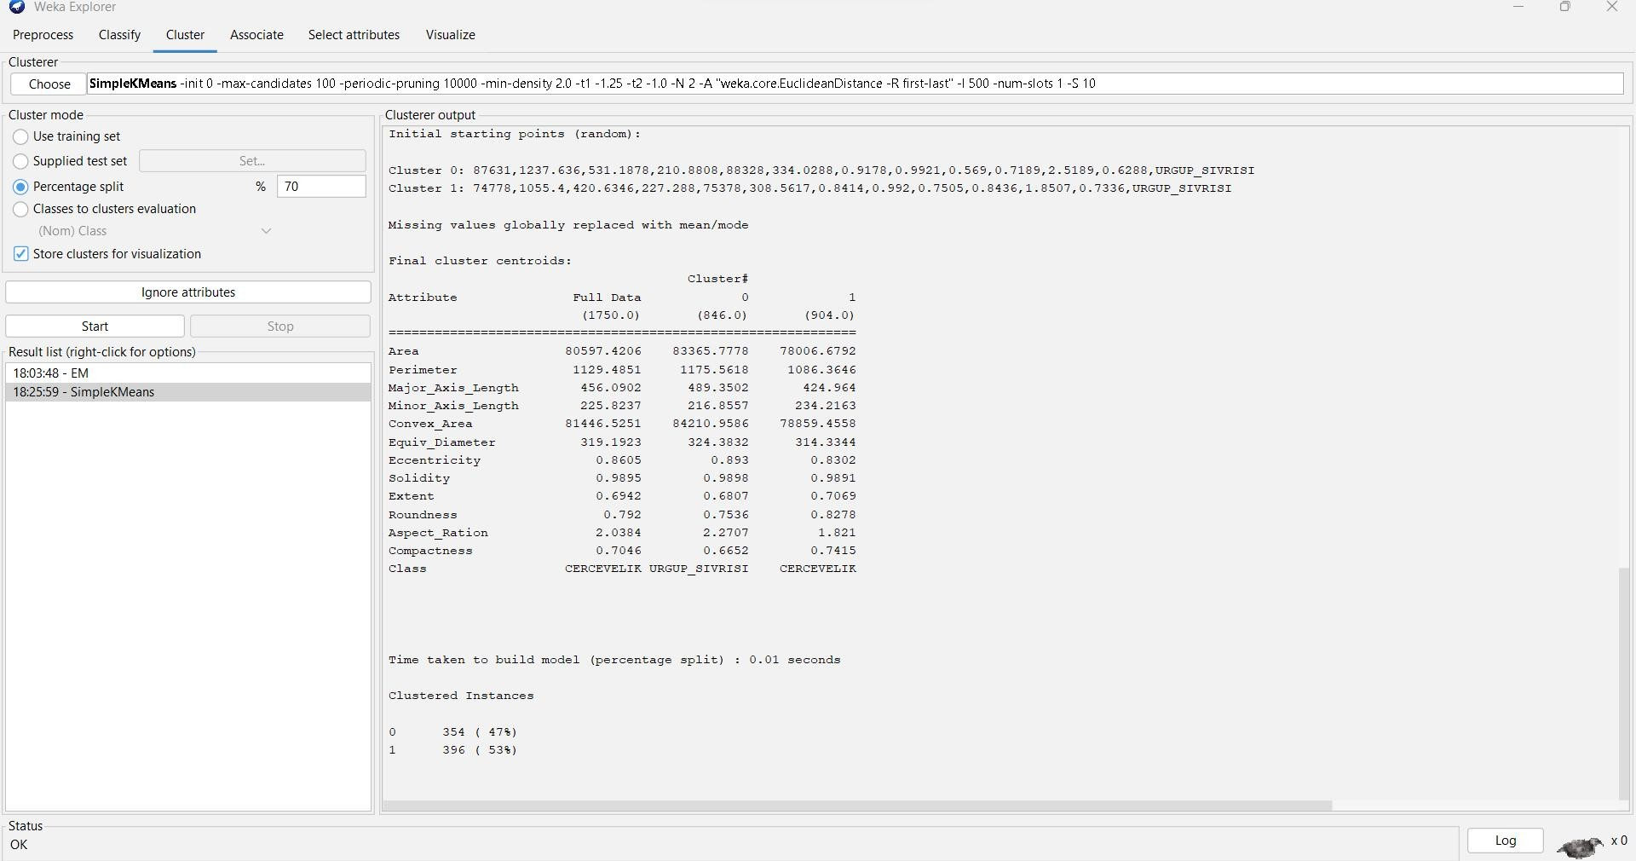

=== Run information ===

Scheme: weka.clusterers.SimpleKMeans -init 0 -max-candidates 100 -periodic-pruning 10000 -

min-density 2.0 -t1 -1.25 -t2 -1.0 -N 2 -A "weka.core.EuclideanDistance -R first-last" -I 500 -num-slots

1 -S 10

Relation: Pumpkin_Seeds_Dataset Instances: 2500

Attributes: 13

Area Perimeter

Major_Axis_Length Minor_Axis_Length Convex_Area Equiv_Diameter Eccentricity Solidity

Extent Roundness Aspect_Ration Compactness Class

Test mode: split 70% train, remainder test

=== Clustering model (full training set) ===

kMeans

======

Number of iterations: 3

Within cluster sum of squared errors: 495.0668917079272

Initial starting points (random):

Cluster 0: 67675,1055.24,437.4783,197.9687,68422,293.5413,0.8918,0.9891,0.5709,0.7637,2.2098,0.671,URG UP_SIVRISI

Cluster 1: 91739,1153.294,436.7575,268.4789,92863,341.7685,0.7888,0.9879,0.7342,0.8667,1.6268,0.7825,CE RCEVELIK

Missing values globally replaced with mean/mode

Final cluster centroids:

Cluster#

Attribute Full Data 0 1

(2500.0) (1200.0) (1300.0)

============================================================= Area 80658.2208 83079.5425 78423.1546

Perimeter 1130.279 1174.4319 1089.5225

|  |  |  |  |
| --- | --- | --- | --- |
| Major_Axis_Length | 456.6018 | 489.4585 | 426.2726 |
| Minor_Axis_Length | 225.7949 | 216.0644 | 234.7769 |
| Convex_Area | 81508.0844 | 83914.8133 | 79286.4885 |
| Equiv_Diameter | 319.3342 | 323.8202 | 315.1933 |

|  |  |  |  |
| --- | --- | --- | --- |
| Eccentricity | 0.8609 | 0.8937 | 0.8305 |
| Solidity | 0.9895 | 0.9899 | 0.9891 |
| Extent | 0.6932 | 0.6782 | 0.707 |
| Roundness | 0.7915 | 0.7526 | 0.8275 |
| Aspect_Ration | 2.0417 | 2.2791 | 1.8226 |
| Compactness | 0.7041 | 0.664 | 0.7412 |

Class CERCEVELIK URGUP_SIVRISI CERCEVELIK

Time taken to build model (full training data) : 0.02 seconds

=== Model and evaluation on test split ===

kMeans

======

Number of iterations: 3

Within cluster sum of squared errors: 383.2112635867874

Initial starting points (random):

Cluster 0: 87631,1237.636,531.1878,210.8808,88328,334.0288,0.9178,0.9921,0.569,0.7189,2.5189,0.6288,UR GUP_SIVRISI

Cluster 1: 74778,1055.4,420.6346,227.288,75378,308.5617,0.8414,0.992,0.7505,0.8436,1.8507,0.7336,URGUP

_SIVRISI

Missing values globally replaced with mean/mode

Final cluster centroids:

Cluster#

Attribute Full Data 0 1

(1750.0) (846.0) (904.0)

============================================================= Area 80597.4206 83365.7778 78006.6792

Perimeter 1129.4851 1175.5618 1086.3646

|  |  |  |  |
| --- | --- | --- | --- |
| Major_Axis_Length | 456.0902 | 489.3502 | 424.964 |
| Minor_Axis_Length | 225.8237 | 216.8557 | 234.2163 |
| Convex_Area | 81446.5251 | 84210.9586 | 78859.4558 |
| Equiv_Diameter | 319.1923 | 324.3832 | 314.3344 |

|  |  |  |  |
| --- | --- | --- | --- |
| Eccentricity | 0.8605 | 0.893 | 0.8302 |
| Solidity | 0.9895 | 0.9898 | 0.9891 |
| Extent | 0.6942 | 0.6807 | 0.7069 |
| Roundness | 0.792 | 0.7536 | 0.8278 |
| Aspect_Ration | 2.0384 | 2.2707 | 1.821 |
| Compactness | 0.7046 | 0.6652 | 0.7415 |

Class CERCEVELIK URGUP_SIVRISI CERCEVELIK

Time taken to build model (percentage split) : 0.01 seconds

Clustered Instances

0 354 ( 47%)

1 396 ( 53%)

**BAGGING :**

**ACCURACY: 88.08%**

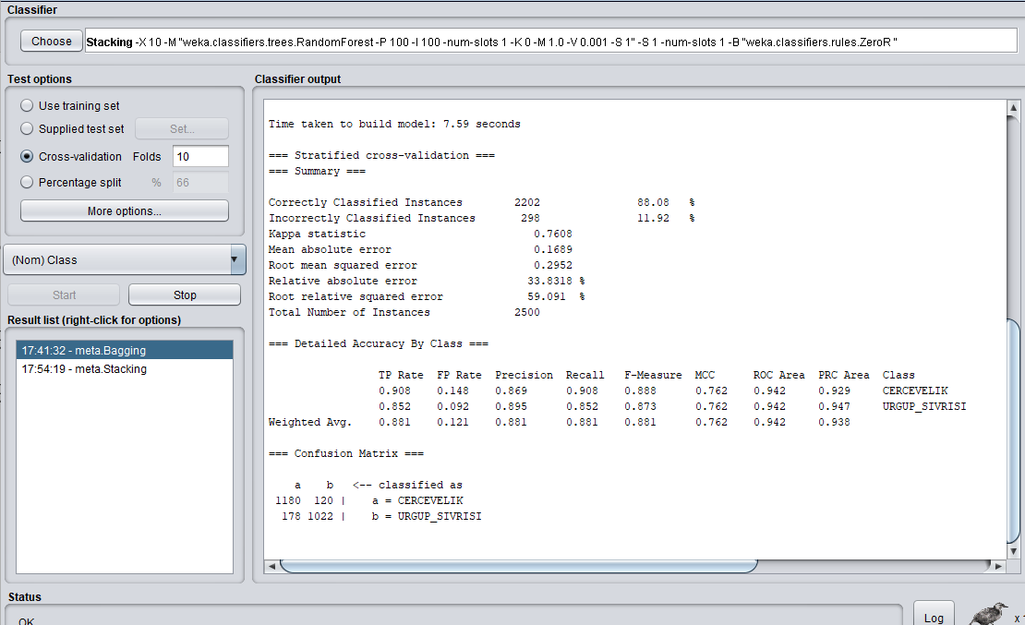

=== Run information ===

Scheme: weka.classifiers.meta.Bagging -P 100 -S 1 -num-slots 1 -I 10 -W weka.classifiers.trees.RandomForest -- -P 100 -I 100 -num-slots 1 -K 0 -M 1.0 -V 0.001 -S 1

Relation: Pumpkin_Seeds_Dataset

Instances: 2500

Attributes: 13

Area

Perimeter

Major_Axis_Length

Minor_Axis_Length

Convex_Area

Equiv_Diameter

Eccentricity

Solidity

Extent

Roundness

Aspect_Ration

Compactness

Class

Test mode: 10-fold cross-validation

=== Classifier model (full training set) ===

Bagging with 10 iterations and base learner

weka.classifiers.trees.RandomForest -P 100 -I 100 -num-slots 1 -K 0 -M 1.0 -V 0.001 -S 1

Time taken to build model: 7.59 seconds

=== Stratified cross-validation ===

=== Summary ===

Correctly Classified Instances 2202 88.08 %

Incorrectly Classified Instances 298 11.92 %

Kappa statistic 0.7608

Mean absolute error 0.1689

Root mean squared error 0.2952

Relative absolute error 33.8318 %

Root relative squared error 59.091 %

Total Number of Instances 2500

=== Detailed Accuracy By Class ===

TP Rate FP Rate Precision Recall F-Measure MCC ROC Area PRC Area Class

0.908 0.148 0.869 0.908 0.888 0.762 0.942 0.929 CERCEVELIK

0.852 0.092 0.895 0.852 0.873 0.762 0.942 0.947 URGUP_SIVRISI

Weighted Avg. 0.881 0.121 0.881 0.881 0.881 0.762 0.942 0.938

=== Confusion Matrix ===

a b <-- classified as

1180 120 | a = CERCEVELIK

178 1022 | b = URGUP_SIVRISI

**STACKING:**

**ACCURACY : 52%**

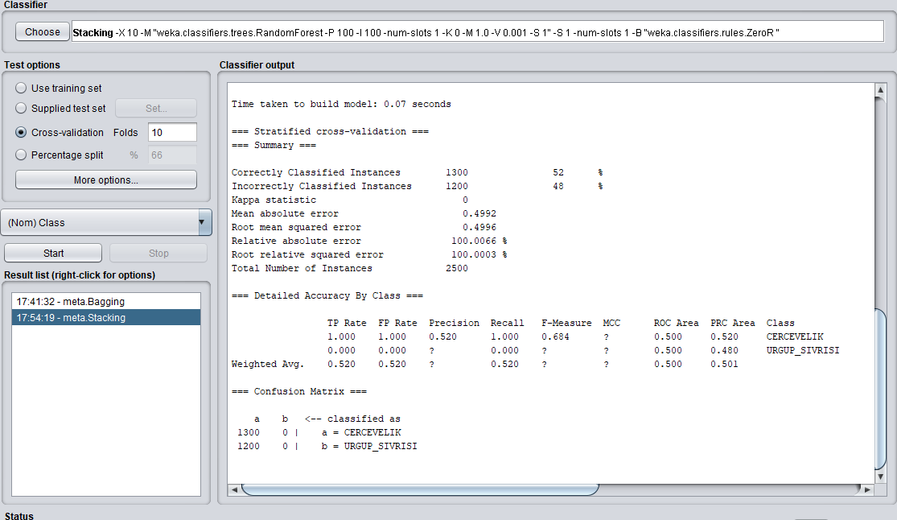

=== Run information ===

Scheme: weka.classifiers.meta.Stacking -X 10 -M "weka.classifiers.trees.RandomForest -P 100 -I 100 -num-slots 1 -K 0 -M 1.0 -V 0.001 -S 1" -S 1 -num-slots 1 -B "weka.classifiers.rules.ZeroR "

Relation: Pumpkin_Seeds_Dataset

Instances: 2500

Attributes: 13

Area

Perimeter

Major_Axis_Length

Minor_Axis_Length

Convex_Area

Equiv_Diameter

Eccentricity

Solidity

Extent

Roundness

Aspect_Ration

Compactness

Class

Test mode: 10-fold cross-validation

=== Classifier model (full training set) ===

Stacking

Base classifiers

ZeroR predicts class value: CERCEVELIK

Meta classifier

RandomForest

Bagging with 100 iterations and base learner

weka.classifiers.trees.RandomTree -K 0 -M 1.0 -V 0.001 -S 1 -do-not-check-capabilities

Time taken to build model: 0.07 seconds

=== Stratified cross-validation ===

=== Summary ===

Correctly Classified Instances 1300 52 %

Incorrectly Classified Instances 1200 48 %

Kappa statistic 0

Mean absolute error 0.4992

Root mean squared error 0.4996

Relative absolute error 100.0066 %

Root relative squared error 100.0003 %

Total Number of Instances 2500

=== Detailed Accuracy By Class ===

TP Rate FP Rate Precision Recall F-Measure MCC ROC Area PRC Area Class

1.000 1.000 0.520 1.000 0.684 ? 0.500 0.520 CERCEVELIK

0.000 0.000 ? 0.000 ? ? 0.500 0.480 URGUP_SIVRISI

Weighted Avg. 0.520 0.520 ? 0.520 ? ? 0.500 0.501

=== Confusion Matrix ===

a b <-- classified as

1300 0 | a = CERCEVELIK

1200 0 | b = URGUP_SIVRISI